
PLANNING PROPOSAL – LP145.1
Nebraska Estate, St Georges Basin Shoalhaven Local Environmental Plan 2014

Resolving a ‘Paper Subdivision’

Prepared by
Strategic Planning Section
City Futures

File: 1013E
Version 2 – Gateway Request
Date: November 2024
www.shoalhaven.nsw.gov.au

Shoalhaven City Council
PO Box 42
NOWRA NSW 2541

Shoalhaven City Council’s website: www.shoalhaven.nsw.gov.au

Contact:
Strategic Planning Team
Phone: (02) 4429 3111
e-mail: council@shoalhaven.nsw.gov.au

Disclaimer
Every effort has been made to provide accurate and complete information.
However, Shoalhaven City Council assumes no responsibility for any direct, indirect, incidental, or consequential damages arising from the use of information in this document.

Copyright Notice
No part of this publication may be reproduced in any form, or stored in a database or retrieval system, or transmitted or distributed in any form by any means, electronic, mechanical photocopying, recording, or otherwise without written permission from Shoalhaven City Council. All rights reserved.

Copyright © 2024, Shoalhaven City Council

Version Control
File: 1013E | Version | Purpose | Date | Officer
D21/231466 | Version No. 1 | Gateway | Nov 2014 | EH
D23/235407 | Version No 2 | Council report | June 2023 | EH/MC
D24/449338 | Version 2.1 | Gateway request | November 2024 | EH/GC

Table of Contents
1 Introduction 7
1.1 Subject Land 8
1.2 Background 12
1.3 Rezoning Investigations Overview 13
1.3.1 Development Footprint - 2010 14
1.3.2 Planning Proposal (2014-2020) 15
1.3.3 Termination of the Previous Gateway Process 16
1.4 Resolution to Restart the Planning Proposal 17
1.5 Updated Conceptual Subdivision and Development Plan 18
1.6 NSW Biodiversity Law Reforms 20
1.6.1 Clause 34A Certification 21
2 Part 1 – Objectives and Intended Outcomes 23
2.1 Objectives 23
2.2 Intended Outcomes 23
3 Part 2 – Explanation of Provisions 25
3.1 Intended Provisions 25
3.1.1 Land Use Zones (LZN) 25
3.1.2 Minimum Lot Sizes (LSZ) 26
3.1.3 Height of Buildings (HOB) 28
3.1.4 Terrestrial Biodiversity (BIO) 29
3.1.1 Local Clauses (CLS) 30
3.2 Supporting Planning Mechanisms and Implementation 31
4 Part 3 – Justification of Strategic Merit and Site-specific Merit 32
4.1 Need for the planning proposal (Section A) 32
4.1.1 Is the Planning Proposal a Result of an Endorsed LSPS, Strategic Study or Report? 32
4.1.2 Is the Planning Proposal the Best Means of Achieving the Objectives or Intended Outcomes, or is there a Better Way? 32
4.2 Relationship to Strategic Planning Framework (Section B) 32
4.2.1 Will the Planning Proposal Give Effect to the Objectives and Actions of the Applicable Regional or District Plan or Strategy 32
4.2.2 Is the Planning Proposal Consistent with an Endorsed LSPS or Another Endorsed Local Strategy or Strategic Plan 34
4.2.3 Is the Planning Proposal Consistent with any Other Applicable State and Regional Studies or Strategies? 38
4.2.4 Is the Planning Proposal Consistent with Applicable State Environmental Planning Policies? 38
4.2.5 Is the Planning Proposal Consistent with Applicable Ministerial Directions (s.9.1 Directions)? 42
4.3 Environmental, Social and Economic Impact (Section C) 63
4.3.1 Is there any Likelihood that Critical Habitat or Threatened Species, Populations or Ecological Communities, or their Habitats, will be Adversely Affected Because of the Proposal? 63
4.3.2 Are there any other Likely Environmental Effects of the Planning Proposal and How are they Proposed to be Managed? 66
4.3.3 Has the Planning Proposal Adequately Addressed any Social and Economic Effects? 68
4.4 Infrastructure (Local, State and Commonwealth) (Section D) 70
4.4.1 Is there Adequate Public Infrastructure for the Planning Proposal? 70
4.4.2 Roads 71
4.4.3 Electricity 71
4.4.4 Water and Sewer Reticulation 71
4.5 What are the Views of State and Federal Public Authorities and Government Agencies Consulted in Order to Inform the Gateway Determination? (Section E) 72
4.5.1 Agency Consultation 73
5 Part 4 – Maps 76
6 Part 5 - Community Consultation 81
7 Part 6 – Project Timeline 82
8 Implementation 83
8.1 Summary 83
8.2 Site-specific Development Control Plan (DCP) 84
8.3 Policy on Voluntary Acquisition of Residual C2 Land in Jerberra and Nebraska Estates 86
8.3.1 Broader Policy on Dealing with Unpaid Rates & Charges in Paper Subdivisions 86
8.3.2 Voluntary Acquisition of Residual C2 Environmental Conservation Land in Jerberra and Nebraska Estates 86
8.4 Proposed Use of ‘Clause 34A Savings Provision’ to Help Landowners Navigate Biodiversity Laws 88
8.5 Provision of Essential Infrastructure 89
8.5.1 Cost Recovery Principle 89
8.5.2 Infrastructure Co-ordination 90
8.5.3 Cost Recoupment Strategy and Mechanisms 90
8.5.4 Cost Estimate 92
9 Further Information 92
9.1 State Environmental Planning Policies (SEPP) Checklist 92
9.2 Local (s9.1) Planning Directions Checklist 94
9.3 Bushfire Assessment – DCP Considerations 95
9.3.1 Minimum APZ and Dwelling Construction Standards 95
9.3.2 Access 97
9.3.3 Provisions to be Incorporated into Planning Controls 97
9.4 Archaeological and Cultural Heritage Assessments 98
9.4.1 Previous Studies 98
9.4.2 Aboriginal Participation and Views 101
9.4.3 Previous State Agency Advice 102
9.4.4 Conclusion 103
9.5 Threatened Species Assessment – Species Distribution and Significance 103
9.5.1 Microchiropteran bats 104
9.5.2 Grey-headed Flying-fox 104
9.5.3 Yellow-bellied Glider 104
9.5.4 Southern Greater Glider 104
9.5.5 Gang-gang Cockatoo 105
9.5.6 Glossy Black-cockatoo 105
9.5.7 Powerful Owl 105
9.5.8 Black-faced Monarch 106
9.5.9 Leafless Tongue Orchid (Cryptostylis hunteriana) 106
9.5.10 Pterostylis ventricosa (orchid) 106
9.5.11 Biconvex Paperbark (Melaleuca biconvexa) 107
9.5.12 Swamp Sclerophyll Forest Endangered Ecological Community (EEC) 107
9.5.13 Koala Habitat Assessment 107
10 Document Library 110
10.1.1 Specialist Studies and Planning Documents 110
10.1.2 Council Reports and Minutes 111
10.1.3 Previous Planning Proposal and Gateway Determinations 112
10.1.4 Photo Montages 113
10.1.5 Abbreviations 113

Figures
Figure 1 - Location Map 8
Figure 2 – Subject Land overlaid onto aerial photo 10
Figure 3 - Current land use zoning under Shoalhaven LEP 2014 11
Figure 4 - Updated constraints analysis and potential development areas adopted by Council in 2010 Note: flooding constraints have been updated using the St Georges Basin Flood Study 2022 14
Figure 5 - Concept subdivision and development plan adopted by Council on 26/2/2024 19
Figure 6 - Land Use Zoning Map (LZN) - Existing (left) and proposed (right) 26
Figure 7 - Lot Size Map (LSZ) - Existing (left) and proposed (right) 27
Figure 8 - Height of Buildings Map (HOB) - Existing (left) and proposed (right) 29
Figure 9 - Terrestrial Biodiversity (BIO) Map - Existing (left) and proposed (right) 30
Figure 10 – Local Clauses (CLS) Map - Existing (left) and proposed (right) 31
Figure 11 - Map 10i, Jervis Bay Settlement Strategy (JBSS, 2003) 35
Figure 12 - SEPP (Resilience and Hazards) 2021 – Coastal Zone 40
Figure 13 - Proposed zoning and extent of flooding (SGB Flood Study, Cardno 2022) 47
Figure 14 - Acid sulfate soil risk mapping overlaid onto the proposed zoning and PMF 54

Tables
Table 1 – Status of threatened species in Nebraska Estate (1 June 2023) 66
Table 2 – Summary of NSW Government agency consultation since 2011 74
Table 3 - Indicative project plan 83
Table 4 - Summary of implementation issues 84
Table 5 – Preliminary infrastructure costs estimate 93

Maps
Map 1 – Land Use Zoning (LZN): Existing (inset) and Proposed (main) 78
Map 2 – Minimum Lot Sizes (LSZ): Existing (inset) and Proposed (main) 79
Map 3 – Height of Buildings (HOB): Existing (inset) and Proposed (main) 80
Map 4 – Terrestrial Biodiversity (BIO): Existing (inset) and Proposed (main) 81

Introduction
This draft planning proposal (PP) seeks to amend the Shoalhaven Local Environmental Plan 2014 (the LEP) to resolve the planning status of Nebraska Estate, a historical ‘paper’ subdivision’ located at St Georges Basin.
Land with important environmental values is proposed to be rezoned from RU2 Rural Landscape to C2 Environmental Conservation, while the less constrained land is proposed to be rezoned to a mix of R5 Large Lot Residential and C4 Environmental Living.
The PP is based on a comprehensive body of work undertaken over many years, and will be supported by a site-specific development control plan (DCP) to help ensure the intended outcomes are realised.
This is an updated version of a previous PP (Planning Portal reference: PP-2021-1236) which was terminated by the then NSW Department of Planning and Environment (the Department) in December 2020, along with four other ‘legacy’ PPs in Shoalhaven.
In December 2021, the Department released a new Local Environmental Plan Making Guideline which was updated in September 2022, August 2023.
The Department’s Local Environmental Plan Making Guideline formalised a significant change to the planning proposal (PP) / rezoning process without changing the statutory framework (Division 3.4 of the Environmental Planning and Assessment Act, 1979). To help facilitate a 33% reduction in assessment timeframes for planning proposals, the Department’s Guideline introduced maximum benchmark times. Consequently, the level of detail required at the initial ‘Gateway’ step has increased substantially because there is now insufficient time to resolve complex planning and environmental issues/matters after the Gateway step.
Due to the time limitations that apply to the post-Gateway stage under the new process, a PP must now be largely complete/resolved before a Gateway determination is sought from the Department (i.e., ‘pre-gateway’). This means that the supporting studies must be largely completed and the findings incorporated into the PP before it is submitted to the Department for Gateway.

Nebraska Estate is the last unresolved paper subdivision identified for investigation in Council’s adopted strategies. If the Estate’s future is not resolved, properties will however continue to be bought and sold on the speculative market; ownership will be further fragmented; and the land’s environmental values will remain at risk.
The PP and intended supporting DCP will resolve the Estate’s planning controls and is part of a broader approach to help bring the proposal to fruition and provide long-term solutions to the Estate’s tenure and management. This broader approach includes:
- A potential special rate arrangement to fund the provision of essential infrastructure, following the approach used in Jerberra Estate (Tomerong) and Verons Estate (Sussex Inlet).
- Council’s adopted policy (Voluntary Acquisition – Residual C2 Environmental Conservation Land – Jerberra & Nebraska Estates) will help resolve the tenure and management of the residual environmental land through time.
This PP has been prepared in accordance with the “Local Environmental Plan Making Guideline”, August 2023, and part 3 of the Environmental Planning and Assessment Act, 1979.

Subject Land
The subject land is located approximately 23 km south of Nowra at the north-western fringe of the St Georges Basin urban area. See Figure 1 - Location of the subject land.
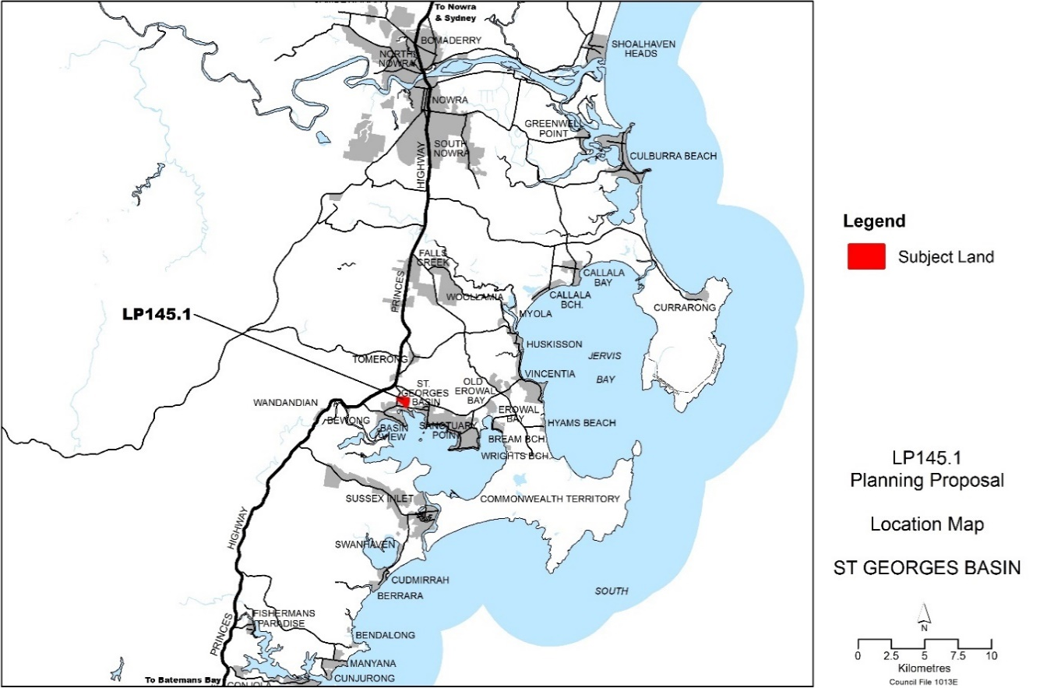
Figure 1 - Location Map
The boundary of the subject land is shown in Figure 2. It has an area of approximately 33 ha and currently includes the following properties:
- Lots 4-6 and 11-20, Section A, DP 9699
- Lots 1-20, Section B, DP 9699
- Lots 1-20, Section C, DP 9699
- Lots 1-13 and 18-20, Section D, DP 9699
- Lots 1-7, & Pt Lot 8 Section F, DP 9699
- Pt Lots 15-16 and Pt Lot 19, Section H, DP 9699
- Lots 2-10, Section J, DP 9699
- Lots 1, 2 and Pt Lot 3, DP 722549
- Lots 1-3, DP 1090657
- Lot 1, DP 777950
- Lot 100, DP 1104506
- Pt Lot 1 DP 1120892
- Pt Lot 1, DP 1223665
The PP also includes Nebraska and Pelican Roads and parts of Waterpark, Grange and Fisherman Roads.
Most of the land is privately owned and is held in approximately 50 separate ownerships. The subject land boundary is overlaid onto aerial photography in Figure 2. Photo montages dated 2014 and 2023 are provided in Attachment 10.1.7.
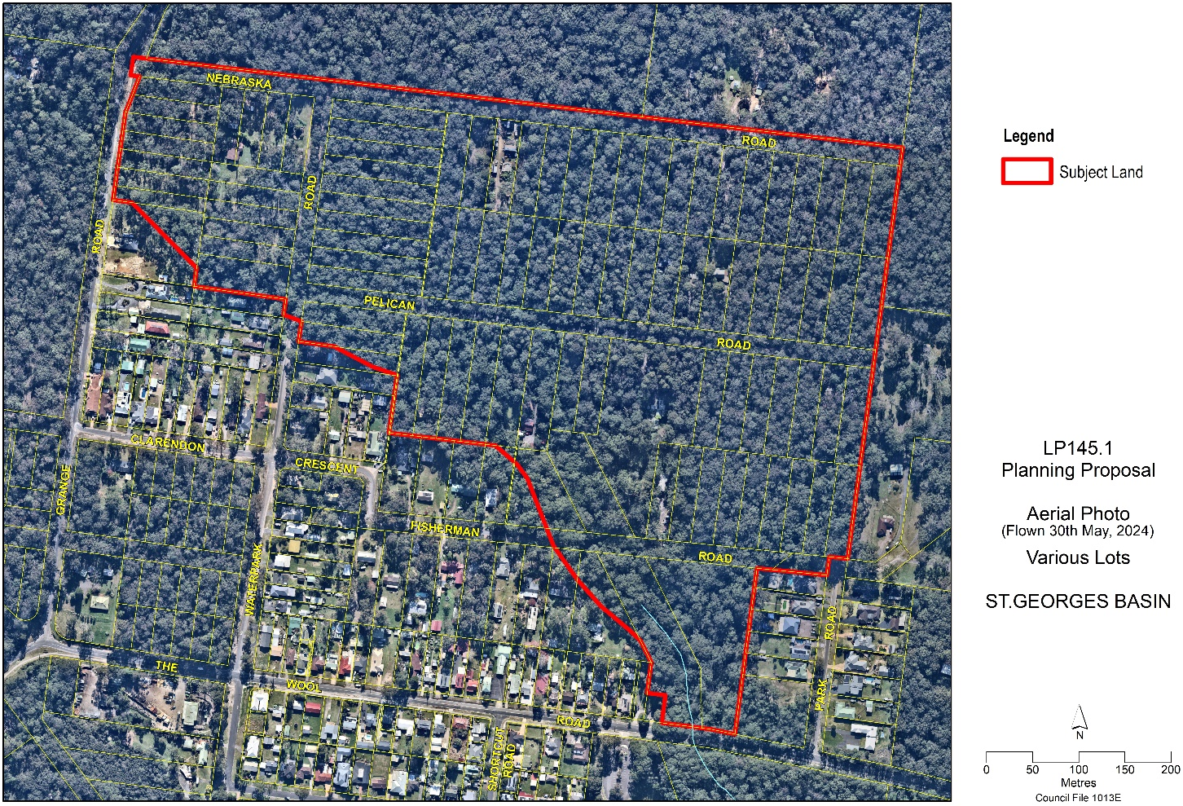
Figure 2 – Subject Land overlaid onto aerial photo

The current zoning of the subject land is shown in Figure 3 (page 11).
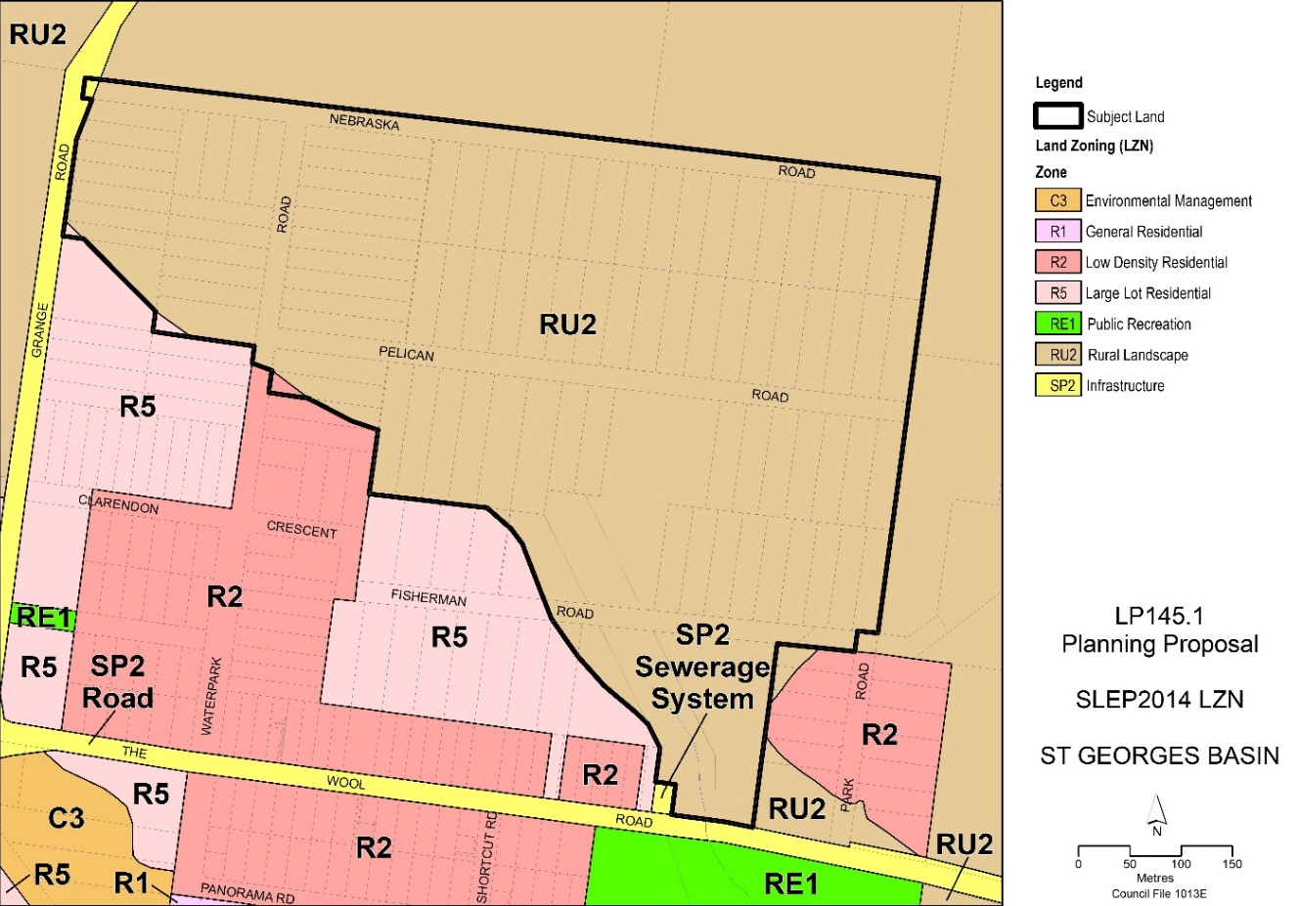
Figure 3 - Current land use zoning under Shoalhaven LEP 2014

The subject land is currently generally zoned RU2 Rural Landscape under Shoalhaven Local Environmental Plan 2014 (SLEP 2014) except for:
- A small area within Grange Road that is zoned SP2 Special Purpose (Roads)
- Two small triangular areas zoned R5 Large Lot Residential
- One small triangular area zoned R2 General Residential
Land to the south of the subject land is currently generally zoned R5 Large Lot Residential apart from lots around the intersection of Waterpark Road and Clarendon Crescent, which are zoned R2 Low Density Residential, and a small area of land adjoining The Wool Road, which is zoned SP2 Infrastructure. Land to the north, east and west is currently generally zoned RU2 Rural Landscape.
The minimum lot size for land zoned RU2 Rural Landscape is 40 hectares. Generally, a dwelling cannot be approved unless the prescribed minimum lot size is satisfied. Council cannot approve a dwelling house on the individual lots within the Estate because the lots are less than 40 hectares (the total area of Nebraska Estate is 33 hectares) and clause 4.2D of SLEP 2014 cannot otherwise be satisfied.
The subject land is also mapped under SLEP 2014 as follows:
- on the “riparian lands and watercourses” map as supporting Category 2 watercourses to which clauses 7.5 and 7.6 of SLEP 2014 apply
- partly as “scenic protection area” - clause 7.8 of SLEP 2014 applies
- partly as “acid sulfate soils – class 2” - clause 7.1 of SLEP 2014 applies and
- on the “local clauses” map - clause 7.20 (“development in the Jervis Bay region”) applies.
The SLEP 2014 map layers can be viewed online.

Background
The Jervis Bay area was the focus of speculative subdivision activity during and immediately after WW1, following the Commonwealth Government’s decision to make Canberra the Australian capital, and for Jervis Bay to be Canberra’s official port. Planning legislation at that time was in its infancy: land use zoning did not exist, and subdivisions could effectively be registered and created on paper, without services or infrastructure.
By the time the Great Depression set in, approx. 10,000 lots had been created in several ‘paper’ subdivisions around Jervis Bay. These paper subdivisions were in bushland and zoned rural when land use zoning was first introduced in 1964. The rural zoning generally prevented the individual lots from being developed for residential purposes.
Notwithstanding the planning restrictions and lack of basic services and infrastructure, Council has never had the legal ability to prevent the sale of individual lots within subdivisions.
Roughly 1,500 individual lots were separately sold across several paper subdivisions in the Jervis Bay area in the 1980s and ‘90s (e.g. Heritage Estates at Worrowing Heights, Jerberra Estate at Tomerong, and Nebraska Estate). Council requested state government intervention to prevent the sale and fragmentation of these paper subdivisions, but to no avail. Meanwhile, landowners in the various subdivisions lobbied the Council to rezone their land. In 1992, the Council resolved to investigate rezoning Nebraska Estate subject to all costs being met by the landowners. Around this time, similar decisions were made in relation to several other paper subdivisions (including the Heritage Estates, Jerberra Estate, and Verons Estate).
Further information on paper subdivisions in the Jervis Bay area is available on Council’s website.

Rezoning Investigations Overview
Rezoning investigations progressed in the 90s but were halted by a NSW Government rezoning moratorium in the Jervis Bay region. The moratorium was lifted in 2003 when the Jervis Bay Settlement Strategy (JBSS) was adopted by Council and endorsed by the NSW Government.
Council recommenced a thorough investigation of the constraints and land capability of Nebraska Estate in 2006.
Several specialist studies have been completed over time and have informed the PP. These include:
- Aboriginal cultural heritage
- Biodiversity - a detailed Threatened Biodiversity Survey and Assessment by Eco Logical Australia P/L (ELA) for which the fieldwork was undertaken from December 2006 to May 2008
- Planning for bushfire protection
- Soil and water management
The rezoning investigations showed that substantial areas of the Estate are heavily constrained. Constraints include flooding, threatened biodiversity, bushfire, acid sulfate soils and Aboriginal archaeology. The key constraints and potential development areas identified are illustrated in Figure 4 below (page 14).
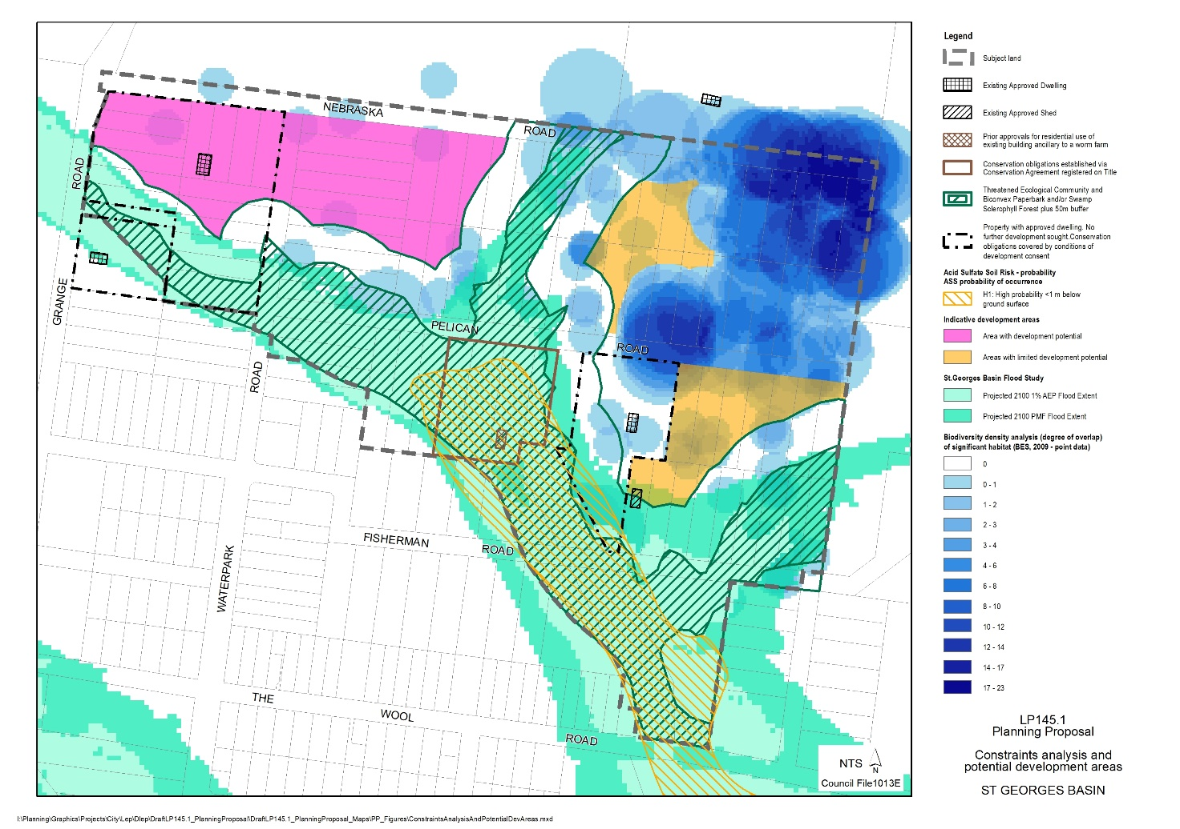
NW Sector
NE Sector
E Sector
Figure 4 - Updated constraints analysis and potential development areas adopted by Council in 2010 Note: flooding constraints have been updated using the St Georges Basin Flood Study 2022

Links to the supporting studies are provided in the Document Library in section 10.1.1. The planning history of Nebraska Estate, from registration of the plan of subdivision in 1919 up to 2003, is described in more detail in the Nebraska Estate Fact Sheet.

Development Footprint - 2010
On 13 April 2010, Council previously adopted a formal position on the extent of land that is potentially suitable for residential development, identifying three sectors with limited development potential (MIN10.376). The three potential development sectors are described below and are shown in Figure 4.
- Northwestern (NW) Sector: this is the least constrained and largest of the potential development areas and relatively close to existing residential land south of the main watercourse.
- Northeastern (NE) Sector: this is a relatively small area of flood-free land bounded to the north, east and south by large numbers of the ‘critically endangered’ orchid Pterostylis ventricosa (P. ventricosa)&. This area has very limited potential for rural residential development.
- Eastern (E) Sector: this area is located on flood free land, between a developed rural residential lot to the west, the Endangered Ecological Community (EEC) – Swamp Sclerophyll Forest and Melaleuca biconvexa (Biconvex Paperbark) to the south and southeast, and the orchid P. ventricosa to the north.
The council resolved that the remaining areas are unsuitable for development due to environmental and land capability constraints.

Planning Proposal (2014-2020)
A draft planning proposal (PP) identifying the constraints and potential development areas was submitted to the Department for consideration in late 2014. The original PP identified two density options for the NW Sector: lower density (equivalent to the R5 Large Lot Residential zone) and higher density (equivalent to the R2 Low Density Residential zone).
A Gateway determination for the PP was issued in March 2015. One of the Gateway conditions required Council to consult with the Estate’s landowners and determine the preferred option for the NW Sector.
After consulting with the landowners, a report was considered on 5 April 2016 (Item 5). Council resolved (MIN16.230) to:
a) Adopt revised version 2 of Option 1 – Lower Density Residential Development outlined in this report and provided in Attachment D, as the preferred option to move forward with, and the Planning Proposal be amended accordingly.
b) Prepare the required water cycle assessment.
c) On completion of a) and b) publicly exhibit the Planning Proposal.
All relevant Council reports and minutes are listed and linked in section 10.1.2 of this PP.

Termination of the Previous Gateway Process
The previous PP did not proceed to public exhibition, in part due to complications associated with the commencement of the Biodiversity Conservation Act 2016 (discussed in section 1.7).
The original Gateway timeframe of 3 March 2017 was extended four times, with a final completion date of 4 March 2021. However, on 1 October 2020 advice was received from the Department that five PPs with Gateways older than four years would need to be finalised by 31 December 2020. The Nebraska PP was one of these ‘legacy’ PPs.
Council considered a report on the deadline (DE20.130) and resolved (MIN20.887) to:
- Request an extension of time from Dept of Planning Industry and Environment to seek further advice, including but not limited to the existing expert reports that have been prepared for the applications; and
- Request an urgent meeting with the Hon Shelly Hancock MP Member for South Coast and The Hon. Robert Stokes MP to discuss the NSW Government Direction on these Planning Proposals.
Council staff wrote to the Department requesting an extension and requested a meeting with the then Member for South Coast, The Hon Shelly Hancock MP and the then NSW Minister for Planning & Public Spaces, The Hon Robert Stokes MP, but no meeting was secured.
Correspondence from the Department, dated 15 December 2020, declined Council’s extension request and terminated all five of the Gateway determinations (via amended Gateways).
Council considered a follow-up report on 18 January 2021 (DE21.5) on timing and progression of each of the terminated PPs. In relation to Nebraska Estate, Council resolved (MIN21.6) to:
seek a new Gateway determination at the appropriate point once the policy is adopted that will help resolve the tenure and management of the proposed E2 land (as per Council resolution MIN20.885) to help secure certification for the new planning controls under Clause 34A of the NSW Biodiversity Conservation (Savings and Transitional) Regulation 2017.

Resolution to Restart the Planning Proposal
Council considered a report on the Nebraska Estate PP on 17 July 2023 that can be viewed via the following links:
- Report to Ordinary Meeting 17 July 2023 (CL23.214)
- Attachment 1: Draft Planning Proposal - Nebraska Estate, St Georges Basin
- Attachment 2: Updated Constraints Summary Map (2023)
The July 2023 report sought Council’s ‘in principle’ support to restart the PP process for the Estate based on an updated version of a concept plan adopted by Council in 2016. In response, Council resolved to:
“… defer consideration … to enable Council to be fully briefed on:
  - The possible expansion of the proposed C2 Environmental Conservation zone to the whole of the subject land, or parts of it, to afford greater protection to the Estate’s environmental values and Jervis Bay wildlife corridors, and
  - Minimise the creation of areas of isolated development in bushland that are at risk from bushfire and may incur large infrastructure maintenance costs per capita.”
The resolved briefing was held on 28 September 2023 and attended by six Councillors. The following options were presented and discussed at the briefing:
- Option 1 – enabling up to potentially 23 new dwellings and rezoning the Estate to a mix of C2 Environmental Conservation, C4 Environmental Living and R5 Large Lot Residential. Based on 2016 concept plan with some minor changes/adjustments.
- Options 2.1 or 2.2 - no new dwellings, rezoning the whole Estate to C2 (Option 2.1) with a variation of rezoning the cleared land west of Waterpark Road to R5 (Option 2.2).
- Options 3.1 and 3.2 - reduced overall development footprint enabling up to either 17 new dwellings (Option 3.1) or 16 dwellings (Option 3.2) and rezoning the Estate to a mix of C2, C4 and R5.
The matter was then reported to Council on 26 February 2024. Links to the report and attachment are provided below.
- Report to Ordinary Meeting on 26 February 2024
- Attachment – Indicative economic feasibility and infrastructure costs
In response, the Council resolved (MIN24.86) to:
- Update the Nebraska Estate Planning Proposal (PP) based on Option 3.1 as outlined in this report, noting that timing will also depend on workloads generated by proponent-initiated PPs.
- Submit the updated PP to the Department of Planning, Housing and Infrastructure (DPHI) for a Gateway determination.
- Subject to receiving a favourable Gateway determination from DPHI, exhibit the PP package.
- Prepare a draft site-specific chapter (Chapter N9 - Nebraska Estate) for inclusion in the Shoalhaven Development Control Plan (DCP) 2014, acknowledging that staff resources available to work on this project will depend on workloads associated with proponent-initiated PP’s and other strategic planning priorities.
This PP reflects part 1 of the resolution. Option 3.1 (referred to in part 1) is detailed in section 1.6 below.

Updated Conceptual Subdivision and Development Plan
The Conceptual Subdivision and Development Plan (concept plan) adopted by Council on 26 February 2024 (referred in MIN24.86 as Option 3.1) is shown in Figure 5 below.
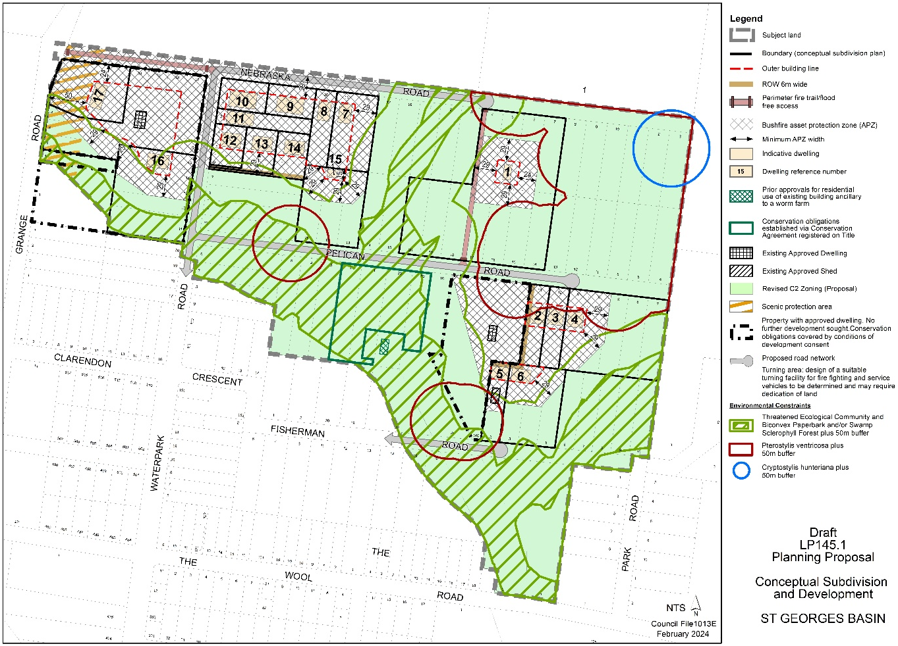
Figure 5 - Concept subdivision and development plan adopted by Council on 26/2/2024
Note: details may be subject to change.
The concept plan illustrates how the land could ultimately be developed if the LEP is amended as proposed. It shows the outer building lines and general location of the 17 new dwellings within the three overall development areas. The outer building lines are based on the calculated APZ widths to avoid exposure to direct flame contact (i.e. ≤29 kW/m²) consistent with Planning for Bushfire Protection (2019) (see section 9.1). The concept plan will be incorporated into the supporting draft site-specific development control plan (DCP) that will also be prepared.
The PP is predicated on all three sectors being serviced with a pressurised sewer system, as advised by Shoalhaven Water. This will eliminate risks associated with onsite and gravity sewer systems. Stormwater management controls will be included in the DCP to protect water quality and downstream environments, informed by the Integrated Water Cycle Assessment (IWCA) that supports this PP and further feedback from Council’s Floodplain Management team and City Services Directorate (stormwater infrastructure asset custodian).
Most of the threatened orchids will be retained within land proposed to be zoned C2 Environmental Conservation. However, a small number of orchids will potentially be located within APZs. The proposed DCP will include provisions to retain and protect as many orchids as possible, including any within APZs.
Management requirements for the C2 land within each development lot will be set out in the DCP and will be given legal effect via conditions of consent. The proposed DCP provisions will be based on those developed for Jerberra Estate, which has similar biodiversity and bushfire issues, in consultation with Council’s biodiversity team and the Environment, Energy and Science (EES) Group within the NSW Department of Climate Change, Energy, the Environment and Water (DCCEEW). This will include the requirement, where relevant, for a positive covenant to be established and registered on title to ensure any important biodiversity values retained within the development parcel will be protected and managed for conservation.

NSW Biodiversity Law Reforms
The NSW Biodiversity Conservation Act 2016 (BC Act) introduced a new Biodiversity Assessment Methodology (BAM) and a new Biodiversity Offsets Scheme (BOS).
An initial assessment of the Nebraska PP at the time suggested that the BOS would be triggered by all of the proposed individual dwellings. The implication of this would be that each development application (DA) for a dwelling would require its own Biodiversity Development Assessment Report (BDAR) prepared in accordance with the BAM, to determine the offsetting requirement for each development.
The cost of preparing individual BDARs and offsetting the impacts (i.e. purchasing credits from the market or paying into the Biodiversity Conservation Fund) would also be borne by each DA applicant. Note: the BC Act does not allow for a comprehensive BDAR to be completed over the whole Estate. These costs would potentially make it unviable to develop the land.
Moreover, there is little prospect of establishing a biodiversity stewardship site within the Estate to protect its conservation values due to the fragmented land ownership and the size and configuration of the properties. This means that any biodiversity gains potentially achieved by applying the offset scheme to the Estate would be located elsewhere.
Since the BC Act commenced, Council has consulted with the EES Group to try to find a workable solution that can protect and manage the Estate’s biodiversity values into the future. Clause 34A certification appears to be the only viable option, and it is explained below.

Clause 34A Certification
Clause 34A(4) of the Biodiversity Conservation (Savings & Transitional) Regulation, 2017 allows DAs in areas where a ‘relevant planning arrangement’ was in place prior to commencement of the BC Act to be assessed under the previous legislation (i.e. it is a ‘savings clause’). Clause 34A (4) sets out the following eligibility criteria for ‘relevant planning arrangements’:
- that the proposed development the subject of a development application is part of a relevant planning arrangement and the biodiversity impacts of the proposed development were satisfactorily assessed before the commencement of the Act as part of the relevant planning arrangement, and
- that conservation measures have been secured into the future (by a planning agreement, a land reservation or otherwise) to offset the residual impact of the proposed development on biodiversity values after the measures required to be taken to avoid or minimise those impacts.
Planning controls for both the Jerberra and Verons Estates were certified as ‘relevant planning arrangements’ under clause 34A of the Biodiversity Conservation (Savings and Transitional) Regulation 2017 in 2019. The certification was granted by the NSW Government recognising that the biodiversity impacts were thoroughly investigated and addressed as part of the rezoning process for each Estate.
Each Estate has strict biodiversity provisions requiring important biodiversity values to be legally protected and managed in perpetuity through a positive covenant or equivalent.
The clause 34A certification means that DAs that fully comply with the strict biodiversity provisions that apply in each Estate can be assessed under the legislation that applied before the BC Act commenced; the BOS is not triggered and a Biodiversity Development Assessment Report (BDAR) is not required to support the DA (provided it fully complies).
Clause 34A can potentially be applied to Nebraska Estate provided:
- the biodiversity impacts of the proposed development were satisfactorily assessed before the commencement of the Act as per part (a); and
- [through the relevant planning arrangement] conservation measures have been secured into the future to offset the residual impact of the proposed development on biodiversity values, as per part (b)
A joint NSW State Agency letter dated 9 December 2011 indicated that the development footprint on which this PP is generally consistent with the findings of the threatened biodiversity assessment, except for the NE Sector, in relation to which the letter stated:
“Any development in this area should be justified in terms of a positive environmental outcome on threatened species habitat and minimising the extent of bushfire asset protection zones. The EPA’s preference would be for no additional dwellings in this area but further investigations may be able to justify some residential development. DP&I’s preference is that should development be needed in this area, that the level of development should maximise the possible number of dwelling envelopes within the disturbed area. This may involve some lot amalgamation or other dwelling types, e.g. attached dual occupancies.” (Note: EPA was the equivalent of the EES Group within DEEWWC and DP&I was the equivalent of the Department of Planning, Housing and Infrastructure (DPHI)).
‘In-principle’ support for clause 34A certification was sought from the then NSW Office of Environmental Heritage (OEH) on 31 May 2018. However, OEH was reluctant to commit to clause 34A certification at that time, noting that the PP had not been publicly exhibited, and a site specific DCP had also not been prepared.
Furthermore, clause 34A was new at that time and importantly, Council’s requests for 34A certification of the Jerberra and Verons Estate planning controls were undetermined at that point. Discussions on the potential use of clause 34A for Nebraska resumed in 2020, following certification of the planning controls for Jerberra and Verons Estates.
In terms of satisfying clause 34A(4)(b), a complicating factor is that a significant proportion of the environmentally sensitive land in Nebraska Estate (proposed to be zoned C2 Environmental Conservation) is unable to be incorporated into a larger development parcel. This ‘residual C2 land’ is therefore unlikely to be protected via development consent conditions. To address this, in 2021, Council adopted a Policy for Voluntary Acquisition – Residual C2 Environmental Conservation Land – Jerberra & Nebraska Estates (MIN21.699). This enables Council to proactively acquire and manage ‘residual C2 land’ in the Estate for conservation in perpetuity, if/when the land is rezoned. The adopted policy is discussed in section 8.3.

Part 1 – Objectives and Intended Outcomes

Objectives
The objectives of this Planning Proposal are to:
- resolve the planning status of Nebraska Estate, the last unresolved “paper subdivision” identified in the Jervis Bay Settlement Strategy
- recognise and protect the environmentally sensitive land and Aboriginal cultural heritage values
- make provision for a limited number of dwelling sites on less constrained land consistent with the relevant statutory and policy framework
- protect waterways and sensitive downstream ecosystems from the potential impacts arising from residential development
- ensure that the land is not developed until arrangements are in place to provide essential services and infrastructure, and
- avoid any unplanned opportunities for additional dwellings and/or land fragmentation.

Intended Outcomes
The intended outcomes are to:
- rezone less constrained land to R5 Large Lot Residential and C4 Environmental Living and amend the minimum lot size map to allow limited residential development consistent with the concept subdivision and development plan shown in Figure 5.
- rezone the remaining land to C2 Environmental Conservation consistent with the identified environmental and land capability constraints
- to correct an existing anomaly, rezone a small parcel of RU2 Rural Landscape zoned land within the boundaries of Grange Road, to SP2 Infrastructure and remove the 40 ha (AB4) Minimum Lot Size (LSZ)
- to avoid creating anomalies within allotments that straddle the adjoining residential land and the rural-zoned land, rezone two (2) small parcels of land zoned R5 Large Lot Residential and one (1) zoned R2 Low Density Residential at the southern boundary of the subject land to C2 Environmental Conservation and apply a 40 ha (AB4) Minimum Lot Size (LSZ) to these parcels
- include provisions in the LEP to ensure that the following are in place before the land is able to be developed:
  - a site-specific development control plan (DCP) covering subdivision layout, conservation management, desired future character, bushfire protection planning, location and construction standard of dwellings and associated structures, Aboriginal cultural heritage, stormwater and soil management, infrastructure works, flooding and emergency access; and
  - satisfactory arrangements to provide essential infrastructure including water, sewerage, roads and fire trails.

Part 2 – Explanation of Provisions

Intended Provisions
The Planning Proposal seeks to change the following map layers of the SLEP 2014:
- land use zoning (LZN) - Sheet LZN_014F
- minimum lot size (LSZ) - Sheet LSZ_014F* Note: as explained below, introducing a new lot size category (‘Y2’ changing ‘Y’ to ‘Y1’) will require labelling changes to other map sheets in the LSZ overlay.
- height of buildings (HOB) - Sheet HOB_014F
- terrestrial biodiversity (BIO) - Sheet BIO_014F
- local clauses (CLS) - Sheet CLS_014F
A local clause is proposed to ensure that before the land is developed, satisfactory arrangements are in place for the provision of essential infrastructure, and a supporting development control plan (DCP) has been prepared which addresses the matters outlined in section 8.2, namely:
- Subdivision layout
- Biodiversity management (vegetation clearing and retention)
- Desired future character
- Bushfire protection planning
- Building design and location
- Aboriginal cultural heritage
- Stormwater management
- Infrastructure works
- Flooding and emergency access
- Soil management
The proposed mapping changes are described and illustrated below (existing and proposed). More detailed maps (including property details) are provided in section 5.

Land Use Zones (LZN)
It is proposed to rezone the land from RU2 Rural Landscape to a combination of: R5 Large Lot Residential; C4 Environmental Living, and C2 Environmental Conservation.
Proposed land use zoning changes are illustrated in Figure 6 below. A more detailed zoning map (showing lot and DP) is provided in section 5.
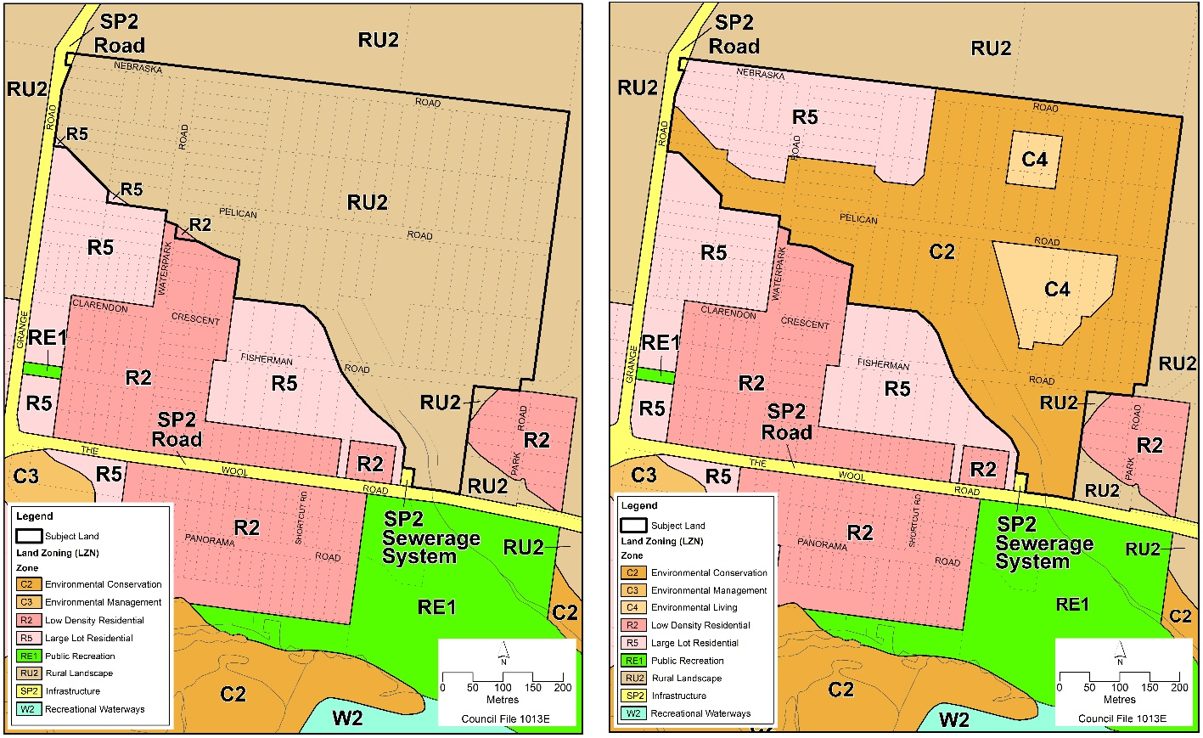
Figure 6 - Land Use Zoning Map (LZN) - Existing (left) and proposed (right)

Minimum Lot Sizes (LSZ)
The minimum lot size map overlay in the SLEP 2014 is proposed to be amended to facilitate the dwelling and subdivision outcomes shown in the concept plan (Figure 5) as illustrated in Figure 7 below.
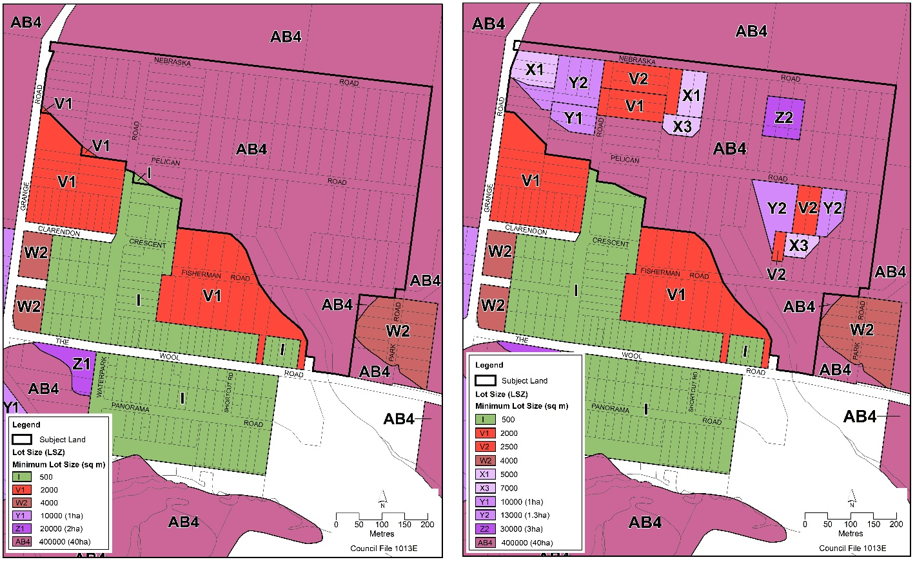
Figure 7 - Lot Size Map (LSZ) - Existing (left) and proposed (right)

The minimum lot sizes have been applied to ensure sufficient land area is available to provide the APZs required to satisfy BAL 29 in accordance with Planning for Bushfire Protection 2019 and, where possible, to limit the necessity for lot consolidation/reconfiguration.
The proposed LSZ overlay has been formulated to specifically allow the creation of the lot layout and dwelling entitlements shown in the concept subdivision and development plan (Figure 5) while also avoiding the creation of additional subdivision potential. The following lot sizes are proposed to be applied to the subject land:
- V1 - 2,000 m²: will allow three (3) new dwelling sites in the NW Sector;
- V2 - 2,500 m²: will allow three (3) new dwelling sites in the NW Sector and three (3) new dwelling sites in the E Sector;
- X1 - 5,000 m²: will allow two (2) dwelling sites in the NW Sector;
- X3 - 7,000 m²: will allow one (1) new dwelling site in the NW Sector and one (1) new dwelling site in the E Sector;
- Y1 – 10,000 m² (1 ha): will allow one (1) new dwelling site in the NW. Note: this lot size is currently identified as “Y” in the SLEP 2014 LSZ map overlay. As such, all references to “Y” in the LSZ overlay will need to be changed to “Y1”. This will affect other map sheets.
- Y2 – 13,000 m² (1.3 ha): will allow one (1) new dwelling site in the E Sector and allow subdivision of the existing approved dwelling at 2 Waterpark Road from the existing larger lot (Lots 1-3 DP 1090657, and Lots 11-20 Section A, DP 9699). Y2 will also be applied to 17 Fisherman Road (Lot 100 DP 1104506) in recognition of the existing approved dwelling (DA05/3226). Note: this is a new lot size; 13,000 m² (1.3 ha) is not currently included in the SLEP 2014 LSZ map overlay.
- Z2 – 30,000 m² (3 ha): will allow one (1) new dwelling site in the NE Sector, subject to the consolidation of 11 existing lots (that are currently held in five ownerships).
- AB4 - 400,000 m² (40 ha): to be applied to the proposed C2 Environmental Conservation zoned land.
- Two fragments of land zoned SP2 within the road casement of Grange Road are included in the subject land boundary. These parcels currently have an allocated minimum lot size of 40 ha (AB4). These anomalies are proposed to be removed by not applying a minimum lot size, consistent with best practice and all roads in the Shoalhaven LGA.

Height of Buildings (HOB)
A maximum building height of 8.5 metres is proposed to be applied to the subject land, apart from the area within Grange Road. The 8.5 m building height limit is consistent with existing adjoining, and adjacent residential development south of the subject land. The general height restriction of 11 metres will remain in place for Grange Road as per Clause 4.3 (2A) – Height of Buildings of Shoalhaven LEP 2014.
Proposed changes to the height of buildings overlay are illustrated in Figure 8 below.
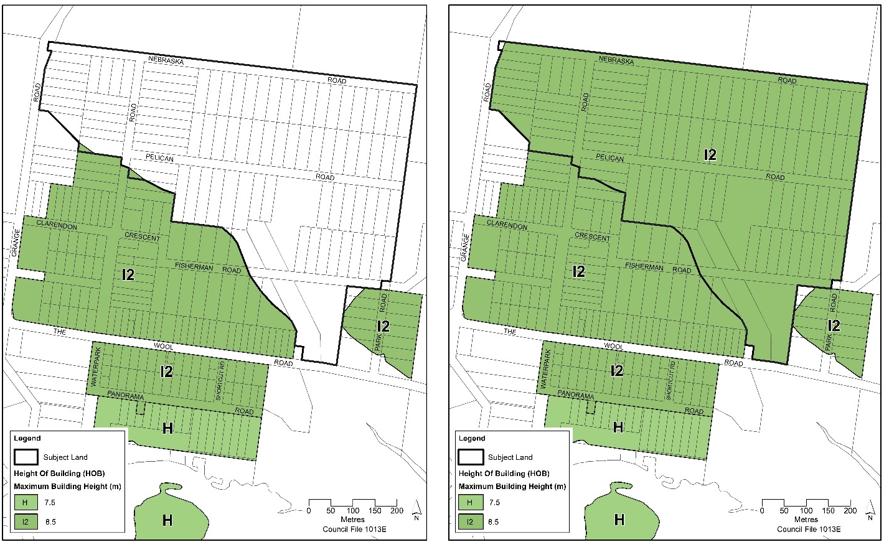
Figure 8 - Height of Buildings Map (HOB) - Existing (left) and proposed (right)

Terrestrial Biodiversity (BIO)
Under SLEP 2014, the subject land is currently mapped as ‘natural resource sensitivity – biodiversity’ to which clause 7.5 of SLEP 2014 applies.
It is proposed to retain the “significant vegetation” and “excluded land” mapping for Nebraska on the basis that this will further protect the Endangered Ecological Community (EEC) Swamp Sclerophyll Forest in the drainage depressions and riparian land that closely corresponds with the occurrence of the protected Biconvex Paperbark plus 50 m buffer also the P. ventricosa orchid and the 50 m buffer. The existing “significant vegetation mapping” is proposed to be removed from land proposed to be zoned R5 Large Lot Residential and C4 Environmental Living (NE Sector) in response to the environmental constraints and proposed landuse zoning.
Proposed changes to the terrestrial biodiversity overlay are illustrated in Figure 9 below.
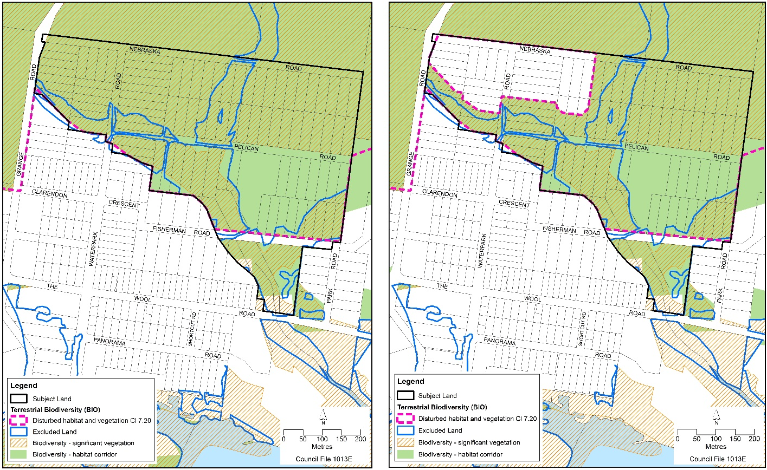
Figure 9 - Terrestrial Biodiversity (BIO) Map - Existing (left) and proposed (right)

Local Clauses (CLS)
The subject land is proposed to be mapped on the Local Clauses overlay in the SLEP 2014, as shown in Figure 10. As discussed, a proposed new local clause will apply to the mapped area.
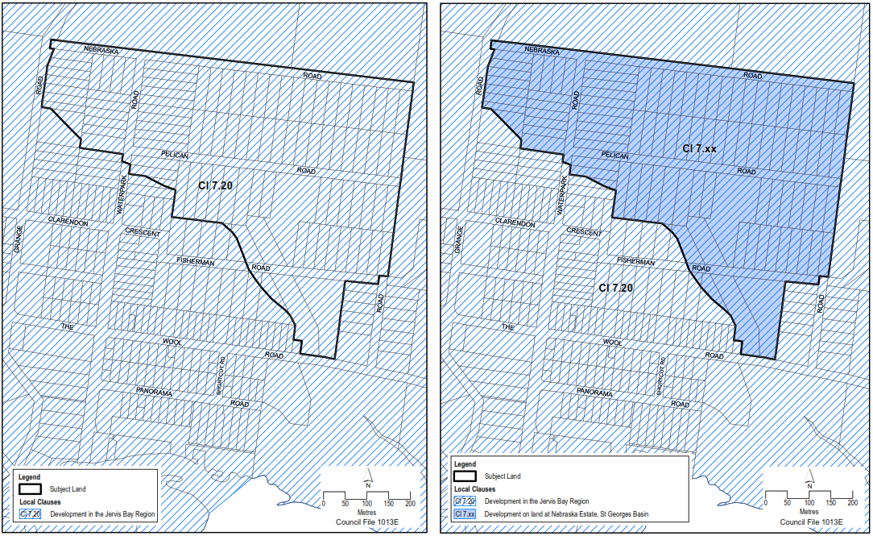
Figure 10 – Local Clauses (CLS) Map - Existing (left) and proposed (right)

Supporting Planning Mechanisms and Implementation
Planning mechanisms required to support and implement the proposed rezoning of Nebraska Estate include:
- DCP preparation
- Infrastructure costings and upgrades
- Special Rate Variation application to IPART
- Policy for acquisition of Residual C2 land
These are discussed in section 8.

Part 3 – Justification of Strategic Merit and Site-specific Merit

Need for the planning proposal (Section A)

Is the Planning Proposal a Result of an Endorsed LSPS, Strategic Study or Report?
Yes. The Shoalhaven 2040 - Strategic Land-use Planning Statement (SLPS 2020) endorsed by the NSW Government, identifies St Georges Basin as a major urban area. The subject land is immediately adjoining and located northwest of existing residential development at St George’s Basin.
Importantly, the PP gives effect to a specific action in the Jervis Bay Settlement Strategy (JBSS, 2003) to investigate rezoning Nebraska Estate – refer to section 4.2.2. The JBSS was endorsed by the NSW Government in 2003 and is embedded within the Shoalhaven Growth Management Strategy (GMS) also endorsed by the NSW Government in 2014. The SLPS, JBSS and GMS are discussed in section 4.2.

Is the Planning Proposal the Best Means of Achieving the Objectives or Intended Outcomes, or is there a Better Way?
Yes. The current zoning needs to be amended to resolve the subject land's development potential, achieve environmental outcomes, and meet contemporary planning requirements. Various environmental and land capability studies have been undertaken, and significant progress has been made in reaching an agreement with the relevant Government agencies on appropriate development, bushfire management, and environmental outcomes.

Relationship to Strategic Planning Framework (Section B)

Will the Planning Proposal Give Effect to the Objectives and Actions of the Applicable Regional or District Plan or Strategy
Yes. The Shoalhaven LGA is part of the Illawarra-Shoalhaven Region and is included in the Illawarra-Shoalhaven Regional Plan 2041 (2021) (ISRP 2041). The PP is generally consistent with the ISRP 2041 as detailed below.
A key objective in ISRP is Objective 18 – Provide housing supply in the right locations. Strategy 18.2 encourages Councils to “Facilitate housing opportunities in existing urban areas. Strategic planning and local plans should consider opportunities to review planning controls so that they are creating flexible and feasible conditions for housing supply”.
The PP is consistent with this objective. St Georges Basin is an existing, fully serviced urban area, and part of the overall Jervis Bay – St Georges Basin strategic centre. Nebraska Estate is separated from existing residential development by a watercourse and associated vegetation. Services can be extended from the adjacent residential area into the Estate. A pressure sewerage system is proposed.
The proposed residential footprint is based on detailed environmental investigations and land capability analysis. The planning controls have been formulated using the same approach used to resolve other similar paper subdivisions in the area (Jerberra and Verons Estates).
Other relevant objectives are:
- Objective 9 – Promote agricultural innovation, sustainability and value-add opportunities (Strategy 9.2)
The PP is consistent with Strategy 9.2 to: “Enable new rural residential development only where it has been identified in a local strategic plan, prepared by council and endorsed by DPE”. The subject land is identified for investigation in the Jervis Bay Settlement Strategy 2003 (JBSS), endorsed by the NSW Government. The relevant provisions of the JBSS are raised in the discussion at section 3.2.18 – Rural Zones and section 3.2.19 – Rural Lands – Applicable Ministerial Directions (s9.1).
- Objective 11 – Protect important environmental assets (Strategies 11.1 and 11.2)
Applicable strategies to meet this objective are:
Strategy 11.1 - Protect, maintain or restore important environmental assets. Strategic planning and local plans should consider opportunities to:
- recognise the validated high environmental value lands in local environmental plans
- minimise potential impacts arising from development on areas of high environmental value and implement the ‘avoid, minimise and offset’ hierarchy
- consistently manage riparian corridors through strategic conservation planning initiatives that accommodate natural physical processes and integrate water sensitive urban design principles; and
Strategy 11.2 - Protect and enhance the function and resilience of biodiversity corridors in strategic planning and local environmental plans.
The PP is aligned with the above strategies.
The overall PP package will increase the level of environmental protection over the land with important biodiversity values, including the riparian corridors that link areas of bushland to the north and south of the Estate.
The proposed C2 land in the Estate’s northeast, which supports a large population of threatened orchids, is contiguous with bushland to the east and north of the Estate. Under Council’s Policy titled Voluntary Acquisition – Residual C2 Environmental Conservation Land – Jerberra & Nebraska Estates, the owners of residual C2 land (i.e. not encompassed within a development lot) will potentially be able to sell their land to Council (subject to agreement by both parties). Any land acquired by Council under the Policy will be managed for conservation in perpetuity.
To protect habitat and connectivity for undetected orchids into the future, a 50 metre buffer has been applied as illustrated in the concept plan at Figure 5.
Additional information is provided in the Threatened Species Assessment (BES, 2009).
- Objective 19 – Deliver housing that is more diverse and affordable (Strategy 19.1)
The PP will provide for 17 new dwelling sites, some of which will be within the C4 Environmental Living zone, and some in the R5 Large Lot Residential zone, adding to the supply and choice of local housing. Other potential options would include dual occupancy and/or secondary dwellings (on land zoned R5) which will help to increase housing choice.

Is the Planning Proposal Consistent with an Endorsed LSPS or Another Endorsed Local Strategy or Strategic Plan
Yes. The PP is consistent with the following strategies:
Jervis Bay Settlement Strategy
The PP reflects and is the outcome of a specific action in the Jervis Bay Settlement Strategy (JBSS, 2003) endorsed by the NSW Government to investigate rezoning Nebraska Estate as shown on the excerpt at Figure 10 (Map 10i) below. JBSS has been previously acknowledged at Chapter 6 – Housing and Settlement of the NSW South Coast Regional Strategy 2006 and is consistent with the Illawarra-Shoalhaven Regional Plan 2041 (May 2021). The JBSS states that:
“ … Nebraska Estate will be investigated to provide for rural residential living opportunities. In order to achieve this, it will be necessary to finalise detailed investigations to determine the actual development potential, having particular regard to flooding risk and native vegetation. It is likely given known information that investigations into Nebraska Estate could ultimately result in rural residential development”.
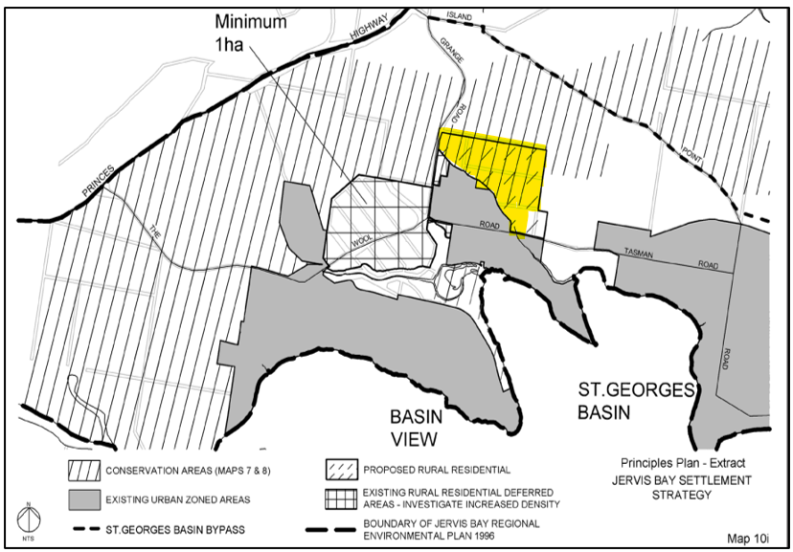
Figure 11 - Map 10i, Jervis Bay Settlement Strategy (JBSS, 2003)
Note: Nebraska Estate has been highlighted yellow
Shoalhaven Growth Management Strategy (GMS) – V1
The current Shoalhaven Growth Management Strategy (GMS) was adopted by Council in December 2012 and endorsed by the NSW Government in May 2014. The GMS sets out broad principles for planning growth across the city and incorporates several more detailed settlement strategies/structure plans, including the endorsed Jervis Bay Settlement Strategy (JBSS, 2003). As such, the JBSS was effectively re-endorsed and embedded within the GMS.
Shoalhaven 2040 - Strategic Land-use Planning Statement (SLPS 2020)
The Shoalhaven 2040 - Strategic Land-use Planning Statement (SLPS 2020), endorsed by the NSW Government identifies St Georges Basin as a major urban area. The subject land is immediately adjoining and located northwest of existing residential development at St George’s Basin. The PP responds to the following Priorities:
- Priority 1 – Providing homes to meet all needs and lifestyles
This planning priority recognises that:
Existing suburbs and villages with limited expansion opportunities need in-fill development to support the supply of housing types and allow people to change homes as their needs change […] and that change needs to be managed to ensure development contributes to neighbourhood character.
Current work (CW1.1) identifies implementation of the GMS and settlement strategies (eg, JBSS) as a way to manage residential growth and deliver some of the dwellings required by 2041. As noted earlier, the subject land was identified for investigation in the JBSS.
- Priority 8 – Supporting Agriculture and Aquaculture
The land is currently zoned rural under SLEP 2014. However, the PP is consistent with the relevant policy statement to “Retain and manage existing rural land, avoiding the rezoning of land for other uses including rural-residential and residential outcomes, unless identified in a relevant Strategy”.
The policy statement is to:
“Retain and manage existing rural land, avoiding the rezoning of land for other uses including rural-residential and residential outcomes, unless identified in a relevant Strategy”.
The land is currently zoned rural under SLEP 2014. The PP is consistent with the policy statement because the PP is also consistent with the JBSS, 2003.
- Priority 10 – Protecting the Environment
The subject land supports an Endangered Ecological Community (EEC) and a range of other endangered and vulnerable species. The PP will recognise, protect and conserve 23.3 ha of environmentally sensitive land (71% of the rural-zoned land) for long-term management by rezoning the land to C2 Environmental Conservation. Further, the “significant vegetation” and “exempt land” provisions of the Biodiversity Conservation layer of SLEP 2014 to which clause 7.5 applies.
A range of environmental protection provisions will be included in a supporting site-specific DCP.
The above will contribute to current work on: Managing the assessment of development proposals to protect/improve habitats, prioritise water quality and limit adverse effects on areas with recognised or potential biodiversity values (ref: CW10.1).
Shoalhaven 2032 – Community Strategic Plan (SCSP)
The PP is consistent with Council’s Community Strategic Plan (Shoalhaven 2032). The key priorities for Sustainable, Liveable Environments, specifically are:
2.2 Manage growth and development with respect for environmental & community values
2.3 Protect the natural environment and enhance sustainability.
The PP seeks to manage growth at St Georges Basin by providing for rural-residential development on the less constrained land within the Estate, consistent with the JBSS. At the same time, it is proposed to rezone approx. 23.3 ha of environmentally sensitive land to C2 Environmental Conservation.
The PP will resolve a longstanding planning matter, providing much-needed certainty for the local community.
Council Policy - Voluntary Acquisition – Residual C2 Environmental Conservation Land – Jerberra & Nebraska Estates
The overall PP package includes Council’s adopted and self-funded Policy which has been established to facilitate the voluntary acquisition of ‘residual’ environmental properties using the profits from the sale of Council’s developable properties in the Estate (if/when it is rezoned). ‘Residual’ properties would otherwise stay in fragmented private ownership and the land’s environmental values would remain at risk indefinitely. The Policy will come into effect only if/when the land is rezoned.
The Council Policy is unique in that it provides a new, proactive option to help resolve the tenure and management of the Estate’s environmentally sensitive land that has no ability to be included in a development lot (i.e. residual C2 land).
The PP and supporting Policy are financially, environmentally, and socially responsible:
- Financial: the Policy is designed to be cost-neutral over the long term; the acquisition and management of conservation land will be funded by the profits from the sale of Council’s developable land in the Estate.
- Environmental: The PP will rezone the environmentally sensitive land to C2. The Policy allows C2 land that cannot be incorporated into a larger development parcel (i.e. residual C2 land) to be acquired by Council and managed for conservation in perpetuity. No alternative options are available to resolve the tenure and management of the Estate’s environmentally sensitive land. The alternative is that the biodiversity values will continue to be subject to disturbances and degradation (even if the land is rezoned to C2).
- Social: the Policy will give owners of the residual C2 land the option of selling their land to a public authority (i.e. Council) and certainty that it will be managed for conservation in perpetuity. The Policy is based on voluntary acquisition only, so owners will be able to retain their land if they wish to.

Is the Planning Proposal Consistent with any Other Applicable State and Regional Studies or Strategies?
Yes. St Georges Basin is recognised in the Shoalhaven Regional Economic Development Strategy 2018-2022 as a regional centre. ‘Strategies’ and ‘Enablers’ were reviewed in the 2033 Update, however, the status of St Georges Basin has not changed.

Is the Planning Proposal Consistent with Applicable State Environmental Planning Policies?
Yes. The PP has been assessed against the new consolidated planning policies that came into effect on 1 March 2022. A checklist of State Environmental Planning Policies (SEPP) is at section 10.1.4. The PP is generally consistent with the applicable and relevant SEPPs discussed below. Any inconsistencies are minor and insignificant.
Housing SEPP 2021
State Environmental Planning Policy (Housing) 2021 (Housing SEPP) commenced on 26 November 2021 and generally applies to the Shoalhaven LGA. The Housing SEPP gives incentives to supply affordable and diverse housing in the right places and for every stage of life. For example, the SEPP provides for the construction of secondary dwellings and short term rental accommodation use in nominated circumstances.
These development types will potentially be permitted on land zoned R5 Large Lot Residential and C4 Environmental Living. More information about the Housing SEPP is available at this link: State Environmental Planning Policy (Housing) 2021.
The PP is generally consistent with the Housing SEPP.
Primary Production SEPP 2021
State Environmental Planning Policy (Primary Production) 2021 (Primary Production SEPP) repealed and consolidated 4 former agricultural-related policies.
- Chapter 2 – Primary Production and Rural Development
This Chapter generally applies to the Shoalhaven LGA. This Chapter aims at 2.1(b): to reduce land use conflict and sterilisation of rural land by balancing primary production, residential development and the protection of native vegetation, biodiversity and water resources.
These aims are reflected in the requirements of Ministerial Direction 9.1 – Rural Zones and Ministerial Direction 9.2 Rural Lands, discussed in detail below at Section 4.2.4 – Applicable Ministerial Directions (s9.1).
Otherwise, the Primary Production SEPP has no relevant provisions and therefore the PP is consistent with the SEPP.
Biodiversity and Conservation SEPP 2021
State Environmental Planning Policy (Biodiversity and Conservation) 2021 (Biodiversity and Conservation SEPP) consolidated and transferred 11 repealed SEPPs (or deemed SEPPs) into Chapters.
Chapter 3 – Koala Habitat Protection and Chapter 4 – Koala Habitat Protection apply to the Shoalhaven LGA.
- Chapter 3 – Koala Habitat Protection 2020
This Chapter applies to the PP as the subject land is currently zoned RU2 Rural Landscape. This Chapter aims to encourage the proper conservation and management of areas of natural vegetation that provide habitat for koalas to ensure a permanent free-living population over their present range and reverse the current trend of koala population decline by:
(a) requiring the preparation of plans of management before development consent can be granted in relation to areas of core koala habitat, and
(b) encouraging the identification of areas of core koala habitat, and
(c) encouraging the inclusion of areas of core koala habitat in environment protection zones.
- Chapter 4 – Koala Habitat Protection 2021 (Koala Habitat (2021))
This Chapter also applies because the subject land is located within the South Coast Koala Management Area (KMA 3). KMA 3 includes the coastal areas of the Shoalhaven LGA and extends to the border between NSW and Victoria. Chapter 4 has similar aims to Chapter 3, set out above.
The PP is consistent with Chapter 3 and Chapter 4 of the Biodiversity and Conservation SEPP because neither potential koala habit nor core koala habitat is present on the land. Targeted surveys in 2009 did not detect any evidence of Koalas inhabiting the area. There are no recent records of Koala in Nebraska Estate nor in the Jervis Bay area generally. A detailed assessment is provided in section 9.3.13. DEWWCC (EES) has agreed that no further koala assessment is required.
Resilience and Hazard SEPP 2021
This SEPP commenced on 1 March 2022. Chapter 2 (coastal management) is relevant and is addressed below.
- Chapter 2 – Coastal management
This Chapter is relevant because the PP applies to land within the coastal zone as defined under the Coastal Management Act 2016 (Act) and as identified by Chapter 2 of the State Environmental Planning Policy (Resilience and Hazards) 2021 (SEPP – Resilience and Hazards).
The NSW Coastal Zone comprises 4 distinct coastal management areas:
- coastal wetlands and littoral rainforests area
- coastal vulnerability area
- coastal environment area
- coastal use area.
The subject land is not within the coastal wetlands and littoral rainforests area; the coastal vulnerability area; or the coastal use area. However, part of the subject land to the north of Fisherman Road is mapped as ‘coastal environment area’ as shown in Figure 11 below.
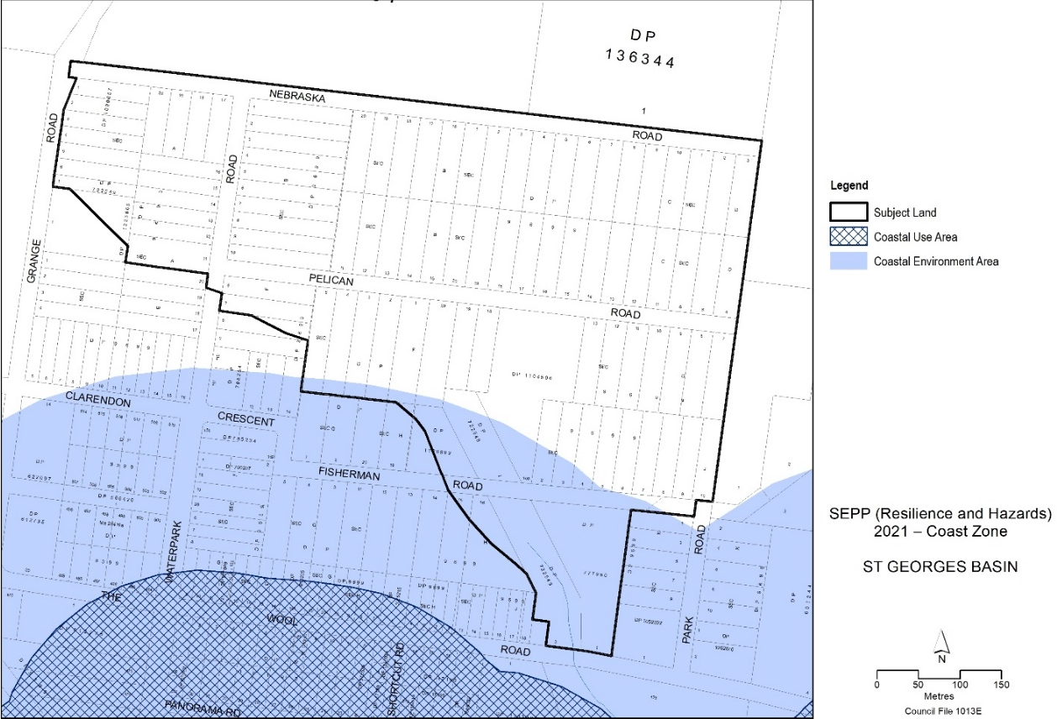
Figure 12 - SEPP (Resilience and Hazards) 2021 – Coastal Zone
Clause 2.10 of the SEPP contains development controls for land in the ‘coastal environment area’. Council is required to consider whether development is likely to have an adverse impact on the following:
- the integrity and resilience of the biophysical, hydrological (surface and groundwater) and ecological environment,
- coastal environmental values and natural coastal processes,
- the water quality of the marine estate (within the meaning of the Marine Estate Management Act 2014), in particular, the cumulative impacts of the proposed development on any of the sensitive coastal lakes identified in Schedule 1,
- marine vegetation, native vegetation and fauna and their habitats, undeveloped headlands and rock platforms,
- existing public open space and safe access to and along the foreshore, beach, headland or rock platform for members of the public, including persons with a disability,
- Aboriginal cultural heritage, practices and places,
- the use of the surf zone.
The management objectives for the ‘coastal environment area’ are set out at section 8(2) of Part 2 of the Coastal Management Act 2016 as follows:
- to protect and enhance the coastal environmental values and natural processes of coastal waters, estuaries, coastal lakes and coastal lagoons, and enhance natural character, scenic value, biological diversity and ecosystem integrity,
- to reduce threats to and improve the resilience of coastal waters, estuaries, coastal lakes and coastal lagoons, including in response to climate change,
- to maintain and improve water quality and estuary health,
- to support the social and cultural values of coastal waters, estuaries, coastal lakes and coastal lagoons,
- to maintain the presence of beaches, dunes and the natural features of foreshores, taking into account the beach system operating at the relevant place,
- to maintain and, where practicable, improve public access, amenity and use of beaches, foreshores, headlands and rock platforms.
The ‘coastal environment area’ is not part of the Marine Estate or within the surf zone. There is no existing public open space, foreshore, beach, headland, or rock platform within the subject land.
The PP does not propose to increase development opportunities or facilitate more intensive land-uses within the ‘coastal environment area’ which is proposed to be zoned C2 Environmental Conservation. All proposed dwellings will be on flood-free land, i.e. above the Projected 2100 FPA (FPA) and Projected 2100 PFM Extent (PMF), beyond the ‘coastal environment area’ and unaffected by natural coastal processes.
Any land proposed to be zoned C2 that is not able to be managed as part of a proposed development parcel (i.e. residual C2 land) has the potential to be voluntarily acquired for conservation and management in perpetuity under Council’s adopted Policy – Voluntary Acquisition – Residual C2 Environmental Conservation Land – Jerberra & Nebraska Estates. The Policy would apply to certain land within the ‘coastal environment area’ in the vicinity of Fisherman Road but will only come into effect if/when the land is rezoned.
Aboriginal cultural heritage is addressed at Section 9.2 . There are three known Aboriginal sites on the subject land. All are located on low lying land that is proposed to be zoned C2, where no new residential development is proposed. Some ground disturbance will be necessary for construction of infrastructure in these areas in which case, an AHIP will be required.
The PP is consistent with the Key Outcomes for Planning Proposals in the Coastal Zone in section 3.2 of the NSW Coastal Design Guidelines (2023). Refer to the NSW Coastal Desing Guidelines checklist. Chapter 2 of the Resilience and Hazards SEPP is also relevant in relation to Ministerial Direction 4.2 (Coastal Management) – refer to section 4.2.5 of this PP.
- Chapter 3 - Hazardous and offensive development
This Chapter does not apply because “hazardous industries” and “offensive industries’ are not permitted in any of the proposed zones.
- Chapter 4 - Remediation of land
This Chapter relates to the assessment of development applications and therefore, does not apply to the PP. Ministerial Direction 4.4 – Remediation of contaminated land applies and is discussed below.

Is the Planning Proposal Consistent with Applicable Ministerial Directions (s.9.1 Directions)?
Yes. The PP is generally consistent with the relevant Ministerial Directions. Any inconsistencies are minor and justified. The applicable Directions are discussed below. A checklist is provided in section 10.1.5.
Direction 1.1 – Implementation of Regional Plans
Direction 1.1 (1) requires PPs to be consistent with a regional plan released by the Minister for Planning.
The PP is consistent with this Direction. Nebraska Estate is specifically identified for investigation in the JBSS, endorsed by the NSW Government, and is consistent with the Illawarra Shoalhaven Regional Plan. Refer to the discussion at section 4.2.1.
Direction 3.1 – Conservation Zones
Summary: The PP is consistent with this Direction because the PP aims to recognise, protect and conserve the Estate’s environmentally sensitive land; 23.3 ha or 71% of the Estate is proposed to be rezoned from RU2 Rural Landscape to C2 Environmental Conservation.
Background
The objective of this Direction is to protect and conserve environmentally sensitive areas. This Direction applies to all planning proposals. Direction 3.1 (1) requires that a planning proposal must include provisions that facilitate the protection and conservation of environmentally sensitive areas.
Consistent with the objective of recognising the constraints and protecting the environmental values of sensitive land and Aboriginal cultural heritage values, the PP seeks to rezone 71% of the Estate from RU2 to C2.
The PP also seeks to allow a limited number of dwellings on less constrained land. A supporting site-specific DCP chapter will include, among other things, provisions to protect important biodiversity, similar to DCP Chapter N20 – Jerberra Estate. DCCEEW and Council’s biodiversity team will be consulted in the preparation of the DCP to ensure the provisions for Nebraska Estate are robust and effective.
Furthermore, all environmentally sensitive land, not able to be included in a development parcel, is proposed to be zoned C2 Environmental Conservation and has the potential to be voluntarily acquired by Council and managed for conservation in perpetuity under Council’s adopted policy: Voluntary Acquisition – Residual C2 Environmental Conservation Land – Jerberra & Nebraska Estates. The Policy is discussed in section 8.3.

Direction 3.2 – Heritage Conservation
Summary: The PP is consistent with this Direction because:
- Previous Aboriginal Cultural Heritage Assessments (ACHAs) have identified three Aboriginal sites, all of which are located along or adjacent to watercourses, and are within the proposed C2 Environmental Conservation zone where no new residential development is proposed.
- The sites were concluded to have limited cultural and scientific significance.
- ‘Residual’ C2 lots (those unable to be included in a development parcel) will be eligible for voluntary acquisition by Council and any acquired land will be managed for conservation in perpetuity.
- The supporting DCP will include provisions to ensure that an Aboriginal Heritage Impact Permit (AHIP) is obtained prior to work being undertaken within C2-zoned land adjacent to the watercourses that could potentially harm the sites, such as for the provision of subdivision infrastructure. Note that consultation with the Aboriginal community is an integral part of the AHIP process.
- The Jerrinja Local Aboriginal Land Council (LALC) and stakeholders in the local Aboriginal community are proposed to be consulted on this approach prior to public exhibition of the PP.
Background
This Direction requires that items of Aboriginal and other cultural heritage be identified in a study of the area’s environmental heritage. The objective is to conserve items, areas, objects and places of environmental heritage significance and indigenous heritage significance. There are no items of environmental heritage significance.
Since 1994, three Aboriginal archaeological studies have been studies have been undertaken related to the subject land:
- Marshall, B, Webb C, 1994. An Archaeological survey of Nebraska Estate, St Georges Basin, New South Wales. Report prepared by South East Archaeology for Shoalhaven City Council
- Marshall, B, 1995. Archaeological excavations at Nebraska Estate, St Georges Basin, New South Wales. Report prepared by Austral Heritage Consultants for Shoalhaven City Council
- Dibden, J, 2009 Proposed Road Upgrade Nebraska Estate – Aboriginal Archaeological Assessment. Report prepared by NSW Archaeology P/L for Shoalhaven City Council

An Aboriginal cultural heritage assessment was also undertaken by Kuskie (2001) as part of the rezoning investigations for Park Road component of Nebraska Estate that was rezoned in 2001 – a link is provided in the document library.

As a result of the previous assessments, there are three known Aboriginal sites on the subject land. Two small scatters of stone artifacts and one isolated artifact were found in the 1994 assessment. These are described below.
- Pelican Road site (NPWS Site no. 58-2-305): Lithic scatter extending over 175 m along Pelican Road in the vicinity of the watercourse. The extent of this site beyond the road is unknown. 23 artifacts consisting mainly of quartzite and silcrete flakes were recorded at a density of <1 artifact/m². Two blade cores, a small circular sandstone grindstone and a broken hammerstone were also recorded.
- Nebraska Road site (NPWS Site no. 58-2-307): An isolated chert flake was found on a ridge on Nebraska Road.
- Fisherman Road site (NPWS Site no. 58-2-306): A small lithic scatter 5 metre square on a ridge overlooking the creek. Four artifacts were recorded; one quartzite and two silcrete flakes, and a silcrete backed blade.

All three sites were classified as low density, open artifact scatters typical of those found in the St Georges Basin/Tomerong area and all were within the flood liable land, on either side of the watercourse. The artifacts consisted predominantly of simple flakes with little retouch to indicate subsequent reuse. The backed blade from Fisherman’s Road and the two blade cores from the Pelican Road site were estimated to be 1,000 to 5,000 years old.

All three sites are located within the proposed C2 Environmental Conservation zoned land associated with the watercourses, where no new residential development is proposed.

It was recommended that the Jerrinja LALC be consulted prior to any development occurring that could potentially harm the sites. As explained below, it is proposed to consult with the Jerrinja Local Aboriginal Land Council (LALC) and other local Aboriginal community stakeholders as part of the PP process, and further consultation would occur if/when an AHIP is required.
Under Council’s Voluntary Acquisition – Residual C2 Environmental Conservation Land – Jerberra & Nebraska Estates Policy, ‘residual’ C2 lots (those unable to be incorporated in a development parcel and legally protected via consent conditions) will be eligible for voluntary acquisition by Council. Any land acquired by Council under the Policy will be managed for conservation in perpetuity.
While no new residential development is proposed within the C2 zoned land, some ground disturbance will be necessary to construct infrastructure in these areas. Any disturbance of the site will be subject to the requirements of the NSW National Parks and Wildlife Act 1974 and the National Parks and Wildlife Regulation 2019 in relation to Aboriginal cultural heritage protection. Council must follow the “Due Diligence Code of Practice for the Protection of Aboriginal Objects in New South Wales” prepared by the NSW Department of Environment, Climate Change and Water (2010) to determine if an Aboriginal Heritage Impact Permit (AHIP) is required.
If an AHIP is required, Council will undertake the necessary consultation and impact assessment requirements in order to comply with contemporary assessment requirements. Informal advice, dated 13 September 2018, from the former Office of Environment and Heritage (OEH) (Conservation and Regional Delivery Division) was received generally in the following terms:
“ … apply for an AHIP to cover all of Council’s proposed road works under a Part 5 REF, and accept the rationale for not including the low potential development areas which are outside the Part 5 process. People building in the areas outside the recorded sites and area of sensitivity will be operating under a due diligence defence. This means that if Aboriginal objects are found during construction works they will need to stop work and apply for an AHIP if harm to the Aboriginal objects cannot be avoided.
It is proposed to include provisions in the DCP chapter to clarify where an AHIP may be required (i.e. for the provision of infrastructure) and the legal requirements and in relation to unexpected finds.
Given the passage of time and that all of above studies pre-date the current code of practice: Guide to investigating, assessing and reporting on aboriginal heritage in NSW (Office of Environment & Heritage (former) , 2011) it is proposed to seek input from the Jerrinja Local Aboriginal Land Council (LALC) and other local Aboriginal community stakeholders if the PP proceeds through the Gateway step.

Direction 4.1 – Flooding
Summary: The PP is generally consistent with this Direction because:
- No development is proposed on flood-prone land.
- It is proposed to include provisions in the DCP chapter to ensure all dwellings have flood free access as shown in Figure 5, and that a flood survival plan similar to a Bush Fire Survival Plan is prepared at development application stage for the affected properties.
Any inconsistencies with this Direction are considered of minor significance.
Background
The objectives of this Direction are to ensure that development of flood-prone land is consistent with the NSW Government’s Flood-Prone Land Policy and the principles of the Floodplain Development Manual 2005, and that the provisions of an LEP that apply to flood-prone land are commensurate with flood hazard and include consideration of the potential flood impacts both on and off the subject land.
Clause (2) of this Direction states:
A planning proposal must not rezone land within the flood planning area from Recreation, Rural, Special Purpose or Conservation Zones to a Residential, Business, Industrial or Special Purpose Zones.
The St Georges Basin Flood Study (Cardno, 2022) (Flood Study) was adopted by Council on 23 January 2023 (MIN23.12). This Direction applies as part of the subject land is identified in the Flood Study as flood-prone land and the PP proposes to alter the applicable zoning and planning provisions.
As detailed further below, the PP is generally consistent with this Direction in so far as:
- all of the proposed dwellings will be on flood-free land, i.e. above the Projected 2100 Flood Planning Area (FPA) and Projected 2100 Probable Maximum Flood extent (PMF).
- a supporting DCP will demonstrate how a network of public roads, rights-of-way and emergency access routes can achieve flood free access for each of the proposed dwelling sites, and
- within the floodway, infrastructure works will be limited to essential widening/upgrading of the existing culvert at the intersection of Waterpark/Pelican Roads from one lane to two lanes and to widening and strengthen the existing pavement of Fisherman and Pelican Roads.
Figure 12 illustrates the how the FPA and PMF relate to the proposed new zones, identified dwelling sites and APZs.
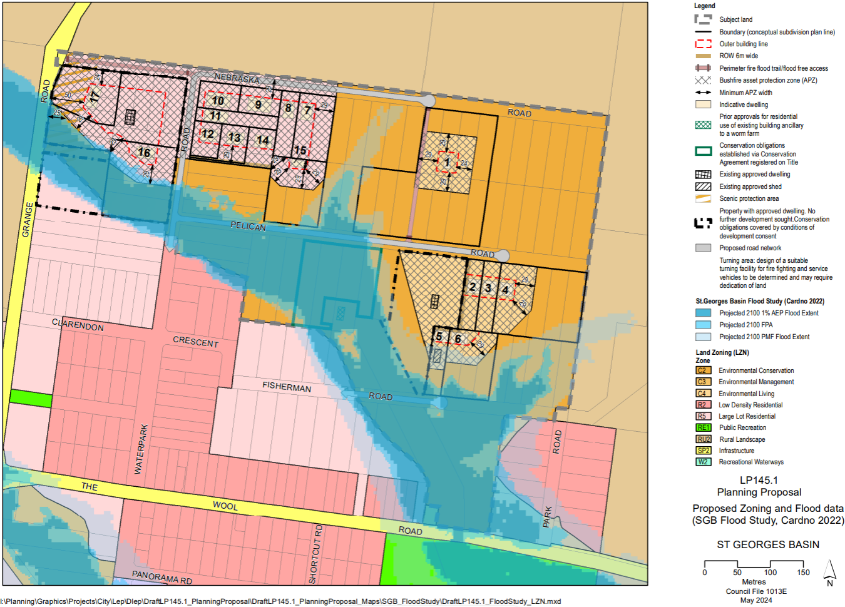
Figure 13 - Proposed zoning and extent of flooding (SGB Flood Study, Cardno 2022)
Clause (3) of this Direction requires:
(3) A planning proposal must not contain provisions that apply to the flood planning area which:
- permit development in floodway areas,
- permit development that will result in significant flood impacts to other properties,
- permit development for the purposes of residential accommodation in high hazard areas,
- permit a significant increase in the development and/or dwelling density of that land,
- permit development for the purpose of centre-based childcare facilities, hostels, boarding houses, group homes, hospitals, residential care facilities, respite day care centres and seniors housing in areas where the occupants of the development cannot effectively evacuate,
- permit development to be carried out without development consent except for the purposes of exempt development or agriculture. Dams, drainage canals, levees, still require development consent,
- are likely to result in a significantly increased requirement for government spending on emergency management services, flood mitigation and emergency response measures, which can include but are not limited to the provision of road infrastructure, flood mitigation infrastructure and utilities, or
- permit hazardous industries or hazardous storage establishments where hazardous materials cannot be effectively contained during the occurrence of a flood event.
The Projected 2100 Flood Planning Area (FPA) and Projected 2100 Probable Maximum Flood (PMF) are wholly contained within the proposed C2 zoned land with the following minor exceptions:
- Northwest development sector, proposed R5 zoned land:
  - West of Waterpark Road to the south of proposed dwelling sites #16 and #17, there is a minor overlap of the FPA and the APZs for these dwelling sites. The building envelopes are not affected.
- Eastern development sector, proposed C4 land:
  - The APZs for dwelling sites #5 and #6 are affected by the PMF but this is considered to be a minor overlap as no dwellings will be permitted in this location. The building envelopes are not affected.
As stated earlier, the majority of the flood-prone land is proposed to be zoned C2. The current 40 ha minimum lot size will be retained on the C2 land. Further, under Council’s Policy, ‘residual’ C2 lots (those unable to be included in a development parcel) will be eligible for voluntary acquisition by Council. Any acquired land will be managed for conservation in perpetuity.
As Nebraska Estate is a paper subdivision and the road reserves are owned by Council, proposed infrastructure upgrades will be managed by Council, subject to putting in place a special rate or other suitable funding mechanism to recoup the costs from benefitting landowners. Flooding constraints will be a key design consideration that will be assessed under Part 5 of the Environmental Planning and Assessment Act, 1979.
In relation to Clause (2) of this Direction, no dwellings are proposed to be constructed in the floodway and infrastructure works will be limited to essential widening/upgrading of the existing culvert at the intersection of Waterpark/Pelican Roads from one to two lanes and to widening and strengthening the existing pavement of Fisherman and Pelican Roads.
Having regard to the above, the PP is generally consistent with Clause (3).
Clause (4) of this Direction requires:
(4) A planning proposal must not contain provisions that apply to areas between the flood planning area and probable maximum flood to which Special Flood Considerations apply which:
- permit development in floodway areas,
- permit development that will result in significant flood impacts to other properties,
- permit a significant increase in the dwelling density of that land,
- permit the development of centre-based childcare facilities, hostels, boarding houses, group homes, hospitals, residential care facilities, respite day care centres and seniors housing in areas where the occupants of the development cannot effectively evacuate,
- are likely to affect the safe occupation of and efficient evacuation of the lot, or
- are likely to result in a significantly increased requirement for government
    - spending on emergency management services, and flood mitigation and
    - emergency response measures, which can include but not limited to road
    - infrastructure, flood mitigation infrastructure and utilities.
According to the guideline titled ‘Considering Flooding in Land Use Planning’, Special Flood Considerations (SFC) apply to certain types of development that have a higher risk to life, warranting the consideration of the impacts of rarer flood events on land located outside the Flood Planning Area (FPA). SFCs also apply to land between the FPA and the Probable Maximum Flood (PMF) where there is a particular risk to life, the evacuation of people may be required, or there are other safety considerations. SFC provisions can be introduced through an optional clause in the Standard Instrument LEP, which councils can choose to adopt in their LEP(s).
The SFC clause was added to the SLEP 2014 on 10 November 2024 – refer to as clause 5.22. The clause applies to:
- for sensitive and hazardous development - land between the FPA and the PMF, and
- for development that is not sensitive and hazardous development - land the consent authority considers to be land that, in the event of a flood, may
  - cause a particular risk to life, and
  - require the evacuation of people or other safety considerations.
Concerning (a) this PP is not seeking to facilitate additional ‘sensitive and hazardous development’ uses, however, ‘group homes’ are a permissible use in the R5 zone and ‘emergency services facilities’ are permissible in the R5, C4 and C2 zones. The supporting DCP, will identify an indicative building envelope for each dwelling site above the PMF.
As previously noted, the remainder of Nebraska Estate is proposed to be zoned C2 Environmental Conservation.
Concerning (b) this PP identifies 17 proposed dwelling sites. It is acknowledged that additional development could occur within these sites, particularly dual occupancy and/or secondary dwellings.
It is intended that flood free access for all 17 proposed dwelling sites will be achieved by a network of public roads, rights-of-way and emergency access trails. This network is identified on the concept plan at Figure 5. Keys for the gates to the emergency access trails are proposed to be provided to the landowners, as well as being held by the SES, RFS etc.
The PP appears to be generally consistent with the Department’s guidelines on SFC. It is noted that Councils who adopt the SFC clause in their LEP are also encouraged to amend their development control plan (DCP) to include supporting controls.
Note that Chapter G9 - Development on Flood-Prone Land in the Shoalhaven Development Control Plan 2014 (DCP) includes planning controls that apply to land affected by the PMF. Chapter G9 currently includes a provision in section 5.4.9 that only a minimal increase in development and population will be permitted in Nebraska Estate. This will need to be reviewed if the PP is ultimately finalised.
Having regard to all of the above, the PP is generally consistent with this Direction and any inconsistencies are of minor significance.

Direction 4.2 – Coastal Management
Summary:
The subject land is not affected by the coastal wetlands and littoral rainforests area; the coastal vulnerability area; or the coastal use area. Neither does the PP affect any land identified as current or future coastal hazard. Furthermore, any land within the ‘coastal environment area’ (Figure 11) is proposed to be zoned C2. Direction 4.2 (4) is not applicable as the PP does not propose to amend any of the coastal maps under chapter 2 of SEPP (Resilience and Hazards) 2021. No increased development opportunities or intensive land-uses are proposed within the ‘coastal environment area’ which is also proposed to be zoned C2 Environmental Conservation. The PP is consistent with this Direction.
Background
The objective of this Direction is to protect and manage coastal areas of NSW. This Direction applies if a planning proposal applies to land within the coastal zone as defined under the Coastal Management Act 2016 (Act) and as identified by chapter 2 of the State Environmental Planning Policy (Resilience and Hazards) 2021 (SEPP – Resilience and Hazards).

Direction 4.3 – Planning for Bushfire Protection
Summary: Based on the findings of a Strategic Bushfire Assessment prepared by Eco Logical Australia P/L and preliminary consultation with the NSW RFS, the PP is generally consistent with this Direction, noting that the RFS will be consulted prior to public exhibition and will undertake a more detailed assessment.
Background
The objectives of this Direction are to protect life, property, and the environment from bushfire hazards, by discouraging incompatible land uses in bushfire prone areas, and to encourage sound management of bush fire prone areas.
This Direction applies because the subject land is mapped on the Bush Fire Prone Land Map certified by the Commissioner of the NSW RFS.
The RFS has been consulted in relation to this PP over several years. Note that this was required by the previous Gateway determination of 3 March 2015 (See section 10.1.3). In 2019, Council engaged Eco Logical Australia (ELA) to prepare a Strategic Bushfire Assessment (SBA) to inform the preparation of the Nebraska Estate planning proposal (PP - LP145.1) and supporting Development Control Plan (DCP) being prepared for public exhibition by Council.
The SBA pre-dated the finalisation of Planning for Bushfire Protection (PBP) 2019. Hence, in 2021, Council re-engaged ELA to provide an updated version of the SBA to replace the October 2019 report to ensure the PP is consistent with the strategic principles set out in Sections 2.3 and 4 – Strategic Planning of Planning for Bushfire Protection (PBP) 2019 as required by this Direction.
The minimum components of a Strategic Bushfire Study are listed in Table 4.2.1 of PBP 2019, are addressed by the Strategic Bushfire Assessment (SBA) and additional information has been provided where necessary.
The key findings of the SBA are:
- the Assessment found no significant adverse effects of the proposed re-zoning under the Table 4.2.1 assessment considerations of bushfire landscape, land use, emergency services, infrastructure and adjoining land;
- the environmental and heritage constraints of the site meant two issues under ‘access and egress’ could not be resolved with PBP Acceptable Solutions;
- however, it is likely the PBP Performance Criteria can be met by the proposed fire trail (with locked gates) between Grange Road and Nebraska Road as an appropriate means of lowering the risk of the 175 m portion of single egress road to the south of the subject land on Waterpark Road;
- the 300 m single access road to proposed dwelling sites 9 and 10 meets the PBP Performance Criteria, as it is only 100 m longer than the Acceptable Solution and it is only for two lots;
- The proposed Conceptual Development Layout¹⁴ includes various measures to reduce the bushfire risk associated with the re-zoning, including:
  - Enlarged and clustered APZs;
  - Integration of non-combustible infrastructure within APZs such as roads, easements and parking areas;
  - The existing bridge at the intersection of Pelican Road and Waterpark Road should be upgraded to two lanes (8 m);
  - Management of fuel loads between Grange Road and Waterpark Road be formalised through a Vegetation Management Plan and positive covenant to ensure environmental objectives are met in the future;
  - A study of the likelihood of traffic blockages occurring at the intersections of Waterpark Road and Pelican Road, and Waterpark Road and Clarendon Crescent undertaken prior to the infrastructure design stage;
  - Underground electricity services provided, where possible;
  - PBP compliant water supplies;
  - Emergency response planning, including community education and engagement with local brigades on Bushfire Survival Plans and access/egress as dwellings are constructed and occupied.
- the planning proposal (and supporting draft DCP) is consistent with Ministerial Direction 4.3 (Planning for Bushfire Protection) issued on 1 March 2022 under section 9.1 of the Environmental Planning and Assessment Act subject to the inclusion of the bushfire risk reduction strategies identified in this Assessment.
- the proposed Conceptual Subdivision and Development Plan¹⁴ for the Subject Land provides the bushfire protection measures, including the required APZ’s for the residential development proposed.
The SBA concluded that the PP is consistent with Direction 4.3 “… subject to the inclusion of the bushfire risk reduction strategies identified in this Assessment.”
The updated SBA was referred to the RFS on 15 March 2022. On 20 May 2022, the RFS responded:
The Strategic Bush Fire Study by Ecological Australia dated March 2022 and Concept Plan by Shoalhaven City Council re: LP145.1 are consistent with the agreed outcomes of the on-site meeting on 26 June 2019 held with Council, NSW RFS and Ecological Australia. NSW RFS will undertake a full assessment of the proposal following re-referral of the development post-Gateway Determination.
Any additional comments received from the RFS post-Gateway determination will be included and addressed in the PP prior to public exhibition.

Direction 4.4 – Remediation of contaminated land
Summary: Any inconsistency with this Direction is justified and minor. If a Gateway determination is issued, Council will undertake a Phase 1 – Preliminary Land Contamination Assessment prior to public exhibition.
Background
The objective of this Direction is to reduce the risk of harm to human health and the environment by ensuring that contamination and remediation are considered by planning proposal authorities.
This Direction applies because while most of the proposed residential land is bushland, knowledge is incomplete as to whether development for a purpose referred to in Table 1 to the contaminated land planning guidelines has been carried out on any of the land. Council will, therefore, commission a Phase 1 – Preliminary Land Contamination Assessment Report and incorporate the findings into the PP package prior to public exhibition. The completed report will be available for comment at that stage.

Direction 4.5 – Acid sulfate soils
Summary: The PP is consistent with this Direction. The area mapped as H1 – high probability of acid sulfate soils occurring within one (1) metre of the ground surface, is proposed to be zoned C2 and the 40 ha minimum lot size will be retained on the C2 zoned land. This approach is consistent with the NSW Acid Sulfate Soils Planning & Assessment Guidelines.
Background
The objective of this Direction is to avoid significant adverse environmental impacts from the use of land that has a probability of containing acid sulfate soils.
Direction 4.5 (1) requires that the planning authority must consider the NSW Acid Sulfate Soils Planning Guidelines when preparing a PP that applies to any land identified on the Acid Sulfate Soils Planning Maps as having a probability of acid sulfate soils being present.
This Direction applies because part of the subject land is mapped as H1 – high probability of acid sulfate soils occurring within one (1) metre of the ground surface on the Acid Sulfate Soils Risk Maps held by the Department of Planning and Environment (Figure 13) and is already mapped as “acid sulfate soils – class 2” to which clause 7.1 of SLEP 2014 applies.
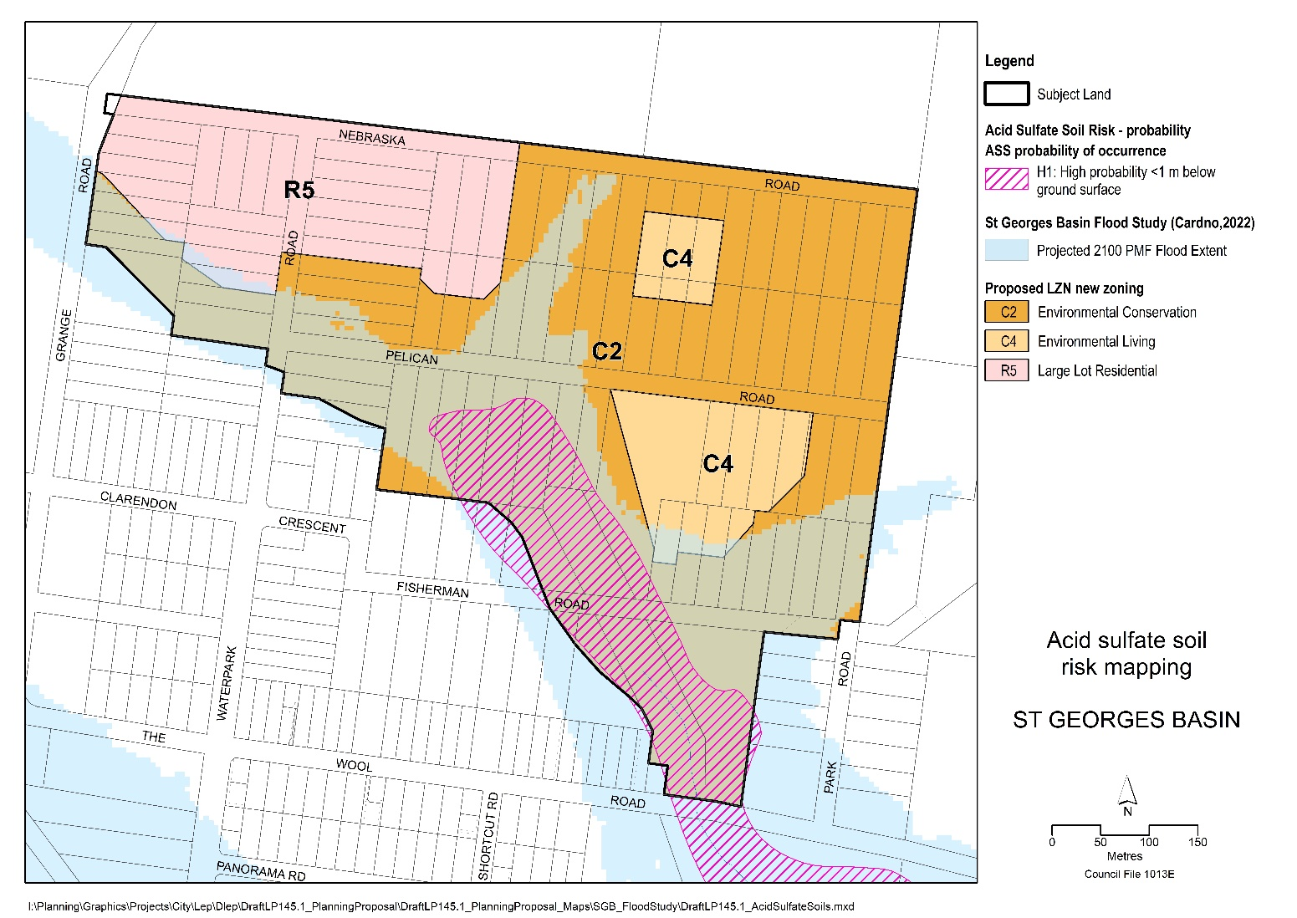
Figure 14 - Acid sulfate soil risk mapping overlaid onto the proposed zoning and PMF

As required by Direction 4.5 (2), these provisions are consistent with the Acid Sulfate Soils Model LEP and are proposed to be retained. Section 3 (Rezoning land in acid sulfate soil areas) of the Acid Sulfate Planning Guidelines, states:
“It is preferable that only land uses that will minimise the likelihood of disturbance of the soil or groundwater be undertaken in acid sulfate soil areas. Avoiding disturbance of acid sulfate soils is often the best and in some cases, the only practical and economic management option. Environmental protection or ecotourism zones may be preferable …”
The affected area is located within the lower lying part of the flood-prone land and is included within the proposed C2 zoned land as recommended.
Direction 4.5 (3) requires that the “planning authority must not prepare a PP that proposes an intensification of land uses on land identified as having a probability of containing acid sulfate soils unless the planning authority has considered an acid sulfate soils study assessing the appropriateness of the change of land use given the presence of acid sulfate soils”.
Rezoning the affected area to C2 as proposed will significantly reduce the range of land uses currently permitted under the existing RU2 Rural Landscape zone.
In 2001, Environmental and Earth Sciences P/L undertook a potential acid sulfate soils (PASS) investigation along the path of the proposed sewer line for Park Road, Nebraska Estate. This investigation involved soil and groundwater testing at the southern end of the subject land. The results of the investigation are summarised below:
- There was negligible PASS. A borehole within the main watercourse contained low concentrations of soil sulphides but these were considered non-reactive.
- As a cautionary measure, it was recommended that any soil excavated from the watercourse, should be mixed with 4 kg of lime per ton of soil.
- Groundwater should be monitored if dewatering is undertaken for periods exceeding one week.
- Any concrete or metallic structures placed between the banks of the watercourse should have a buffer of at least 150 mm of sand mixed with lime at a ratio of 5 kg per ton of sand.
An additional study is not required as the PP is consistent with Direction 4.5(3).
Appropriate investigations, including preparation of an ASS management plan, would be carried out prior to undertaking any works associated with upgrading of Fisherman Road or excavation for the purpose of providing water or sewer services.
Part (4) of the Direction does not apply as no intensification of land uses is proposed and the Acid Sulfate Soils Model LEP provisions already apply.

Direction 5.1 – Integrating Land Use and Transport
Summary: Any inconsistency with this Direction is justified and minor. Public transport planning and provision is a city-wide, long term challenge having regard to the widespread 49 towns and villages in the Shoalhaven and low population density. Travel from St Georges Basin to the regional centre of Nowra will continue to be car-dependent in the foreseeable future.
Background
The objective of this Direction is to ensure that urban structures, building forms, land use locations, development designs, subdivision and street layouts achieve the following:
- improving access to housing, jobs and services by walking, cycling and public transport, and
- increasing the choice of available transport and reducing dependence on cars, and
- reducing travel demand including the number of trips generated by development and the distances travelled, especially by car, and
- supporting the efficient and viable operation of public transport services, and
- providing for the efficient movement of freight.
This Direction applies because the PP is seeking to rezone land for residential development, but it is more relevant to densely populated urban areas.
PPs are required to give effect to, and be consistent with the aims, objectives, and principles of:
- Improving Transport Choice – Guidelines for planning and development (DUAP 2001)
- The Right Place for Business and Services – Planning Policy (DUAP 2001)
In 2003, the JBSS recognised that public transport provision is low, consisting of school buses, taxis and a limited commercial bus service. Council’s Shoalhaven 2032 – Community Strategic Plan (SCSP) recognises the limitations of public transport services and connectivity. Shoalhaven 2040 – Our Strategic Land-use Planning Statement (SLPS) acknowledges that new forms of public transport to connect communities, urban areas and employment hubs are an emerging opportunity (Planning Priority 2). Public transport priorities include:
- Advocate with Transport for NSW and public transport service providers to enhance and expand bus services and strategic bus corridors. (Collaboration Activity A2.3)
- Investigate options to improve public transport service levels which better link centres, corridors and growth areas to Metro Wollongong (Action 3.2.1)

Direction 6.1 – Residential Zones
Summary: The PP is consistent with this Direction. The JBSS identifies Nebraska Estate as having potential for rural residential development subject to further investigation. The PP is informed by and consistent with the results of detailed constraints analysis.
The existing subdivision can be reconfigured consistent with contemporary planning requirements and best practice. Existing/new infrastructure can be extended/provided as required and impacts on the environment can be minimised. The R5 Large Lot Residential zone permits a range of housing types in proximity to existing urban zoned land. Attached dual occupancies are permissible in both the R5 and the C4 Environmental Living zones.
Background
The objectives of this Direction are to:
- encourage a variety and choice of housing types to provide for existing and future housing needs,
- make efficient use of existing infrastructure and services and ensure that new housing has appropriate access to infrastructure and services, and
- minimise the impact of residential development on the environment and resource lands.
This Direction applies because the PP seeks to rezone the parts of the Estate that are suitable for residential development to either R5 (Northwest Sector) or C4 (Eastern and Northeast Sectors) to provide additional housing opportunities in St Georges Basin.
This Direction requires that a PP must encourage the provision of housing that will:
- broaden the choice of building types and locations available in the housing market, and
- make more efficient use of existing infrastructure and services, and
- reduce the consumption of land for housing and associated urban development on the urban fringe, and
- be of good design;
and also
- contain a requirement that residential development is not permitted until land is adequately serviced (or arrangements satisfactory to the council, or other appropriate authority, have been made to service it), and
- not contain provisions which will reduce the permissible residential density of land.
A variety of low density housing types is permissible in the R5 and C4 zones. The C4 zone is more limited and will be applied to the proposed development footprints in the East and Northeast Sectors.
The C2 zone will be applied to the environmentally sensitive land that is unsuitable for development. Any land proposed to be zoned C2 that is unable to be managed as part of a development parcel (i.e. residual C2 land) will be eligible for voluntary acquisition under Council’s adopted Policy for Voluntary Acquisition – Residual C2 Environmental Conservation Land – Jerberra & Nebraska Estates. Any land acquired under this Policy will be managed for conservation in perpetuity.
The PP will allow the existing subdivision pattern to be reconfigured to create some opportunities for serviced residential development adjoining and adjacent to existing urban development. Existing services and infrastructure in the area are proposed to be extended. New/upgraded infrastructure would be wholly funded by benefitting landowners via a special rate arrangement or other suitable funding mechanism. Infrastructure provision and staging will be addressed by the proposed DCP and will be managed by Council, as was done with the Jerberra and Verons Estates.
An Integrated Water Cycle Assessment (IWCA) prepared by Footprint (2017) demonstrates that “the proposed rezoning and development of Nebraska Estate can achieve a long term beneficial effect on water quality, water quantity and the receiving environment subject to implementation of the recommended controls and performance standards outlined in the report”.

Direction 6.2 – Caravan Parks and Manufactured Home Estates
Summary: The PP is inconsistent with this Direction because caravan parks are permissible under the current RU2 zoning and are prohibited in the proposed zones. This inconsistency is minor and justified because the land is not suitable for this use due to a range of environmental and land constraints.
Background
This Direction applies to all PPs. The objectives are to:
(a) provide for a variety of housing types, and
(b) provide opportunities for caravan parks and manufactured home estates.
The Direction requires that:
In identifying suitable zones, locations and provisions for caravan parks in a planning proposal, the relevant planning authority must –
- retain provisions that permit development for the purposes of a caravan park to be carried out on land; and
- retain the zonings of existing caravan parks.
The Direction is relevant because caravan parks are a permitted use in the existing RU2 Rural Landscape zone. The PP proposes to zone the land to a combination of R5 Large Lot Residential, C2 Environmental Conservation and C4 Environmental Living, and caravan parks are prohibited in these zones.
Caravan parks will no longer be a permitted use within the subject land. However, there are no existing caravan parks on the land, and the land is not considered suitable for this use. The PP is not seeking to identify suitable zones or locations for caravan parks. However, the proposed R5 and C4 zones will provide for a variety of low density housing types.

Direction 9.1 – Rural zones
Summary: The PP is consistent with the Jervis Bay Settlement Strategy 2003 (JBSS) and the Illawarra Shoalhaven Regional Plan 2041 (ISRP 2041) (May 2021). Any inconsistency with this direction is minor and justified.
Background
The objective of this Direction is to protect the agricultural production value of rural land.
This Direction applies because the subject land is zoned RU2 under SLEP 2014 and the PP proposes to rezone part of the land to a residential zone (R5 Large Lot Residential).
Direction 9.1(1) provides that a planning proposal must be consistent with the following unless justified by an approved strategy:
- not rezone land from a rural zone to a residential, employment, mixed use, SP4 Enterprise, SP5 Metropolitan Centre, W4 Working Waterfront, village or tourist zone.
- not contain provisions that will increase the permissible density of land within a rural zone (other than land within an existing town or village)
The JBSS, endorsed by the NSW Government, identified Nebraska Estate as having potential for rural residential development and, in relation to ‘small lot rural subdivisions’, includes the following Strategy Objective:
To ensure that a process is established for resolving the development potential of existing small lot rural zoned subdivisions in accordance with this Strategy.
The JBSS includes the following specific action in relation to Nebraska Estate:
The development potential of the remainder of the [Nebraska] estate will be investigated through a review of lot sizes and configuration in order to accommodate on site effluent management; having considered the performance and success or otherwise of environment measures at Park Road; and in accordance with the guiding principles and policy actions of this Strategy.
The PP is a direct result of investigations undertaken in accordance with the above action.

Direction 9.2 – Rural lands
Summary: The PP is generally consistent with this Direction because Nebraska Estate is an existing ‘small lot rural subdivision’ identified for investigation in the Jervis Bay Settlement Strategy 2003 (JBSS) and the PP is consistent with the JBSS. The PP is also generally consistent with the Primary Production SEPP, as discussed in the previous section. Any inconsistency is minor and insignificant.
Background
The objectives of this Direction are to:
- protect the agricultural production value of rural land,
- facilitate the orderly and economic use and development of rural lands for rural and related purposes,
- assist in the proper management, development and protection of rural lands to promote the social, economic and environmental welfare of the State,
- minimise the potential for land fragmentation and land use conflict in rural areas, particularly between residential and other rural land uses,
- encourage sustainable land use practices and ensure the ongoing viability of agriculture on rural land,
- support the delivery of the actions outlined in the NSW Right to Farm Policy.
This Direction applies to PPs that:
- will affect land within an existing or proposed rural or conservation zone (including the alteration of any existing rural or conservation zone boundary) or
- change the existing minimum lot size on land within a rural or conservation zone.
The Direction applies because the PP seeks to rezone rural zoned land to a mix of R5 Large Lot Residential, C4 Environmental Living and C2 Environmental Conservation zones.
The subject land has been zoned rural since zoning commenced in 1964. However, the land is:
- not identified as Class 1-3 agricultural land and is not ‘prime crop or pasture land’, and is not identified on the NSW Biophysical Strategic Agricultural Land map
- is extensively vegetated and has important biodiversity values; and
- is generally unsuitable for primary production.
The Direction also applies because the existing minimum lot size (40 ha) is proposed to be changed. However, the 40 ha minimum lot size will be retained over the C2-zoned land.
Direction 9(2) provides that a planning proposal must:
- be consistent with any applicable strategic plan, including regional and district plans endorsed by the Planning Secretary, and any applicable local strategic planning statement
Comment: As above, the PP is consistent with the current strategic planning framework, including the JBSS which specifically identifies Nebraska Estate for investigation.

- consider the significance of agriculture and primary production to the State and rural communities.
Comment: The land is not prime crop or pasture land and has no known history of agricultural use other than a time-limited approval for Use of the existing buildings for Worm Farm, Office and Dwelling that was originally granted in 2001 by the NSW Land and Environment Court on Lots 19 & 20 Section D DP 9699. It is unknown if the worm farm is still operational.

- identify and protect environmental values, including but not limited to, maintaining biodiversity, the protection of native vegetation, cultural heritage, and the importance of water resources
Comment: a thorough investigation of the constraints and land capability has been undertaken by Council over several years. This work has shown that substantial areas of the subject land are affected by one or more significant constraints including flooding, acid sulfate soils, threatened biodiversity, bushfire and Aboriginal archaeology. Accordingly, 23.3 ha or approximately 71% of the subject land is proposed to be zoned C2 Environmental Conservation.
Implementation will be coordinated by Council, guided by a site-specific DCP and will include construction of a town water supply, pressure sewer system and stormwater management controls (funded by benefiting landowners via a special rate or other suitable funding mechanism) to protect waterways and sensitive downstream ecosystems from potential impacts. No residential development is proposed within the area affected by acid sulfate soils. An ASS management plan would be prepared prior to undertaking any works associated with upgrading of Fisherman Road or excavation for the purpose of providing water or sewer services.
- consider the natural and physical constraints of the land, including but not limited to, topography, size, location, water availability and ground and soil conditions
Comment: See (c) above.

- promote opportunities for investment in productive, diversified, innovative and sustainable rural economic activities
Comment: N/A. The land is not suitable for primary production and is proposed to be rezoned to a mix of environment and residential zones, in accordance with the environmental constraints and land capability, consistent with the JBSS.

- support farmers in exercising their right to farm.

Comment: N/A. No known agricultural use has occurred on the subject land other than the operation of a small worm farm. See (b) above. Council proposes to commission a Phase 1 Preliminary Land Contamination Assessment that may reveal other past agricultural uses.

- prioritise efforts and consider measures to minimise the fragmentation of rural land and reduce the risk of land use conflict, particularly between residential land uses and other rural land use.

Comment: The subject land is an old ‘paper subdivision’ registered in 1919. It is currently divided into 89 lots and is already fragmented. The PP provides an opportunity to consolidate some lots into development parcels. Any residual C2 land has the potential to be voluntarily acquired and managed for conservation in perpetuity in accordance with Council’s adopted Policy Voluntary Acquisition – Residual C2 Environmental Conservation Land – Jerberra & Nebraska Estates.

- consider State significant agricultural land identified in chapter 2 of the State Environmental Planning Policy (Primary Production) 2021 for the purpose of ensuring the ongoing viability of this land.

Comment: No State significant agricultural land has been identified at Schedule 1 of SEPP (Primary Production) 2021.

- consider the social, economic and environmental interests of the community.
Comment: See (a), (b), (c), (e) and (g) above. The PP will advance the social, economic and environmental interests of the community because it provides a pathway “for resolving the development potential of existing small lot rural zoned subdivisions” as stated in the JBSS.
The PP will help to resolve longstanding landowner uncertainty by removing doubt about the future development potential of their land. Furthermore, if the land is ultimately rezoned as proposed in the PP, the Council’s abovementioned Policy will help to resolve the tenure and long-term management of the biodiversity values of +23 ha of C2 land by allowing the owners of residual C2 land to sell their land to Council (should they wish to).
Any inconsistency with this Direction is justified and minor because the PP is consistent with the JBSS.

Environmental, Social and Economic Impact (Section C)

Is there any Likelihood that Critical Habitat or Threatened Species, Populations or Ecological Communities, or their Habitats, will be Adversely Affected Because of the Proposal?
Summary
As outlined below, the land proposed to be rezoned to C2 Environmental Conservation encompasses the Estate’s important threatened species habitat. Furthermore, the PP and supporting mechanisms will help to resolve the fragmented private ownership and associated environmental threats in the long term. There are no known viable alternatives capable of resolving the tenure and management of the Estate’s environmentally sensitive land.
Conservation outcomes
The land’s important threatened species habitat will be protected by rezoning 71% or 23.32 ha to C2 Environmental Conservation. Limited residential development is proposed on the less constrained land. Legally binding conditions of consent will enable environmental values retained within each development parcel to be protected and managed in perpetuity.
Management requirements for the C2 land and any important biodiversity within each development lot will be modelled on the DCP chapter for Jerberra Estate (Chapter N20) which has similar characteristics. This will include a requirement for owners to register a positive covenant (88B instrument) on the property title to ensure that any important biodiversity values within the lot will be managed into the future (where applicable).
Council’s adopted Policy that will allow for the voluntary acquisition of ‘residual C2 land’ is designed to ensure that ‘residual’ C2 land (i.e. C2-zoned land that has no prospect of being incorporated into a larger development parcel and legally protected via development consent conditions) can be voluntarily purchased by Council and managed for conservation in perpetuity.
Threatened biodiversity values
A Threatened Biodiversity Survey & Assessment (TBSA) was completed by Bushfire and Environmental Services (BES) on behalf of Council in 2009.
The subject land is understood to have been extensively logged in the 1970s. More recently, the land has been disturbed to varying degrees; some lots have been under-scrubbed or totally cleared (BES, 2009). Much of the existing understorey vegetation is advanced regrowth (ibid) hence the relatively low number of hollow-bearing trees in the subject land. Several unauthorised structures need to either be regularised or removed.
BES (2009) concluded that development of all lots in the Estate was not appropriate, but that it would be possible to maintain the key biodiversity values whilst accommodating limited residential development. The BES report states that achieving long term habitat retention in close proximity to dwellings is ‘difficult but achievable’ provided appropriate development controls are in place, coupled with education and enforcement strategies. The planning controls for Jerberra and Verons Estates provide a blueprint for how this can be achieved.
Proposed zone boundaries have been delineated based on the findings. The proposed zoning has been developed in consultation with the NSW Environment, Energy and Science (EES) division and Council’s biodiversity team to protect high-value conservation land and to minimise any potential impacts on threatened biodiversity. EES and Council’s biodiversity team will be consulted during preparation of the supporting DCP.
Three vegetation communities have been identified within the subject land:
- Currambene Lowlands Forest: the most widespread vegetation community within the subject land, occurring on most of the more elevated land. The north-eastern area was more intensely logged in the past.
- Coastal Sand Swamp Forest: occurs in association with the drainage depressions and watercourses. This community is classed as Swamp Sclerophyll Forest, an Endangered Ecological Community (EEC).
- Coastal Sand Forest: occurs in the south-eastern extremity of the subject land.
Eight threatened fauna species, two threatened flora species and one Endangered Ecological Community (EEC) were identified by the Assessment. One migratory species was also identified. The status of these is set out in Table 1 below. The table is predominantly based on the results of the survey work undertake by BES in 2009, except where otherwise stated.

Table 1 – Status of threatened species in Nebraska Estate (1 June 2023)
Category | Common name | Scientific name | BC Act  Listing/Effective date | EPBC Act  Listing/Effective date¹²
Mammals | Eastern Coastal Free-tailed Bat | Mormopterus norfolkensis | Vulnerable | Not listed
 | Eastern False Pipistrelle | Falsistrellus tasmaniensis | Vulnerable | Not listed
 | Greater broad-nosed Bat | Scoteanax rueppellii | Vulnerable | Not listed
 | Grey-headed Flying-fox | Pteropus poliocephalus | Vulnerable  04-May-2001 | Vulnerable  06-Dec-2001
 | Yellow-bellied Glider | Petaurus australis | Vulnerable | Vulnerable  02-Mar-2022
 | Southern Greater Glider | Petauroides volans | Endangered  25-Nov-2022 | Endangered  05-Jul-2022
Birds | Gang-gang Cockatoo | Callocephalon fimbriatum | Vulnerable  22-Jul-2005 | Endangered  02-Mar-2022
 | Glossy Black-cockatoo | Calyptorhynchus lathami | Vulnerable | Vulnerable  10-Aug-2022
 | Powerful owl | Ninox strenuya | Vulnerable | Not listed
 | Black-faced Monarch | Monarcha melanopsis |  | Migratory species
Flora | Leafless Tongue Orchid | Cryptostylis hunteriana | Vulnerable | Vulnerable  16-Jul-2000
 | Biconvex Paperbark | Melaleuca biconvexa | Vulnerable  18 Sept-1998 | Vulnerable  16-Jul-2000
 | N/A | Pterostylis ventricosa | Critically endangered  8-Jul-2011 | Not listed
Endangered Ecological Community (EEC) | Swamp Sclerophyll Forest | Swamp sclerophyll forest | Endangered  17-Dec-2004 | Endangered  8-Dec-2021
When the biodiversity assessment was completed in 2009, all threatened flora and fauna species recorded within Nebraska Estate were listed as “vulnerable” under the NSW Threatened Species Conservation Act 1995. However, only the threatened flora; the
Grey-headed Flying-fox and the migratory species were also listed on the Commonwealth Environment Protection and Biodiversity Conservation Act, 1999 (EPBC Act).
Since 2009:
- Pterostylis ventricosa has been recognised as critically endangered on the BC Act taking the number of threatened flora species to three.
- the Southern Greater Glider that was recorded by Andrews Neil in 1994 has been listed as endangered on the BC Act.
- Additional species and the EEC have been added to the EPBC Schedules – refer to Table 1.
The Estate’s threatened biodiversity values are addressed in more detail in section 9.5.

Are there any other Likely Environmental Effects of the Planning Proposal and How are they Proposed to be Managed?
St Georges Basin is a relatively large estuary that flows to the Pacific Ocean through a comparatively long and confined channel known as Sussex Inlet. The Estate drains into the St Georges Basin estuary at Home Bay. While St Georges Basin is considered a healthy waterway with generally good water quality, runoff from urban and rural areas is a potential cause of concern (Advisian, 2023).
The 2002 NSW Healthy Rivers Commission Independent Inquiry into Coastal Lakes classified the condition of St Georges Basin as ‘healthy modified’ and identified the following outcomes/actions relevant to this PP:
- Urban/village/rural areas are maintained and/or expanded within defined limits.
- Apply and enforce controls for new development to keep their impact on lake/catchment health within sustainable limits.
- Progressively implement a program to rehabilitate natural riverine corridors.
The PP will help to achieve these outcomes by:
- Rezoning the intermittent watercourses, riparian vegetation and buffers to C2 Environmental Conservation and excluding any residential development from this land.
- Confining low density residential development to a defined footprint located away from the watercourses.
- Subject to a funding mechanism being put in place to construct the required roads and fire trails, addressing the current erosion and land degradation issues within the unmaintained sections of the road reserves and some of the privately owned lots.
- Facilitating the acquisition and management of the C2 land through Council’s ‘residual C2 land’ acquisition policy.
- Incorporating erosion control and stormwater management provisions into the supporting DCP chapter.
An Integrated Water Cycle Assessment (IWCA) (Footprint, 2017) was prepared in accordance with the original Gateway determination in consultation with Council’s stormwater and floodplain engineers.
The IWCA report concluded that the PP can achieve a “neutral or beneficial” effect (NorBE) on water quality, water quantity and the receiving environment, subject to implementing the report’s recommendations.
The key strategy would be to manage stormwater at source as far as possible, i.e. within the individual lots and road reserves. Factors which favour this approach include:
- the catchments are relatively small
- the proposed lot sizes are large in comparison to those in most urban release areas.
The recommended on-lot measures might include a combination of rainwater tanks and rain gardens / stormwater infiltration trenches on lots. On-lot measures such as these would be implemented by the landowner as part of the development. The IWCA proposed that in addition to the on-lot measures, stormwater treatment measures, such as grassed or landscape swales/bioretention systems may be needed on public land. Further feedback will be sought from Council's Floodplain Management team and City Services (stormwater infrastructure asset custodian) to ensure the proposed stormwater approach aligns with the current version of DCP Chapter G2 (stormwater management). Any stormwater treatment required on Council’s land would be funded by the benefitting landowners (i.e. through special rates or equivalent).
Stormwater management controls will be included in the DCP to prevent erosion and to protect water quality and downslope vegetation, noting that the IWCA also included a Primary Erosion and Sediment Control Plan – Infrastructure Development, which will also be incorporated into the DCP to help protect water quality during the infrastructure construction phase.
Comments will be requested from Water NSW and Department of Primary Industries (Fisheries) before public exhibition, and considered before finalising the PP.

Has the Planning Proposal Adequately Addressed any Social and Economic Effects?
Potential social and economic effects are discussed below, informed by the Council’s experiences with other paper subdivisions. A social impact assessment has not been undertaken.
The Nebraska Estate rezoning investigations date back to a 1992 Council resolution, so the community expects that the planning status of this paper subdivision will be resolved. Finalising the PP will provide certainty on the Estate’s development potential and environmental outcomes.
Council’s decision in 1992 to investigate the Estate’s zoning was on the proviso the benefiting landowners to pay any costs associated with rezoning the land and upgrading the infrastructure. Council has communicated this principle to the Estate’s landowners over many years. The user-pays principle has also been applied to other paper subdivisions through special rate arrangements to recoup costs associated with the rezoning process (Heritage Estates, Jerberra Estate and Verons Estate) and infrastructure provision (Jerberra Estate and Verons Estate).
A special rate arrangement is potentially the only viable mechanism to fund the infrastructure upgrades in Nebraska Estate. As was the case in Jerberra and Verons Estates, such an arrangement would require approval from the NSW Independent Pricing and Regulatory Tribunal (IPART). This would enable the Council to borrow the required funds to construct the infrastructure up front and meet the loan repayments using special rates levied on the benefitting properties for the life of the loan. More information on potential cost recovery mechanisms, including special rates, is provided in section 8.5.
Initial estimates indicate that the infrastructure costs would be substantial (refer to Section 8.5). Note: the initial cost estimates are based on unit rates that have been updated by applying the relevant construction cost indices.
The potential dwelling yield has also been reduced from 23 to 17 due to the Council’s resolution on 26 February 2024 (MIN24.86), meaning the total infrastructure cost would be spread across six fewer dwellings.
The available information indicates that the value of vacant serviced residential land has outstripped the higher infrastructure construction costs since the COVID-19 pandemic. As such, the potential land values (if the Estate is rezoned and serviced) should outweigh the cost of servicing the land.
The infrastructure costs will be challenging for the owners, particularly those whose land is proposed to be rezoned to enable some form of residential development (including those that will have to be incorporated into a larger ‘development parcel’). Even though a special rate arrangement allows the infrastructure cost to be spread over several years, the rates may be beyond the financial means of many. These owners, however, will have the option of selling their land, which is expected to increase significantly in value.
Experience with Jerberra and Verons Estates shows that if the land is rezoned and a special rate arrangement is put in place to fund the infrastructure upgrade (as intended):
- The developable land values would increase significantly. For example, from 2011 to 2022, rateable land values typically increased threefold (i.e. ~300%) in Verons Estate and tenfold (i.e. ~1000%) in Jerberra Estate. Comment: pre-rezoning rateable land values were considerably higher in Verons Estate, potentially due in part to Veron’s larger lot size (8 ha) and more rural setting, compared to the smaller lot sizes of Jerberra Estate (typically between 2,000 m² and 2 ha).
- Many properties would be expected to change ownership in the years after the land is rezoned and the enabling infrastructure is put in place.
- Potential purchasers should be aware of the total special rate liability (i.e., the total amount of special rates that will be payable for the arrangement period) in the purchase price. See notes below.
Owners of land that will remain undevelopable or cannot be incorporated into a larger development parcel (i.e. ‘residual environmental land) will potentially have the option of selling their land to Council following the process set out in Policy POL23/18 (Voluntary Acquisition – Residual C2 Environmental Conservation Land – Jerberra & Nebraska Estates). The Policy is discussed in section 8.3.

Notes:
- Vendors and agents are obliged to disclose material facts and not deceive potential purchasers;
- Potential purchasers are obliged to do thorough due diligence (i.e. the ‘buyer beware’ principle applies).
- Council’s role in the sale process is limited to issuing certain certificates and documents.
- Documents required to be included in a draft contract of sale are set out in the Conveyancing (Sale of Land) Regulation 2022. This includes a current ‘planning certificate’ issued by the Council under Section 10.7(2) of the Environmental Planning and Assessment Act 1979). Note:
  - the information included in a ‘Part 2’ certificate is strictly prescribed and covers the key zoning; state, regional and local planning controls; and certain property issues.
  - additional information on the land is provided under a ‘Part 5 certificate’. A ‘Part 5 certificate’ includes additional information that may be relevant to the buyer but is optional and it also incurs an additional fee. In most cases, only a Part 2 certificate is obtained.
Other types of certificates issued by Councils include:
  - Section 735a certificates (Local Government Act 1993) - outstanding notices and orders
  - Section 603 certificates (Local Government Act 1993) - amount (if any) due or payable to the council, by way of rates, charges or otherwise, in respect of a parcel of land
  - Building information certificates (Section 6.26 of the Environmental Planning and Assessment Act 1979): the building (whole or part thereof) covered by the certificate will not be subject to any regulatory action by the council for seven years.
In addition to issuing the above certificates when they are applied for, the intention is that Council would make information on the Estate readily available on its website to help educate buyers, sellers and the broader community. This may be supplemented by media release(s) and/or social media. This strategy was used for the Jerberra and Verons Estates.

Infrastructure (Local, State and Commonwealth) (Section D)

Is there Adequate Public Infrastructure for the Planning Proposal?
Although the subject land is located close to existing residential infrastructure, Nebraska Estate is a paper subdivision, and substantial infrastructure upgrades will be required to enable residential development.
The costs of designing, acquiring land (where relevant), and constructing proposed infrastructure upgrades, including roads, fire trails, reticulated water, sewer, and stormwater management, would be borne by the benefiting landowners via a special rate or other suitable funding mechanism.
Figure 12 - Proposed Zoning and Flood data (SGB Flood Study, Cardno 2022) shows that the flood-prone land is largely encompassed in the proposed C2 Environmental Conservation zoned land, and broadly aligns with the Swamp Sclerophyll Forest Endangered Ecological Community (EEC) and population of the threatened Biconvex Paperbark. Flooding, biodiversity constraints and Aboriginal archaeology and cultural heritage values will be key design considerations for the construction of infrastructure that will be assessed under Part 5 of the Environmental Planning and Assessment Act, 1979.
Infrastructure cost estimates were updated in 2021 and are included in the PP in Table 5 in section 8.5.3. Conceptual designs for infrastructure upgrades and cost estimates will be developed and refined as part of the post-PP planning / implementation phase.

Roads
The Wool Road provides ready access to the east (St Georges Basin, Sanctuary Point, Old Erowal Bay and Vincentia etc) and west (Basin View and to the Princes Highway). Grange Road extends north to Island Point Road, allowing access to the Princes Highway (west), Tomerong (north) and St Georges Basin, Sanctuary Point, Old Erowal Bay and Vincentia (east).
The road reserves within the Estate are owned by Council. Some sections of road are unformed and are not maintained by Council in accordance with Council’s resolution of 2 November 2005. (MIN05.1555).
The Estate’s roads will need to be upgraded prior to any residential development occurring. The proposed road upgrades are generally shown in the concept plan (Figure 5). These proposed upgrades have been formulated over several years in consultation with relevant Council staff and the NSW RFS, and taking into consideration bushfire planning requirements, and requirements under the Shoalhaven DCP. Further details including concept designs and cost estimates will be developed as the planning process progresses toward implementation.
Comment: Transport for NSW (TfNSW) and the RFS will be consulted as part of the PP process.

Electricity
Preliminary advice on electricity reticulation was provided by AKH Design in 2014 subsequently Council’s Electrical Engineer in 2021. As with road upgrades, electricity reticulation requirements will be refined as the planning process progresses toward implementation. As the subject land is adjacent to existing urban development, Endeavour Energy may require underground electricity reticulation.
Comment: Endeavour Energy will be consulted during public exhibition of the PP.

Water and Sewer Reticulation
The subject land is not currently serviced by reticulated water and sewer. Shoalhaven Water has indicated that it is feasible to extend both water and sewer services into the subject land to service the proposed 17 new dwelling sites. The PP is predicated on the provision of reticulated sewer to ensure that downstream water quality is protected and that development is sustainable.
Nearby residential land is served by a gravity sewer line. The areas identified for rezoning to allow development in this planning proposal, are located on the opposite side of a watercourse, making connection to the existing gravity system problematic. The technical solution to this is to provide a pressure sewer system. A pressure sewer system could be provided in accordance with Council’s Pressure Sewer Policy.
In a pressure sewer system, each lot has a pressure sewer unit (i.e. a collection tank and pump unit) which is connected to the common pressure main in the road reserve via a small diameter pressure sewer drainage line. As in a gravity system, sewage gravitates from the dwelling to the pressure sewer unit. The pressure unit then pumps it through the pressure mains, discharging into the existing gravity system.
Pressure sewer systems have significant practical and environmental advantages over traditional gravity systems, including:
- Pressure systems are much less constrained by topography.
- Pressure sewer systems do not have potential infiltration points that gravity systems have.
- Pressure lines are laid much shallower than gravity lines and have a much smaller diameter.
- There are no large chambers for manholes and the like. This means the mains can generally be located within the road reserve, minimising the need for easements over private land.
- The potential build-up of solid waste in gravity pipes is avoided because the pressure sewer unit has a grinder pump which macerates the waste to a consistent slurry.
Comment: Shoalhaven Water will be further consulted and asked to review and update their previous advice and costings prior to public exhibition of the PP.

What are the Views of State and Federal Public Authorities and Government Agencies Consulted in Order to Inform the Gateway Determination? (Section E)
If a Gateway determination is granted by DPHI, this section will be augmented in accordance with relevant Gateway conditions.

Agency Consultation
Consultation with Government agencies in recent years is summarised in Table 2.
Table 2 – Summary of NSW Government agency consultation since 2011
Agency | Key issues | Comments / PP response
 | Biodiversity & Conservation
Department of Planning & Infrastructure (DPI) (former) and Environmental Protection Agency (EPA) (former) | 9 December 2011 – DPI and EPA provided combined support for the PP subject to review of:  - effluent disposal/reticulation options  - biodiversity constraints for NE Sector  - Council may wish to prepare guidelines or policy to address tenure and management of land that cannot be developed in paper subdivisions  - Council should consider including the small residual areas of rural land between the subject land boundary and adjoining residential land. | - PP is predicated on reticulated sewerage (pressure system) based on advice from Shoalhaven Water.  - Proposed dwelling sites are clustered in NE corner, minimising the overall footprint and potential impacts on threatened orchids.  - Council’s Policy will enable voluntary acquisition of the residual C2 land – see below.  - Subject land boundary was expanded to avoid creating residual areas of rural land.
Office of Environmental Heritage (OEH) (former) | 31 May 2018 – Council request for in-principle support for clause 34A Certification consistent with Jerberra and Verons Estates. | Jerberra and Verons Estates received 34A certification in 2019.
Department of Environment & Planning (DPE) (Biodiversity and Conservation Division) (BCD) | 12 July 2019 - BCD advised:  - unable to provide in-principle support until the planning provisions for conservation are in place.  - Need to satisfy “test of security” for offsets for cl34A applications  - Options could include potential acquisition of the 12 lots in the north-east corner by Council. | - High value conservation land will be zoned C2 and the 40 ha minimum lot size retained.  - Council has an adopted Policy allowing for voluntary acquisition of residual C2 land if/when the Estate is rezoned.  - The relevant 12 lots are identified for priority acquisition.
 | 27 June 2022 – advice that no further Koala habitat assessment is required. | Refer to Section 9.5.13.
 | 16 March 2023 – Reviewed draft biodiversity map layer and raised no concerns.
 | Aboriginal archaeology & cultural heritage
NSW Heritage | 13 September 2018 – Email advice noted that an Aboriginal heritage impact permit (AHIP) application, supported by an Aboriginal cultural heritage assessment report will be required for Council’s proposed roadworks. “Given the time that has passed, an archaeologist should also re-assess impact areas and provide an up to date site assessment” | Refer to Section 9.4 for additional detail.  All three Aboriginal sites are located with the proposed C2 zone.  Given the passage of time, renewed consultation with the Jerrinja LALC and other local Aboriginal stakeholders is proposed prior to public exhibition.
Natural Hazards | Planning for Bushfire Protection 2019
NSW RFS | 20 May 2022 – “The Strategic Bush Fire Study by Ecological Australia dated March 2022 and Concept Plan by Shoalhaven City Council re: LP145.1 are consistent with the agreed outcomes of the on-site meeting on 26 June 2019 held with Council, NSW RFS and Ecological Australia”. | Refer to Section 3.2.12 of the PP and Ministerial Direction 4.3.  NSW RFS will undertake a full assessment of the proposal following re-referral of the development post-Gateway Determination.
 | Flooding
DPE Senior Natural Resources Officer | 15 December 2022 – Discussions about flooding and Ministerial Direction 4.1. No major concerns raised subject to resolving emergency access details. | Refer to Section 3.2.10 of the PP. Options for emergency flood access are illustrated in Figure 5. Discussions are ongoing.
 | Service Infrastructure
Shoalhaven Water | 10 July 2014 – Advice received that provision of reticulated water and sewerage (pressure system) is feasible – conceptual design and costs estimates provided. | The PP is predicated on provision of reticulated water and sewer consistent with this advice. Costings were updated in 2021 and will be updated again.

The following Government/statutory agencies are proposed to be consulted:
- NSW Rural Fire Service (RFS)
- NSW State Emergency Service (SES)
- NSW Department of Climate Change, Energy, the Environment and Water (DCCEEW) - Heritage
- NSW DCCEEW – Environment, Energy and Science (EES)
- NSW Department of Primary Industries (DPI) - Fisheries
- Water NSW
- Endeavour Energy
- Shoalhaven Water
- Jerrinja LALC

Part 4 – Maps
The proposed changes to the land use zoning (LZN), minimum lot size (LSZ), height of buildings (HOB) and terrestrial biodiversity (BIO) map layers in SLEP 2014 are shown in detail in Maps 1 to 4.

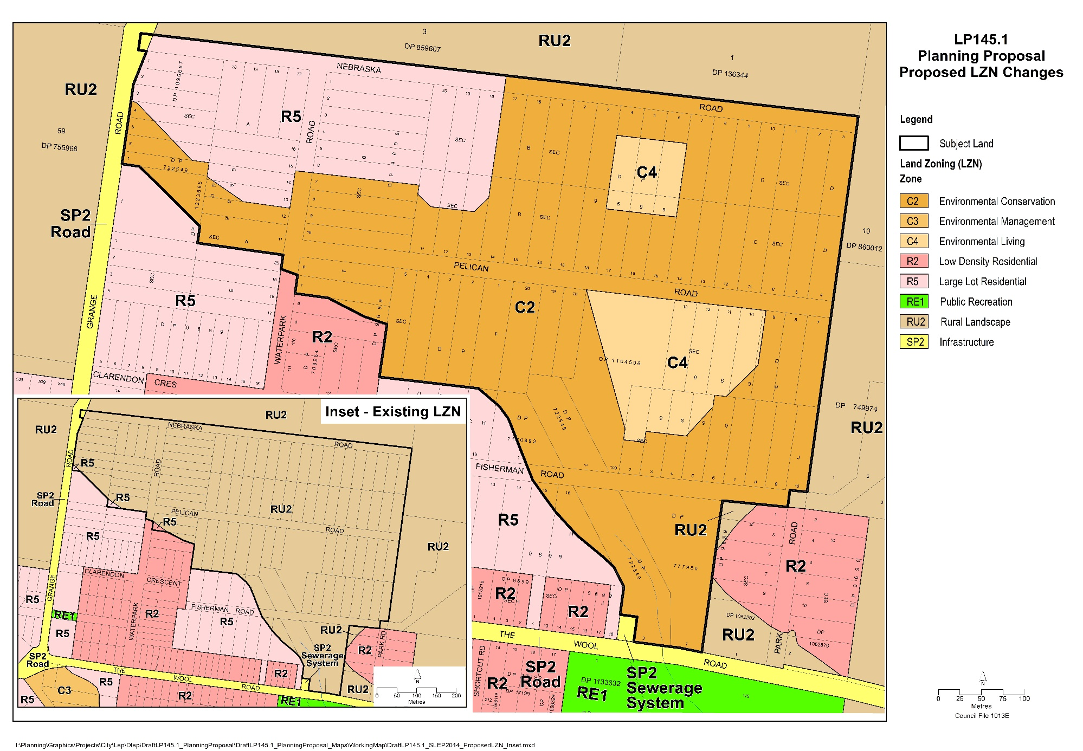
Map 1 – Land Use Zoning (LZN): Existing (inset) and Proposed (main)
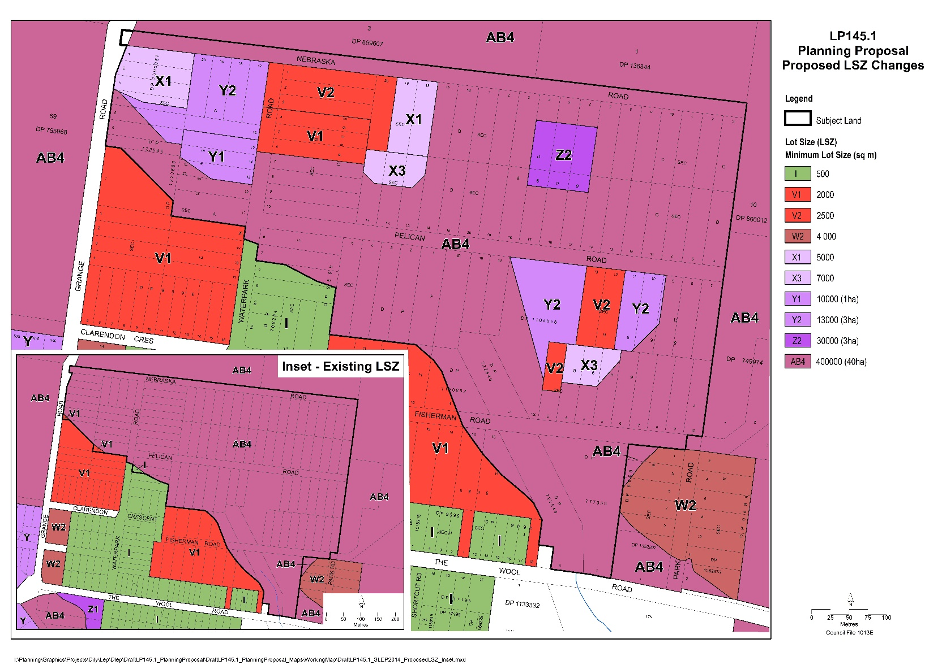
Map 2 – Minimum Lot Sizes (LSZ): Existing (inset) and Proposed (main)
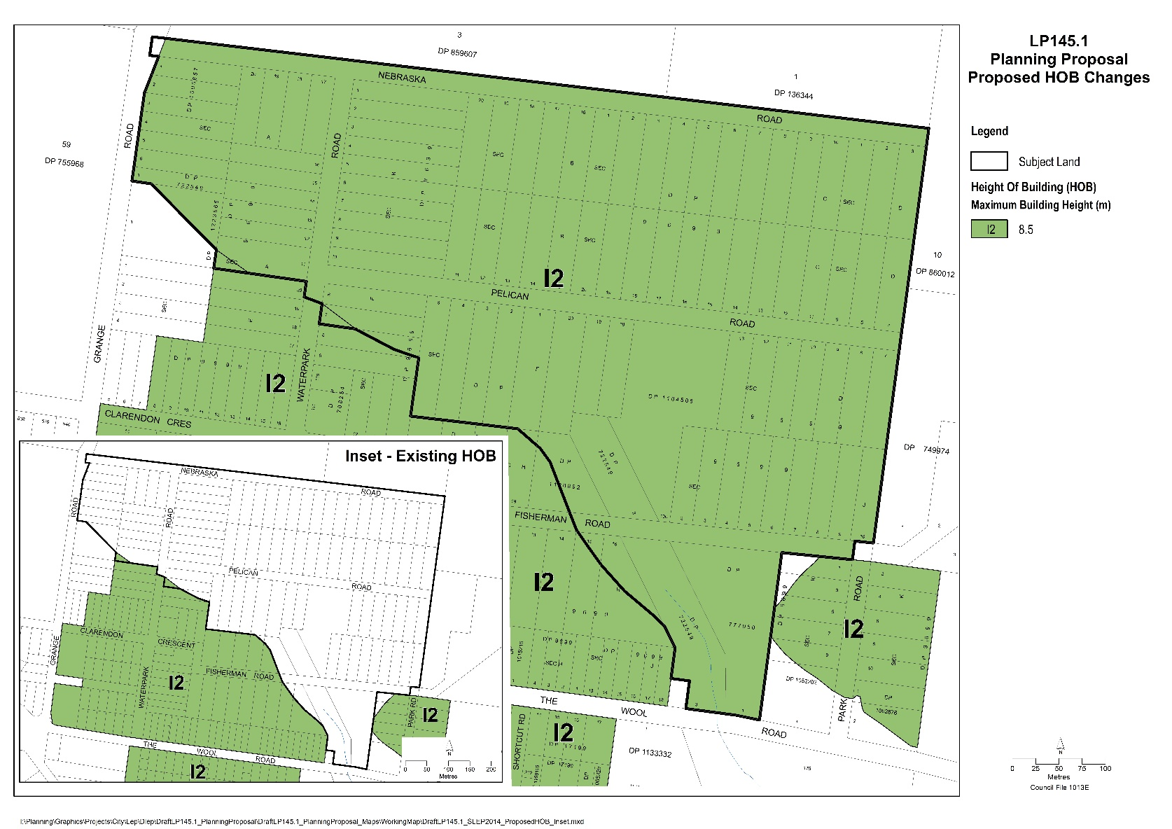
Map 3 – Height of Buildings (HOB): Existing (inset) and Proposed (main)
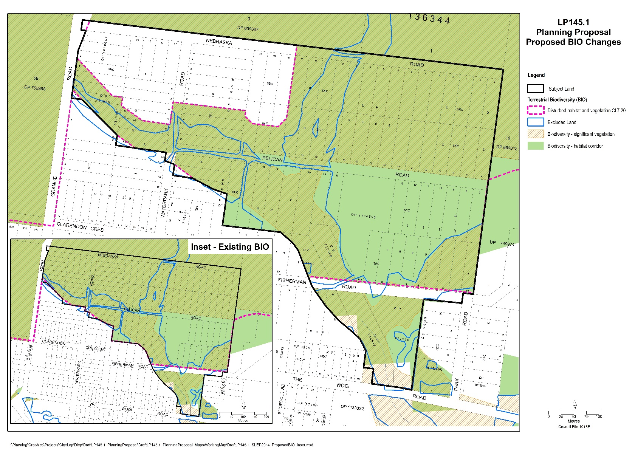
Map 4 – Terrestrial Biodiversity (BIO): Existing (inset) and Proposed (main)

Part 5 - Community Consultation
The PP will be publicly exhibited in accordance with the requirements of the NSW Environmental Planning and Assessment Act 1979, and any conditions set out in the Gateway determination.
The PP is proposed to be exhibited for at least 30 business days (42 calendar days). The PP will be publicly exhibited via the NSW Planning Portal and on the Documents on Exhibition page on Council’s website.
Electronic copies of the exhibited package will also be accessible at Council’s City Administration Centre (Bridge Road, Nowra) and at the Ulladulla Administration Building (Deering Street, Ulladulla) during business hours for the duration of the exhibition period.
A range of engagement methods will be employed consistent with Council’s Community Engagement Strategy (note, Council exhibited a draft ‘Community Engagement Strategy 2022-26’ from 16 January to 15 March 2023). Engagement methods will include but not be limited to:
- Notify landowners in writing prior to any relevant Council meetings.
- Council officers will continue to be available to respond to inquiries on the PP from landowners and other community members.
- Establish a Project Page on Council’s “Get Involved” platform to facilitate community engagement. Landowners will be able to subscribe to this for updates.
- Hold an information drop-in information session during the exhibition.
The Estate’s landowners have been consulted over many years via a range of means. The last detailed consultation occurred in 2016, when Council held a facilitated workshop and a landowner survey to help decide if the low-density and higher density option would be pursued for the NW Sector. A dedicated paper subdivision webpage and Nebraska Estate Fact Sheet have been maintained for several years.

Part 6 – Project Timeline
The timeline for completing the PP based on the Department’s maximum benchmark timeframes is outlined in the table below. The project plan may be updated as the PP progresses through the Gateway process.
Table 3 - Indicative project plan
Activity / milestone | Benchmark timeframe (business days) | Forecast completion date
Gateway request |  | November 2024
Gateway determination | 45 | January 2025
Post Gateway (complete Gateway requirements) | 70 | May 2025
Public exhibition & assessment | 115 | October 2025
Finalisation | 70 | January 2026

Implementation

Summary
Table 4 summarises the development issues that need to be resolved if/when the land is rezoned. It identifies the key issues, how they are proposed to be resolved, who will be responsible, and the likely time frame. The table is not exhaustive and will be refined in response to stakeholder consultation as the PP and draft DCP progress.
Table 4 - Summary of implementation issues
Issue | How resolved | Responsibility | Time Frame
Subdivision infrastructure on public land
Design & costing | Update preliminary design and costings in consultation with relevant stakeholders. More detailed design and costings would be needed to support a special rate variation application (SRV) to IPART – see below. | SCC (City Futures & City Services), SES, RFS | Post PP
Funding | Special rates are the preferred cost recoupment mechanism. This would require Council to apply to IPART for a Special Rate Variation after consulting with affected landowners | SCC (City Futures, City Performance and City Services), IPART | Post PP
Construction | Guided by DCP provisions where appropriate, e.g. staging and conceptual designs and costings prepared as part of the SRV application. | SCC (City Services, Shoalhaven Water) | Post PP
Stormwater management | Guided by DCP provisions where appropriate and conceptual designs and costings prepared as part of the SRV application. The DCP will be informed by the IWCA subject to further review by Council’s Floodplain Management team and City Services (stormwater infrastructure asset custodian) | SCC & landowners | During road upgrades and the construction of dwellings
Emergency evacuation (bushfire, flooding)
Establishment of rights of way on private land for fire trails and emergency access | DCP provision/DA condition | Benefitting landowners & SCC | Post PP
Bush fire survival plan (BFSP) | DCP provision - to be submitted with DA for approval | Landowners | Before lodgement of a DA
Biodiversity
Impact assessment at DA stage | An application for Clause 34A(4) Certification for the relevant ‘planning arrangements’. If approved, compliant DAs could be approved without a BDAR. | SCC (City Futures) - 34A application  EES - 34A assessment  Landowners – DA application | Post-PP and adoption of the DCP
Long term protection of biodiversity values within development parcels | DCP will require positive covenant to be registered on title prior to issue of a Construction Certificate | SCC – conditions of consent  Landowners | Subject to landowners obtaining development consent
Protection of biodiversity values on ‘residual C2 land’ | Update the “Policy - Voluntary Acquisition of ‘Residual C2 Land’ – Jerberra & Nebraska Estates” to confirm effect of the provisions for Nebraska Estate and provide the opportunity for owners of ‘Residual C2 Land’ to sell their land to Council for an agreed value. | SCC (City Futures) | If/when the Estate has been rezoned, before seeking Clause 34A certification
 | Landowners will be responsible for managing their land.  Any land acquired by Council under the voluntary acquisition of residual C2 land Policy will be managed by Council for conservation in perpetuity. | SCC, landowners | Post PP, subject to landowners wanting to sell and both parties agreeing on the sale price

Site-specific Development Control Plan (DCP)
A supporting site-specific chapter in the overall Shoalhaven Development Control Plan (DCP) 2014 will be needed to resolve complexities associated with developing the Estate and to help achieve intended outcomes.
The site-specific DCP chapter would provide additional objectives, performance controls and acceptable solutions, supported by relevant maps and figures based on the concept plan (see Figure 5). The following themes and development issues are proposed to be covered, building on the DCP chapters that are in place for Jerberra and Verons Estates. (Note: the structure of the DCP would be refined to minimise any overlap between these.)
Subdivision layout: The draft concept plan in Figure 5 shows any consolidation and/or re-subdivision proposed to be required/allowed under the LEP. The draft concept plan will continue to be refined and improved.
Biodiversity management (vegetation clearing and retention): Detailed controls to ensure development is designed to avoid and minimise impacts on biodiversity. Where relevant, a positive covenant (88B instrument) will need to be registered on the property title to ensure that any important biodiversity values within the lot will be protected and managed into the future – as is required in Jerberra and Verons Estates.
Desired Future Character: Desired future character provisions would aim to facilitate residential development that responds to the land’s environmental qualities and achieves ecologically sustainable development principles, particularly in the proposed C4 Environment Living zoned areas.
Bushfire protection planning: Provisions will be informed by the Bushfire Strategic Assessment completed by Eco Logical Australia to support the PP, including:
- Location and construction standard of dwellings and associated structures.
- Provision and management of asset protection zones (APZ), including need for legal arrangements to be put in place where an APZ for a proposed dwelling overlaps an adjoining property that is yet to be developed.
- Access arrangements for fire fighting vehicles and emergency vehicles, including the provision of fire trails.
- A Bush fire survival plan (BFSP) is intended to be required to support each DA.
Further details are provided in section 9.1
Building Design and Location: The location and design of dwellings and ancillary structures should be responsive to the environmental constraints that exist within the Estate including bushfire, flooding and threatened species, and the desired future character of the Estate.
Aboriginal Cultural Heritage: Controls are to be introduced to ensure that Aboriginal sites previously identified, which are within the proposed C2 Environmental Conservation zoned land, are not developed or disturbed unless the relevant approvals have been obtained and further assessment undertaken if necessary. Note: no residential development is proposed within these areas.
Stormwater management: Provisions will be informed by the recommendations of the Integrated Water Cycle Assessment prepared by Footprint Engineering (2017) and consultation with Council’s stormwater management engineers. These will aim to protect and maintain water quality and associated downstream ecosystems.
Infrastructure works: controls to ensure that roads, fire trails, rights-of-way and other subdivision infrastructure are designed and managed consistent with objectives to manage bushfire risk, protect adjoining biodiversity habitat, and maintain natural flow conditions and protect water quality.
Flooding & Emergency access: All dwellings are proposed to be located above the Projected 2100 PMF Flood Extent. A Home Emergency Plan (Flood) is proposed to be required with each DA for a dwelling, putting in place a ‘shelter in place’ strategy and/or identify emergency flood-free access routes.
Soil Management: Provisions to ensure risks associated with Acid Sulfate Soils (ASS) and soil erosion are minimised during the construction phase.
Part 4 of Council’s resolution on 26 February 2024 (MIN24.86) is to:
4. Prepare a draft site-specific chapter (Chapter N9 - Nebraska Estate) for inclusion in the Shoalhaven Development Control Plan (DCP) 2014, acknowledging that staff resources available to work on this project will depend on workloads associated with proponent-initiated PP’s and other strategic planning priorities.

Policy on Voluntary Acquisition of Residual C2 Land in Jerberra and Nebraska Estates

Broader Policy on Dealing with Unpaid Rates & Charges in Paper Subdivisions
The Council’s longstanding policy position is that it does not purchase properties in paper subdivisions, as doing so would set an unacceptable precedent and be financially untenable (particularly given the number of paper subdivisions in the Shoalhaven LGA).
However, Council’s policy ‘Rates – Small Lot Rural Subdivisions – Dealing with Unpaid Rates & Charges’ facilitates the acquisition of lots in paper subdivisions in lieu of unpaid rates in limited circumstances.
Land can only be acquired if requested by the owner in lieu of unpaid rates or via public auction if more than five years of rates or charges are outstanding. The landowner is not paid; however, the Council does cover the legal cost of transferring the land.
As explained below however, a policy originally adopted by Council in 2021 allows Council to purchase ‘residual C2 land’ in Jerberra Estate, with the intention of extending this to Nebraska Estate if/when the PP and supporting DCP are finalised.

Voluntary Acquisition of Residual C2 Environmental Conservation Land in Jerberra and Nebraska Estates
The Policy titled Voluntary Acquisition – Residual C2 Environmental Conservation Land – Jerberra & Nebraska Estates was first adopted by Council on 5 October 2021 (MIN21.699). The Policy currently applies to Jerberra Estate which was rezoned in 2014. The Policy will apply to Nebraska Estate if/when this PP is finalised.
The policy allows the profit from the sale of Council’s developable land in each estate to be used to purchase residual C2 land within that estate. The Policy currently applies to Jerberra Estate only; it will apply to Nebraska Estate if/when the PP is finalised and the DCP is in place. The Policy was developed to:
- enable Council to help resolve the tenure and management of ‘residual C2 land’ in Jerberra Estate and ultimately Nebraska Estate (if/when it is rezoned) without negatively impacting on Council’s finances
- provide legal certainty that any C2 land acquired by Council in each Estate will be managed for conservation in perpetuity, as per clause 34A(4)(b) of the NSW Biodiversity Conservation (Savings and Transitional) Regulation, 2017. This will assist Council in meeting the “test of security” for providing offsets within the boundaries of the Estate.
The objective of the Policy is to “facilitate and provide a mechanism for the cost-neutral voluntary acquisition of ‘Residual C2 Land” in the Jerberra and Nebraska Estates “using net profits from the sale of Council land [in the relevant Estate] that is both zoned and suitable for development (developable)”.
Implications for owners of ‘residual C2 land’
The Policy means that owners of ‘residual C2 land’ in Nebraska will potentially be able to sell their land to the Council (if they wish) subject to an agreement on the value. Council will not compulsorily acquire land. Any landowners interested in pursuing this option could submit a no-obligation expression of interest (EOI) to the Council, which will arrange for the land to be independently valued.
The Policy will not apply to Nebraska Estate until the land has been rezoned and a DCP is in place. Any EOIs received by Council in the interim will not be progressed.
Management of land acquired under the Policy
Any land acquired under the Policy will be included in a management plan as required by s36 of the Local Government Act 1993. The management plan will provide for:
- Management of the land for in-perpetuity protection / conservation of its ecological/ biodiversity values in accordance with the BC Act.
- Monitoring of conservation outcomes on the above values;
Management of any acquired residual C2 land will be principally funded by the net profits from the sale of developable Council land in the Estate as an internal funding source. This will potentially be supplemented by any external funds that are able to be secured for environmental/biodiversity conservation management/works, e.g., under Commonwealth or NSW State Government programs.
Options for establishing a Biodiversity Stewardship Agreement (BSA) or Conservation Agreement (CA) over consolidated areas of ‘Residual C2 Land’ will be considered. If a BSA or CA is deemed to be the preferred management tool to conserve the environmental values of the land, management plans under the Local Government Act 1993 would not be required.
Without the Council’s residual C2 land acquisition policy, Council would only be able to accept the properties in lieu of outstanding rates if offered by the owner; Council would not purchase any properties, and would not have funding to actively manage the land for conservation.
The north-eastern corner of the subject land contains a large number of threatened orchids including +400 individual pot-bellied greenhood orchids P. ventricosa and a single leafless tongue orchid Cryptostylis hunteriana.
There are conservation strategies in place for both C. hunteriana and P. ventricosa. Nebraska is identified as a priority management site for P. ventricosa under the NSW government’s ‘Saving Our Species’ Program.
The Department’s EES Division indicated support for the Policy, in particular, provision (clause 6.5.3) to prioritise voluntary acquisition of land in the north-eastern corner of the Estate where the population of P. ventricosa is at its greatest density.
More information about the background to the Policy is available on Council’s website at: https://getinvolved.shoalhaven.nsw.gov.au/jerberra-nebraska-estates

Proposed Use of ‘Clause 34A Savings Provision’ to Help Landowners Navigate Biodiversity Laws
Clause 34A certification of Nebraska Estate planning controls, if granted, would have the effect of allowing compliant development applications to be approved without a Biodiversity Development Assessment Report (BDAR). Moreover, it would provide a direct, legally binding pathway to permanently protecting the Estate’s biodiversity values.
This is unlikely to be achieved through the biodiversity offset scheme because the Estate’s small lots and fragmented private ownership would preclude establishment of biodiversity stewardship site(s) within the Estate. Any offsetting obligations would be directed elsewhere: developers can either pay into a fund in order to meet their offset obligations, or they can purchase credits from sites elsewhere.
As explained below, certifying the Estate’s planning controls under Clause 34A would greatly increase the weight of the biodiversity provisions in both the LEP and DCP. At the same time, it would help to streamline and reduce the cost of the development application process for individual landowners in the Estate.
Offsetting any ‘residual impacts’ in Nebraska Estate, as required to satisfy part (3)(b) of Clause 34A could in part be achieved by including appropriate consent conditions in any development approvals, such as requiring a positive covenant to be registered on title which legally requires the owner to manage environmentally sensitive land for conservation purposes in perpetuity. This would be facilitated by including a development control plan (DCP) provision, as is the case in the DCP chapters for Jerberra and Verons Estates. Thus, although a DCP is not legally binding, it would give rise to legally binding arrangements for any environmentally sensitive land that is subject of a development consent, to be managed for conservation in perpetuity.

Provision of Essential Infrastructure
This section contains supplementary information to inform stakeholders about the financial implications and mechanisms available to deliver the PP outcomes, after the land is rezoned. It covers:
- the user-pays principle
- co-ordination of infrastructure provision
- proposed cost recovery via special rates and a special rate variation
- information about prior and existing special rates
- review of options for future cost recovery and
- cost estimate.

Cost Recovery Principle
Council has a longstanding position that the benefiting landowners will need to meet the costs of rezoning the land and of providing essential infrastructure. All efforts to resolve the planning status of Nebraska Estate have been on this basis since the initial decision to investigate rezoning the land in 1993.
This ‘user-pays’ principle was recommended by the NSW Commission of Inquiry into the Heritage Estates (a large paper subdivision near Vincentia) in 1999, and has been consistently applied by Council to paper subdivisions in the area, including Jerberra and Verons Estates at Sussex Inlet where the planning controls have been settled and development is continuing in accordance with the area-specific chapters of Shoalhaven DCP 2014.
Cost recoupment mechanisms are discussed in section 8.5.3.

Infrastructure Co-ordination
Like the Jerberra and Verons Estates, if the land is rezoned, it is proposed that Council would co-ordinate the subdivision works to provide the essential infrastructure via a public tender contract. This process would allow residential development to be staged to occur concurrently and progressively with the delivery of infrastructure works and with minimal delay.

Cost Recoupment Strategy and Mechanisms
Cost recoupment strategies must minimise the financial risks to Council and be fair and equitable to both the benefitting landowners and the broader community.
The potential cost recoupment mechanisms are very limited, but in theory could include:
- Schedule 7 (Paper subdivisions) of the Environmental Planning and Assessment Act, 1979 (EPA Act)
- Planning Agreement(s) under Part 7 Division 7.1 Subdivision 2 of the EPA Act
- Special rates under Section 495 of the Local Government Act, 1993 (LG Act)
- Developer contributions under Division 7.1 of the EPA Act and Section 64 contributions under the LG Act.
Of these options:
- An overall Planning Agreement would generally be impractical due to the high number of landowners. However, a Planning Agreement with a much smaller set of landowners could be considered to resolve an infrastructure issue affecting a small number of landowners, e.g. to establish a fire trail.
- The developer contributions approach would have an unacceptable financial risk. Council would need to fund the essential infrastructure upfront, but would only have the ability to recoup costs as individual properties are developed. This would take many years and place a significant cost burden on Council.
- Schedule 7 of the EPA Act can only be utilised if agreement is secured by a formal ballot from at least 60% of all landowners and the owners of at least 60% of the total land area. Given the ratio of total lots (89) to proposed new dwelling sites (23), it is unlikely that the required landowner agreement could be secured. Hence, Council does not propose to attempt to utilise Schedule 7 of the EPA Act.
- Special rates have been successfully used to the provision of infrastructure in Jerberra and Verons Estates. In principle, special rates are the preferred cost recoupment option because it allows the costs to landowners to be spread over a number of years and provides more financial certainty for Council. In broad terms, Council could potentially take out a loan, coordinate the infrastructure upgrades, and meet the loan repayments using special rates levied from the Estate.
Special rates and the associated Special Rate Variation (SRV) process are discussed below.
Special Rates & Special Rate Variation (SRV)
Section 495 of the Local Government Act (1993) allows Councils to levy Special Rates. A Council may make a special rate for or towards meeting the cost of any works, services, facilities or activities provided or undertaken, or proposed to be provided or undertaken, by the Council within the whole or any part of the Council’s area, other than domestic waste management services. The special rate is to be levied on such rateable land in the council’s area as, in the council’s opinion:
- benefits or will benefit from the works, services, facilities or activities; or
- contributes or will contribute to the need for the works, services, facilities or activities; or
- has or will have access to the works, services, facilities or activities.
To avoid impacting on other expenditure programs, a special rate variation (SRV) to the ‘rate peg’ must be sought from IPART to increase the total rate revenue above the rate pegging limit.
IPART would assess the application against the guidelines published by the Office of Local Government. Council would need to engage and consult with the community and demonstrate to IPART that the criteria for special variations have been satisfied. Details on expenditure and revenue would need to be provided as part of the application to IPART.
If IPART did not approve the special variation and proposed special rate arrangements, Council would not have the financial means to provide the essential infrastructure.
Previous and existing special rate arrangements
In 2006, Council determined that the most appropriate way to raise the funds necessary to carry out the re-zoning and associated road design for Nebraska Estate was via a special rate. Council was granted a special rate variation and subsequently introduced special rates in 2006/2007 to repay the relevant loans. The special rates ceased in 2016 when the loans were repaid.
In 2008/2009, a special rate for road construction was introduced to provide nominal funding to progressively construct a ‘spinal route’ through the Estate and associated drainage work. The amount raised by this special rate is minimal and insufficient to complete road construction within an acceptable timeframe, which in turn would impact on the timeframe for development of the individual lots and their value. This special rate currently has no specified end date. This arrangement will need to be reviewed as the planning process continues.

Cost Estimate
As noted in Section 4.4.1, flooding, biodiversity constraints and Aboriginal archaeology will influence the design of the required infrastructure. Indicative cost estimates have been prepared and are set out below in Table 5. These estimates are based on 2021 estimates that were derived from generic unit rates, which have been adjusted using applicable construction cost indices (to account for rising costs).

Table 5 – Preliminary infrastructure costs estimate
 | Roads | Fire trails | Roadside swales | Electricity | Water | Sewerage | Total
Total length (m) | 1235 | 540 | 730
unit rate ($/m) | $2,745 | $458 | $171
2024 cost estimate | $3,391,000 | $248,000 | $125,000 | $977,000 | $446,000 | $183,000 | $5,367,000
The costs are a rough guide only. More accurate cost estimates based on preliminary engineering design plans would be prepared at the appropriate point after the land has been rezoned.
As a rough guide only, a total infrastructure cost of $5,416,000 would equate to an average cost per dwelling (total cost divided by 17) of approx. $319,000.

Further Information

State Environmental Planning Policies (SEPP) Checklist
State Environmental Planning Policy | Applies? | Relevant? | Consistent?
State Environmental Planning Policy | Yes/No | Yes/No | Yes/No
Housing SEPP 2021 | Yes | Yes | Yes – Refer to section 3.2.4.
Primary Production SEPP 2021 | Yes | No | Yes – Refer to section 3.2.5.
Biodiversity and Conservation SEPP 2021 | Yes | Yes | Yes – Refer to section 3.2.6
Resilience and Hazards SEPP 2021 | Yes | Yes | Yes – Refer to section 3.2.7 Direction 4.2 – Coastal Management
Industry and Employment SEPP 2021 | No | No | N/A
Resources and Energy SEPP 2021 | No | No | N/A
Planning Systems SEPP 2021 | No | No | N/A
Precinct SEPPs 2021 | No | No | N/A
Exempt and Complying Development Codes 2008 | No | No | N/A
SEPP 65 – Design Quality of Residential Apartment Development 2002 | No | No | N/A
SEPP (Building Sustainability Index) 2004 | No | No | N/A
SEPP (Sustainable Buildings) 2022 | No | No | N/A
Transport and Infrastructure SEPP 2021 | No | No | N/A

Local (s9.1) Planning Directions Checklist
1 March 2022 Version (except where otherwise stated)
# | Subject | Applies?  Yes/No | Relevant?  Yes/No |  | Consistent?
Focus Area 1: Employment & Resources
1.1 | Implementation of Regional Plans | Yes | Yes |  | Yes
1.2 | Development of Aboriginal Land Council Land | No | No |  | N/A
1.3 | Approval and Referral Requirements | No | No |  | N/A
1.4 | Site Specific Provisions | No | No |  | N/A
1.5 – 1.17 | Planning  Systems (Place based) | No | No |  | N/A
Focus Area 3: Biodiversity & Conservation
3.1 | Conservation Zones | Yes | Yes |  | Yes
3.2 | Heritage Conservation | Yes | Yes |  | Yes
3.3 | Sydney Drinking Water Catchments | No | No |  | N/A
3.4 | Application of C2 and C3 Zones and Environmental Overlays in Far North Coast LEPs | No | No |  | N/A
3.5 | Recreation Vehicle Areas | No | No |  | N/A
3.6 | Strategic Conservation Planning: 20/2/2023 | No |  | No | N/A
3.7 | Public Bushland: 21/11/2022 | No |  | No | N/A
3.8 | Willandra Lakes Region: 21/11/2022 | No |  | No | N/A
3.9 | Sydney Harbour Foreshores and Waterways Area: 21/11/2022 | No |  | No | N/A
3.10 | Water Catchment Protection 21/11/2022 | No |  | No | N/A
Focus Area 4: Resilience & Hazards
4.1 | Flooding | Yes | Yes |  | Justified
4.2 | Coastal Management | Yes | Yes |  | Yes
4.3 | Planning for Bushfire Protection | Yes | Yes |  | Yes
4.4 | Remediation of Contaminated Land | Yes | Yes |  | Justified
4.5 | Acid Sulfate Soils | Yes | Yes |  | Yes
4.6 | Mine Subsidence and Unstable Land | No | No |  | N/A
Focus Area 5: Transport & Infrastructure
5.1 | Integrating Land Use and Transport: 20/2/2023 | Yes | Yes |  | Justified
5.2 | Reserving Land for Public Purposes | No | No |  | N/A
5.3 | Development Near Regulated Airports and Defence Airfields | No | No |  | N/A
5.4 | Shooting Ranges | No | No |  | N/A
Focus Area 6: Housing
6.1 | Residential Zones | Yes | Yes |  | Yes
6.2 | Caravan Parks and Manufactured Home Estates | Yes | Yes |  | Justified
Focus Area 7: Industry and Employment
7.1 | Employment Zones 20/2/2023 | No | No |  | N/A
7.2 | Reduction in non-hosted short-term rental accommodation period: 3/6/2022 | No | No |  | N/A
7.3 | Commercial and Retail Development along the Pacific Highway, North Coast | No | No |  | N/A
Focus Area 8: Resources and Energy
8.1 | Mining, Petroleum Production and Extractive Industries | No | No |  | N/A
Focus Area 9: Primary Production
9.1 | Rural Zones: 20/2/2023 | Yes | Yes |  | Justified
9.2 | Rural Lands | Yes | Yes |  | Justified
9.3 | Oyster Aquaculture | No | No |  | N/A
9.4 | Farmland of State and Regional Significance on the NSW Far North Coast: 13/12/2022 | No | No |  | N/A

Bushfire Assessment – DCP Considerations
This appendix provides additional information about the bushfire assessment addressed in Section 3.2.12 of the PP. These matters will be discussed during consultation with the NSW Rural Fire Service (RFS) and the NSW State Emergency Services (SES) during preparation of the DCP.

Minimum APZ and Dwelling Construction Standards
APZs are required to ensure that buildings are not exposed to radiant heat of more than 29 kW/m². Guidance on management of inner protection areas (IPA) and outer protection areas (OPA) is provided in Planning for Bushfire Protection 2019 (PBP 2019) and Standards for asset protection zones (NSW RFS). In summary, APZs should be managed as follows:
- Ground fuels should be removed on a regular basis.
- Grass needs to be kept short and where possible, green.
- Tree crowns should be separated from each other and the asset by at least two (2) to five (5) metres.
- Native shrubs and trees can be retained as clumps or islands covering no more than 20% of the area.
A legal mechanism such as a positive covenant (under section 88B of the Conveyancing Act 1919) will be required to ensure the APZs will be maintained in perpetuity. This effectively means that dwellings must be positioned so that the APZs are either; accommodated within the property boundary; or are clustered so that APZs overlap with APZs on adjoining properties (i.e. APZs are mutually beneficial). These principles are embedded in the Jerberra Estate DCP (Chapter N20 in the Shoalhaven DCP 2014) and will be applied in the Nebraska Estate DCP.
APZ management standards are set out in Appendix 4 of PBP 2019 and the NSW RFS document Standards for Asset Protection Zones. The determining factors are:
- Predominant vegetation, which in this case is forest (dry and wet sclerophyll forest).
- Effective slope, which is generally 0-5 degrees (refer to Figure 12 in the Strategic Bushfire Assessment).
- Fire danger index (FDI) which is a measure of regional fire weather. The FDI for the Shoalhaven region is 100.
- Standard of construction under AS3959: for Planning Proposals, APZs must be calculated assuming BAL–29 or less.
The minimum construction standard for dwellings is set out under AS3959-2018. While the APZs between dwellings and bushfire prone vegetation are based on BAL-29, the DCP could require a higher construction standard (i.e. BAL-40) in certain circumstances to provide an extra factor of safety.
The conceptual subdivision and development plan (concept plan) (Figure 5) has been designed to accommodate the minimum APZs required for BAL-29, i.e. 24 m or 29 m, depending on the slope.

Access
Some of the existing road reserves are not formed/constructed or are not constructed to the standard required in PBP 2019.
The proposed road network is shown in the concept plan (Figure 5) and includes:
- Waterpark Road from Pelican Road to Nebraska Road
- Nebraska Road, east from Waterpark Road Construction and provide a formal turning head
- Pelican Road – widen and extend eastward and provide a formal turning head
- Fisherman Road - extend eastward and provide a formal turning head
Environmental and Aboriginal heritage constraints and associated costs must be considered as part of any planned road upgrades.
Appropriately designed turning heads would be required at the dead ends. These turning heads may need to be aligned with indented property driveways and/or require the dedication of land to ensure firefighting and service vehicles have adequate turning room.
The roads would be supplemented by fire trails (with locked gates) for potential use in bushfire and flooding emergencies at:
- Nebraska Road from Waterpark Road to Grange Road
- Between Nebraska Road and Pelican Road on the western edge of the NE Sector. This will provide alternative access if Pelican Road is unable to be used.
- The western edge of Lot 13 Sec D DP 9699 to the northern end of Lots 2 and 3 Sec J DP 9699. An easement will need to be established. The potential for this flood-free access to be extended to Fisherman Road to also provide an alternate emergency access in the event of bushfire can be discussed with the NSW RFS and the SES.
All dwellings would be required to provide adequate access and defendable space for firefighting vehicles.

Provisions to be Incorporated into Planning Controls
The LEP and DCP would reinforce the principles in Planning for Bush Fire Protection (PBP 2019) and the findings of the SBA including in relation to:
- The level of construction for dwellings under AS3959
- Establishment of APZs in accordance with PBP 2019
- Appropriate access standards for residents and firefighters/emergency workers including the provision of perimeter access before certain lots can be developed
- Provision of turning heads for firefighting vehicles at the eastern end of Nebraska, Pelican and Fisherman Roads
- Where provision of access for fire fighting vehicles to the rear of dwellings is a requirement for individual landowners
- Adequate water supply and pressure
- Emergency management arrangements for fire protection and evacuation, to include Bush Fire Survival Plans to be lodged with DA for approval
- Council’s intention to coordinate subdivision infrastructure upgrades (subject to special rates or similar funding arrangement to recoup costs from the benefiting landowners). Refer to section 8.5 (implementation)
- Available tools to strategically manage bushfire risk.

Archaeological and Cultural Heritage Assessments

Previous Studies
Archaeological studies were undertaken in Nebraska Estate in1994, 1995, 2001 and 2009. The first of these identified two small scatters of stone artifact and one isolated artifact within the drainage lines. Archaeological excavations in the second study by the same author failed to identify any subsurface evidence of past Aboriginal occupation, leading the author to suggest that artifacts previously identified may have been introduced in imported material.
The findings of these four studies are explained in more detail below. Links to the studies are provided in the Document library.
1. Marshall, B, Webb C, 1994. An Archaeological survey of Nebraska Estate, St Georges Basin, New South Wales. Report prepared by South East Archaeology for Shoalhaven City Council
The report states that most of the study area was densely vegetated and that the survey was restricted to the roads and other areas of high visibility such as partially cleared lots and a walking track in the southeast of the Estate. Approximately 10% of the study area was intensively surveyed.
Two small scatters of stone artifact and one isolated artifact were found. These are described below.
Pelican Road site (NPWS Site no. 58-2-305): Lithic scatter extending over 175 m along Pelican Road in the vicinity of the watercourse. The extent of this site beyond the road is unknown. 23 artifacts consisting mainly of quartzite and silcrete flakes were recorded at a density of <1 artifact/m². Two blade cores, a small circular sandstone grindstone and a broken hammerstone were also recorded.
Nebraska Road site (NPWS Site no. 58-2-307): An isolated chert flake was found on a ridge on Nebraska Road.
Fisherman Road site (NPWS Site no. 58-2-306): A small lithic scatter 5 m square on a ridge overlooking the creek. Four artifacts were recorded; one quartzite and two silcrete flakes, and a silcrete backed blade.
All three sites were classified as low density, open artifact scatters typical of those found in the St Georges Basin/Tomerong area and all were within the flood liable land, on either side of the watercourse. The artifacts consisted predominantly of simple flakes with little retouch to indicate subsequent reuse. The backed blade from Fisherman Road and the two blade cores from the Pelican Road site were estimated to be 1,000 to 5,000 years old.
It was concluded that the artifacts found are probably representative of open camp sites in the region and that their scientific significance is moderate with little educational value.
The report stated their significance to Aboriginal people was assessed by a member of the Jerrinja Local Aboriginal Land Council during the survey, and was considered to be low. The report recommended that:
- Disturbance/vegetation removal within the flood liable land should be minimised and that any major development on flood liable land should not proceed without further archaeological investigation including sub-surface testing.
- Written permission should be sought from the Jerrinja Local Aboriginal Land Council (LALC) and the Director of the NSW NPWS prior to the destruction of recorded sites.
2. Marshall, B, 1995. Archaeological excavations at Nebraska Estate, St Georges Basin, New South Wales. Report prepared by Austral Heritage Consultants for Shoalhaven City Council
Archaeological excavations in the form of backhoe scrapes were conducted at eight locations. A total of eight scrapes exposed a total of 58 m² of ground but revealed no subsurface evidence of past Aboriginal occupation. A foot survey of the major roads also revealed no additional archaeological sites. The report suggests that the surface artefacts at the Pelican Road site (NPWS Site no. 58-2-305) and the Nebraska Road site (NPWS Site no. 58-2-307) may have been introduced via sand/gravel used to surface the roads.
The report concludes that because of their low density, high degree of disturbance and possible association with imported fill, the previously recorded sites are of low significance. In relation to the Fisherman Road site (NPWS Site no. 58-2-306) it was concluded that the artifacts may derive from local deposits and the site is of moderate to low scientific significance.
The cultural significance of all three sites was assessed by a member of the Jerrinja LALC who participated in both surveys, as low.
The report recommended that:
- No further archaeological investigations are necessary;
- Written permission should be sought from the Jerrinja LALC prior to any development which is likely to impact on the recorded sites; and
- Written permission be sought from the Director of NSW NPWS prior to any development likely to impact on the recorded sites.
3. Kuskie, P. 2001 Further archaeological assessment of a proposed subdivision of the Park Road area, at Nebraska Estate, St Georges Basin, New South Wales. Report prepared by South East Archaeology for Shoalhaven City Council.
A further archaeological study was completed in 2001 by Kuskie (South East Archaeology) as part of the rezoning investigations for Park Road at the southern end of Nebraska Estate. The study aimed to reassess the potential for sub-surface archaeological deposits to occur immediately to the south of the current study area, in the vicinity of Park Road (approx. 2.7 ha). A cursory inspection was also made of the remainder of Nebraska Estate (the current study area), focusing on the flood liable land. Survey coverage was estimated to be 18% in Park Road and 0.9% in the remainder of the Estate. No Aboriginal heritage sites were found in the vicinity of Park Road and the land has since been rezoned and developed.
The report states:
“In relation to the remainder of the watercourse bordering flats in the Nebraska Estate, if extensive development is to occur it is recommended that sub-surface testing be undertaken in at least one location of such development, preferably close to the recorded Fisherman’s Road or Pelican Road sites, to test for the presence of heritage evidence and permit an adequate assessment of the nature, scope and significance of any evidence. The Jerrinja Local Aboriginal Land Council has requested that a representative be engaged to monitor initial ground disturbance works in this area if future construction occurs.”
The report by Kuskie in 2001 did not refer to the subsurface testing reported by Marshall in 1995 so it is uncertain if Kuskie was aware that substantial sub-surface testing had previously been undertaken.
4. Dibden, J, 2009 Proposed Road Upgrade Nebraska Estate – Aboriginal Archaeological Assessment. Report prepared by NSW Archaeology P/L for Shoalhaven City Council.
This 2009 study was completed for the following road works, to be undertaken in two stages:
- Stage 1 – Construction of a culvert and road upgrading with the eventual provision of kerb and guttering along a section of Waterpark Road (completed); and
- Stage 2 – Construction and sealing of the remainder of Waterpark Road and Nebraska and Pelican Roads (partly completed).
The survey results were:
- Stage 1 proposal area – No Aboriginal objects were identified within any of the Stage 1 proposal area. The proposed impact areas within Stage 1 were assessed to be of low archaeological sensitivity.
- Stage 2 proposal area – The location of the two previously recorded Aboriginal objects were subject to a detailed inspection however no stone artefacts were recorded during the current assessment. The proposed impact areas within Stage 2 are all assessed to be of low archaeological sensitivity given high levels of previous disturbance.
The conclusions/recommendations were:
  - There are no Indigenous legislative constraints relating to the proposed Stage 1 works.
  - Shoalhaven City Council should seek to obtain a s90 AHIP from the Director-General, NSW DECC, for the previously recorded Aboriginal objects #58-2-0307 “Nebraska Road” and #58-2-0305 “Pelican Road” before the commencement of the proposed works in the Stage 2 area.
  - No further archaeological assessment such as subsurface test excavation is required in respect of the proposal.
It is acknowledged that all of above studies pre-date the current code of practice: Guide to investigating, assessing and reporting on aboriginal heritage in NSW (Office of Environment & Heritage (former) , 2011)

Aboriginal Participation and Views
The Jerrinja LALC was involved in all three archaeological studies undertaken in Nebraska Estate. Written comments were submitted and incorporated into the final report by Kuskie (2001). These comments indicated that the Jerrinja LALC was satisfied with the results and that a member of Jerrinja LALC should be engaged to monitor any excavation of low-lying land near the watercourse.
A member of the LALC also participated in the 2009 archaeological study for the proposed road upgrade.

Previous State Agency Advice
A letter from the former Department of Environment and Conservation (DEC) dated 12 January 2007, provided the following advice:
- It is impossible to determine whether the Aboriginal objects identified in the assessment completed in 1994 by Marshall and Webb were imported with road base or are an in situ Aboriginal site.
- The Department accepts that the findings of the reports is indicative of what is expected of the archaeological record in the region based on previous archaeological research and current models of pre-contact Aboriginal land use strategies.
- The Department considers that Aboriginal consultation has been adequate in the context of the consultation requirements in effect at the time.
- No further archaeological work is required in the areas of low archaeological potential.
- In areas of high potential (i.e. the drainage depressions) further controlled hand excavation will be required, together with input from the Aboriginal community.
- Before making a final determination on the matter, the Department would appreciate Council’s written advice on the steps that Council will take to ensure the areas of high potential are not going to be subject to major ground disturbance. If development is to occur within the three recorded sites, a section 90 Consent to Destroy will be required.
Email advice, dated 13 September 2018, was received from the former Office of Environment and Heritage (OEH) (Conservation and Regional Delivery Division) generally in the following terms:
“ … apply for an AHIP to cover all of Council’s proposed road works under a Part 5 REF, and accept the rationale for not including the low potential development areas which are outside the Part 5 process. People building in the areas outside the recorded sites and area of sensitivity will be operating under a due diligence defence. This means that if Aboriginal objects are found during construction works they will need to stop work and apply for an AHIP if harm to the Aboriginal objects cannot be avoided.
“The AHIP application will need an Aboriginal cultural heritage assessment report – this is a requirement in the NPW Regulation (clause 80D). The report will need to include the information in clause 80D and in section 3 of the Guide to investigating, assessing and reporting on Aboriginal cultural heritage in NSW. However, it’s likely that the report will be able to draw on and update much of the information in the previous reports, so that significant previous work will not be disregarded . … include an up-to-date AHIMS search, and the final REF.
“Given the time that has passed, an archaeologist should also re-assess impact areas and provide an up to date site assessment. This will also help the archaeologist resolve the AHIMS site numbers and any duplication, and identify any unrecorded sites that may have been exposed in the intervening time.”

Conclusion
All three Aboriginal sites are located within the proposed C2 zone and no further residential development is proposed on the affected land. Some ground disturbance will be necessary for construction of infrastructure.
Any disturbance of the site will be subject to the requirements of the NSW National Parks and Wildlife Act 1974 and the National Parks and Wildlife Regulation 2019 in relation to Aboriginal cultural heritage protection. There are known Aboriginal sites on the subject land and, as a result, Council must follow the “Due Diligence Code of Practice for the Protection of Aboriginal Objects in New South Wales” prepared by the NSW Department of Environment, Climate Change and Water (2010) to determine if an Aboriginal Heritage Impact Permit (AHIP) is required for any works that Council undertakes. Consultation requirements for the preparation of Aboriginal cultural heritage assessments have changed. If an AHIP is required, Council will undertake the necessary consultation and impact assessment requirements in order to comply with the Act and regulations.

Threatened Species Assessment – Species Distribution and Significance
A Threatened Biodiversity Survey & Assessment was completed by Bushfire & Environmental Services (BES) on behalf of Council in 2009. Two assessments were also completed in 1994:
- Assessment of Faunal Impact – Proposed Rezoning, Nebraska Estate, St Georges Basin, Antcliff Ecological Services, 1994
- Review of Proposed Wildlife Corridor and Fauna Assessment for Draft Local Environmental Plan LP145 Andrews Neil, 1994
The following is a brief summary of survey findings for the individual species and ecological community recorded on the subject land.

Microchiropteran bats
Distribution and significance: The Eastern Coastal Free-tailed Bat, Eastern False Pipistrelle, and the Greater broad-nosed Bat were detected and are expected to forage throughout the subject land as part of much larger home ranges. No evidence of communal roosting was found but several large hollow-bearing trees are potentially suitable as potential refuge and breeding sites.
Comment: The PP aims to retain as many hollow-bearing trees as possible within land proposed to be zoned C2 Environmental Conservation. If/when the land is rezoned, Council’s Policy for the Voluntary Acquisition of Residual C2 Land will facilitate and provide a mechanism for the voluntary acquisition of approximately 50% (15 ha) of the subject land. Land acquired under the Policy will be managed for environmental and biodiversity conservation purposes in perpetuity.

Grey-headed Flying-fox
Distribution and significance: The Grey-headed Flying-Fox was recorded foraging within the subject land. Breeding activity was not detected and the species has extensive foraging areas.
Comment: The recommendation for the retention of areas of forest and scattered trees would be achieved by the PP.

Yellow-bellied Glider
Distribution and significance: The subject land forms part of the home range of a group of Yellow-bellied Gliders, with the core habitat on adjoining land to the north. One individual Yellow-bellied Glider and two sap feeding trees were identified within the subject land. Sap feeding trees were also observed to the north and southwest of the subject land.
Comment: The PP would enable a large proportion of the key Yellow-bellied Glider habitat to be retained within the C2 Environmental Conservation zone.

Southern Greater Glider
Distribution and significance: The Southern Greater Glider was not observed by BES in 2009, but it was recorded in 1994 by Andrews Neil. Greater gliders were recorded at the northern edge of the subject land and within a then proposed regional “wildlife corridor” which extended from Pelican Road to north of Island Point Road. The Southern Greater Glider was listed in 2022 as ‘endangered’ on the NSW BC Act and the EPBC Act. This species has therefore been included in Table 1 – Status summary of threatened species in Nebraska Estate at Section 3.3.1 of the PP.
Comment: Given that the Greater Glider was not recorded in the 2009 assessment by BES, it is unclear if the species is still locally present. The PP seeks to rezone the higher value conservation land, including some potential Greater Glider habitat, to C2.

Gang-gang Cockatoo
Distribution and significance: The species was recorded foraging within the subject land and a nest tree was located just outside the northern boundary. Much of the subject land contains suitable foraging habitat, and the species is expected to forage in the area on a regular basis. Potential nesting resources also occur in larger hollow-bearing trees, however these are of lower quality relative to the larger hollow-bearing trees within less disturbed areas of forest in the locality, including forest areas to the north.
Comment: The PP would enable some Gang-gang cockatoo habitat to be retained within the C2 zone. The Gang-gang cockatoo was listed as ‘vulnerable’ in 2005 but has since (2022) been listed as ‘endangered’ on the EPBC Act.

Glossy Black-cockatoo
Distribution and significance: Feed trees (Black She-oaks) were identified, mostly in the northern part of the subject land. A small number were also located in the south eastern corner. No nesting activity was recorded, although there are many potentially suitable hollow-bearing trees.
Comment: The PP has been designed to minimise the potential removal of the identified Glossy Black-cockatoo feed trees and hollow-bearing trees. Approximately 50% of Glossy Black-cockatoo feed trees identified are within land proposed to be zoned C2. Others are located within the proposed bushfire asset protection zones (APZs) and therefore are likely to be removed in the long term. The Glossy Black- cockatoo was listed as ‘vulnerable’ under the EPBC Act in 2022.

Powerful Owl
Distribution and significance: A Powerful Owl was observed roosting by day in the northern gully of the subject land. According to BES, the subject land is likely to form part of a much larger home range and habitat within the subject land is generally marginal or unsuitable.
Comment: The PP is generally consistent with the recommendations of the Threatened Species Assessment. The PP aims to retain the identified roost site within land proposed to be zoned C2.

Black-faced Monarch
This migratory species, listed on the EPBC Act, is known to breed in damp forest types and forage in rainforest and eucalypt forest. Several individuals were heard calling from the gully near the northern boundary of study area. Primary habitat (including potential breeding habitat) for this species occurs throughout the dense, forested creek lines of the study area. Foraging habitat may extend into adjacent drier forest. Breeding by this species was not confirmed in the study area, although it is possible, given the suitability of habitat
Comment: The primary habitat for this species is proposed to be zoned C2.

Leafless Tongue Orchid (Cryptostylis hunteriana)
Distribution and Significance: A single Leafless Tongue Orchid was found in the north-eastern corner of the subject land. According to BES, the subject land is not expected to contain a large or important population of this species. A 50 metre buffer was recommended to retain habitat for other possible undetected individuals and ensure connectivity with suitable habitat to the northeast of the subject land.
Comment: No development is proposed within 50 metres of the recorded Leafless Tongue Orchid. The northeast corner of the subject land is affected by other threatened biodiversity constraints, in particular the presence of the critically endangered orchid, Pterostylis ventricosa – see below.

Pterostylis ventricosa (orchid)
Distribution and Significance: When the proposed development footprint was adopted by Council in April 2010, it was uncertain whether the orchid Pterostylis ventricosa, would be listed on the NSW Biodiversity Conservation Act (BC Act) and if so, whether it would be as vulnerable, endangered or critically endangered.
Of the 467 individuals found within the subject land, 95% were found within 6 hectares of land in the north-east corner. The former Office of Environmental Heritage (OEH) recommended Council consider options to protect the species and has since supported Council’s Policy for voluntary acquisition of the residual C2 land.
Other scattered individuals were found in association with riparian land on the edges of Pelican Road and Fisherman Road. Most of the individuals were found to be associated with vegetative clearing along forest edges or more open areas with denser forest.
The Threatened Species Assessment states that this species is likely to occur more widely, at least in adjoining areas. Reconnaissance surveys undertaken by Council identified clusters of individuals elsewhere and this information was forwarded to the NSW Scientific Committee for its consideration.
BES recommended that a 50 metre buffer be applied to all known individuals and that appropriate links be provided to adjoining habitat for pollinators and undetected individuals.
Comment: No development is proposed in the areas where the orchid was found. This land is proposed to be zoned C2 Environmental Conservation and a 50 metre buffer has been applied as recommended. The PP does, however, seek to allow some limited rural residential development adjacent to the main occurrence in the north east.
If/when the land is rezoned, Council’s Policy for the Voluntary Acquisition of Residual C2 Land will facilitate and provide a mechanism for the voluntary acquisition of approximately 50% (15 ha) of the subject land. Owners of ‘residual’ C2 land would have the opportunity to apply for voluntary acquisition. Land acquired under the Policy will be managed for environmental and biodiversity conservation purposes in perpetuity.

Biconvex Paperbark (Melaleuca biconvexa)
Distribution and Significance: BES identified around 1,000 Biconvex Paperbark individuals within the drainage lines on the subject land. Several individuals or clusters of individuals were also identified away from the main occurrence. The recommendations for the Swamp Sclerophyll Forest EEC also apply to the Biconvex Paperbark.
Comment: See comments on the Swamp Sclerophyll Forest EEC below.

Swamp Sclerophyll Forest Endangered Ecological Community (EEC)
Distribution and Significance: This EEC occurs in the drainage depressions and riparian land and corresponds closely with occurrence of the Biconvex Paperbark. BES recommended that a 50 m vegetated buffer be provided to the EEC, except where the buffer is dissected by roads. The report also recommended that no disturbances should be allowed within the buffer except that the outer edge could be reduced for bushfire asset protection where this does not substantially compromise the objectives of the buffer.
Comment: The EEC has since been listed as ‘endangered’ on the EPBC. No residential development is proposed within the EEC and the PP is generally consistent with the recommendations of the Threatened Species Assessment. The PP identifies a buffer to the EEC between 30 and 50 metres wide. Where possible, proposed dwelling sites and APZs have been located outside the EEC buffer.

Koala Habitat Assessment
A Threatened Biodiversity Survey & Assessment was completed by Bushfire & Environmental Services (BES) on behalf of Council in 2009. The biodiversity field surveys undertaken did not identify any species listed as koala feed trees in Schedule 2 of NSW State Environmental Planning Policy (SEPP) No 44 – Koala Habitat Protection (SEPP No. 44) (repealed). Targeted surveys did not detect any evidence of koalas inhabiting the area and the study concluded that the subject land does not contain any potential koala habitat pursuant to SEPP 44 – Koala Habitat Protection. There are no recent records of koala in the Nebraska Estate nor in the Jervis Bay area generally. There is no relevant approved Koala Management Plan.
Potential koala habitat is defined in S3.2 of the Biodiversity and Conservation SEPP as:
“potential koala habitat means areas of native vegetation where trees of the types listed in Schedule 1 constitute at least 15% of the total number of trees in the upper or lower strata of the tree component”.
None of the species listed in Schedule 1 were found to occur within the study area and therefore the land is not potential koala habitat. Further, Schedule 1 is linked to DA processes, specifically Part 3.2 – Development control of koala habitats. These provisions apply only in relation to the assessment of development applications on land that is core koala habitat.
As the land is not potential koala habitat it is unlikely to meet the definition of core koala habit (S3.2) due to the lack of historic records and no evidence of Koalas having been found during threatened species surveys.
Chapter 4 – Koala Habitat Protection 2021 (Koala Habitat (2021)) also applies to the City of Shoalhaven because the subject land is located within the South Coast Koala Management Area (KMA 3). KMA 3 includes the coastal areas of the Shoalhaven LGA and extends to the border between NSW and Victoria. Chapter 4 has similar aims to Chapter 3, set out above.
The land does not satisfy the definition of core koala habitat (S4.2).
Koala Habitat 2021 introduced an additional Schedule of Koala use tree species for habitat assessment purposes (Schedule 2). This Schedule includes 27 species for the South Coast Koala Management Area. BES (Table 4) identified 9 of these at Nebraska Estate as follows:
Allocasuarina littoralis | Black She-oak
Angophora floribunda | Rough-barked Apple
Corymbia gummifera | Red Bloodwood
Corymbia maculata | Spotted Gum
Eucalyptus eugenioides | Narrow-leaved Stringybark
Eucalyptus globoidea | White Stringybark
Eucalyptus longifolia | Woollybutt
Eucalyptus pilularis | Blackbutt
Eucalyptus piperita | Sydney Peppermint

Schedule 2 of Koala Habitat 2021 did not exist when the land was surveyed in 2009. It is also linked to DA processes, specifically S4.9, which provides for the assessment of development applications where there is no approved koala plan of management for the land.
As noted above, the land is not potential koala habitat. Further, it does not meet the definition of core koala habit at S4.2 of Chapter 4 as targeted surveys in 2009 did not detect any evidence of Koalas inhabiting the area. In addition, there are no recent records of Koala in the Nebraska Estate nor in the broader Jervis Bay area.
Notwithstanding that Currambene Lowlands Forest is the most widespread community within the subject land and that it is dominated by koala use tree species Eucalyptus pilularis, and Corymbia gummifera, EES has confirmed that no further koala assessment is required.

Document Library

Specialist Studies and Planning Documents
Title | Prepared by | Date
Aboriginal cultural heritage
Aboriginal Cultural Heritage Assessment 2009 – Nebraska Estate Road Upgrades | NSW Archaeology P/L | 2009
Further archaeological assessment of a proposed subdivision of the Park Road Area | South East Archaeology | 2001
Aboriginal Cultural Heritage Assessment – Archaeological Excavations | Austral Heritage Consultants | 1996
Aboriginal Cultural Heritage Assessment | South East Archaeology | 1994
Biodiversity
Nebraska Estate Threatened Biodiversity Survey and Assessment | BES Australia | 2009
Assessment of Faunal Impact – Proposed Rezoning, Nebraska Estate, St Georges Basin | Antcliff Ecological Services | 1994
Review of Proposed Wildlife Corridor and Fauna Assessment for Draft Local Environmental Plan LP145 | Andrews Neil | 1994
Planning for bushfire protection
Strategic Bushfire Assessment | Eco Logical Australia | 2023
Soil and water management
Integrated Water Cycle Assessment | Footprint (NSW) P/L | 2017
Soil & Water Management Plan – Infrastructure/subdivision Scale | Footprint (NSW) P/L | 2017
Soil & Water Management Plan – Lot Based Development | Footprint (NSW) P/L | 2017
Acid Sulfate Soil Investigation, Nebraska Estate, Park Road, St Georges Basin | Environmental & Earth Sciences P | 2001
Land Capability Report for Nebraska Estate, The Wool Road, St Georges Basin | Morse McVey and Associates | 1994
Phase 1 Preliminary Land Contamination Assessment | TBC
Strategic land valuations
Jerberra Valuation Report | Opteon | 2021
Nebraska Valuation Report | Opteon | 2021
Planning strategies and policies
Jervis Bay Settlement Strategy (JBSS) | Shoalhaven City Council | 2003
Shoalhaven Growth Management Strategy (GMS) – V1 | Shoalhaven City Council | 2012
Shoalhaven 2040 - Our Strategic Land-use Planning Statement (SLPS) | Shoalhaven City Council | 2020
Shoalhaven Community Strategic Plan | Shoalhaven City Council | 2023
Illawarra-Shoalhaven Regional Plan 2041 (ISRP) | Department of Planning, Housing & Infrastructure | 2021
POL21/44 - Policy for the Voluntary Acquisition of 'Residual C2 Land’ in the Jerberra & Nebraska Estates | Shoalhaven City Council | 2021

Council Reports and Minutes
Date | Report | Resolution
24-Jan-95 | Report to the Policy and Planning Committee – Nebraska Estate rezoning investigations | MIN95.24 (p.19)
1-Dec-09 &  18-Jan-10 | Report to the Development Committee – Nebraska Estate rezoning investigations (Deferred MIN.1694 & Reconsidered) | MIN10.25
6-Apr-10 | Report to the Development Committee – Nebraska Estate Rezoning Investigations | MIN10.376
18-May-10 | Report to the Ordinary Meeting of Council – Special Rates Levied on Jerberra & Nebraska Estates (Item.57) and removal from certain properties | MIN10.608
12-Apr-11 | Report to Budget Working Party – Jerberra & Nebraska Estates – Removal of special rates from certain properties | MIN11.401
17-July-12 | Report to the Development Committee – Planning proposal and possible zoning options | MIN12.868
5-Apr-16 | Report to the Development Committee – Landowner survey outcomes (Item.5) | MIN16.230
1-Dec-20 | Report to the Development & Environment Committee (DE20.128) – Options for future management of E2 Environmental Conservation Land | MIN20.885
1-Dec-20 | Report to the Development & Environment Committee (DE20.130) – “Legacy’ Planning Proposals – Timing and Progression – NSW Government Direction | MIN20.887
18-Jan-21 | Report to the Development & Environment Committee (DE21.5) – Update on “Legacy’ Planning Proposals – Timing and Progression – NSW Government Direction | MIN21.6
5-Oct-21 | Report to the Development & Environment Committee (DE21.113) – Jerberra & Nebraska Estates – Draft Policy for the Voluntary Acquisition of ‘Residual E2 Land’ | MIN21.699
17-Jul-23 | Report to Ordinary Meeting (CL23.214) Nebraska Estate, St Georges Basin - Potential Recommencement of Planning Proposal | MIN23.361
26-Feb-24 | Report to Ordinary Meeting (CL24.42) Nebraska Estate, St Georges Basin - Planning Proposal (PP) Options | MIN24.86

Previous Planning Proposal and Gateway Determinations
Draft Planning Proposal LP145.1 Nebraska Estate, St Georges Basin, Shoalhaven Council, 2014
Gateway determination – original – 3 March 2015
Gateway alteration – extension – 2 March 2017
Gateway alteration – extension – 7 May 2018
Gateway alteration – extension – 27 February 2019
Gateway alteration – extension – 16 March 2020 (Expiry 4/3/2021)
Gateway alteration – termination – 15 December 2020

Photo Montages
2014: http://doc.shoalhaven.nsw.gov.au/Displaydoc.aspx?Record=D14/281786
2024: http://doc.shoalhaven.nsw.gov.au/Displaydoc.aspx?Record=D24/259798

Abbreviations
ACHA | Aboriginal Cultural Heritage Assessment
AHIP | Aboriginal Heritage Impact Permit
APZ | Asset Protection Zone
ASSMAC | Acid Sulphate Soils Management Advisory Committee
BAM | Biodiversity Assessment Methodology
BC Act | NSW Biodiversity Conservation Act, 2016
BDAR | Biodiversity Development Assessment Report
BES | Bushfire & Environmental Services
BFSP | Bush Fire Survival Plan
Biconvex Paperbark | Melaleuca biconvexa
BIO | Terrestrial Biodiversity
BOM | Commonwealth Bureau of Meteorology
BOS | Biodiversity Offset Scheme
BSA | Biodiversity Stewardship Agreement
CA | Conservation Agreement
C. hunteriana | Cryptostylis hunteriana
Cwlth | Commonwealth of Australia
Concept plan | Conceptual Subdivision and Development Plan
DA | Development Application
DCP | Development Control Plan prepared under Division 3.6 of the EP&A Act
EEC | Endangered Ecological Community
ELA | Eco Logical Australia P/L
EEC | Endangered Ecological Community
EIE | Explanation of Intended Effect
ELA | Eco Logical Australia P/L
EPA | NSW Environment Protection Authority
EP&A Act | NSW Environmental Planning and Assessment Act, 1979
FPA | Flood Planning Area
GMS | Growth Management Strategy
HOB | Height of Buildings
IPART | Independent Pricing and Regulatory Tribunal
ISRP 2041 | Illawarra Shoalhaven Regional Plan 2041
IWCA | Integrated Water Cycle Assessment
JBSS | Jervis Bay Settlement Strategy
KMA | Koala Management Area
LALC | Local Aboriginal Land Council
LEP | Local Environmental Plan
LGA | Local Government Area
LZN | Land Use Zone
LSPS | Local Strategic Planning Statement
LSZ | Lot size
NorBE | Neutral or Beneficial Effect
NRAR | NSW Natural Resource Access Regulator
PASS | Potential Acid Sulfate Soil (Investigation)
PBP 2019 | Planning for Bushfire Protection 2019
PP | planning proposal prepared under s 3.33 of the EP&A Act
PMF | Probable Maximum Flood
P. ventricosa | Pterostylis ventricosa
RFS | NSW Rural Fire Service
SBA | Strategic Bushfire Assessment
SEPP | State Environmental Planning Policy
SFC | Special Flood Considerations
SGB | St Georges Basin
SLEP 2014 | Shoalhaven Local Environmental Plan 2014
SLPS 2020 | Shoalhaven 2040 Strategic Land-use Planning Statement
SDCP 2014 | Shoalhaven Development Control Plan 2014
TBSA | Threatened Biodiversity Survey & Assessment
SCSP | Shoalhaven 2032 – Community Strategic Plan
VPA | Voluntary Planning Agreement
WW1 | World War One

A ‘paper subdivision’ is an undeveloped subdivision that was created prior to the contemporary planning system, and which lacks essential infrastructure. The zoning often prevents the individual lots from being developed.
Pterostylis ventricosa (P. ventricosa) was discovered in 2000 (in Nebraska Estate) and was formally recognised as a new species in 2008. The species was originally published as Speculantha ventricosa (Jones 2008) but was subsequently renamed P. ventricosa.
P. ventricosa is listed as critically endangered on the NSW Biodiversity & Conservation Act 2016.
Swamp Sclerophyll Forest is listed as an Endangered Ecological Community (EEC) under Part 2, Schedule 2 on the NSW Biodiversity & Conservation Act 2016 and also on the Environment Protection & Biodiversity Conservation Act 1999 (Cwlth).
Melaleuca biconvexa is listed as vulnerable on the NSW Biodiversity & Conservation Act 2016 and the Environment Protection & Biodiversity Conservation Act 1999 (Cwlth).
The policy titled Voluntary Acquisition – Residual C2 Environmental Conservation Land – Jerberra & Nebraska Estates was adopted by Council on 5 October 2021 (MIN21.699) – refer to section 7.3 of this PP.
As of 1 December 2021, a reference to an Environment Protection zone E1, E2, E3 or E4 in a document should be taken to be a reference to a Conservation zone C1, C2, C3 or C4. For further information please view Standard Instrument (Local Environmental Plans) Amendment (Land Use Zones) Order 2021.
This is a reference to the Draft Conceptual Subdivision and Development Plan
Acid Sulfate Soils Management Advisory Committee (ASSMAC), August 1998
Figures 4 to 6 have been removed having regard to Section 161 of the NSW National Parks and Wildlife Act 1974 and Clause 12, Schedule 1 of the Government Information (Public Access) Act, 2009.
NSW Biodiversity & Conservation Act 2016
Effective dates are included where these are published
Environment Protection & Biodiversity Conservation Act 1999
The Southern Greater Glider (Petauroides volans) was identified in 1994 in adjoining bushland to the north and at the subject land boundary by Andrews Neil (1994).
Advisian (2023) St Georges Basin and Sussex Inlet Water Quality and Estuary Health Study, prepared for Shoalhaven City Council.
P. ventricosa is listed as ‘critically endangered’ under the NSW Biodiversity Conservation Act 2016
C. hunteriana is listed as ‘vulnerable’ under the NSW Biodiversity Conservation Act 2016 and the Environment Protection and Biodiversity Conservation Act 1999 (Cwlth).
Future development applications that fully comply with the Estates environmental planning provisions in the LEP and DCP at the appropriate point in time.
Construction Index #3101 NSW Road & bridge construction, except for NSW Water Supply and Sewerage Construction Index (applied to water and sewer estimates).
Council gives no warranty to the accuracy, reliability, fitness for purpose, or otherwise of the information. To the extent permitted by law, Council disclaims liability to any person or organisation in respect of anything done, or omitted to be done, in reliance upon the information in Table 5.
https://www.rfs.nsw.gov.au/__data/assets/pdf_file/0010/13321/Standards-for-Asset-Protection-Zones.pdf
Superseded by S61 National Parks & Wildlife Regulation 2019
Figures 4 to 6 have been removed having regard to Section 161 of the NSW National Parks and Wildlife Act 1974 and Clause 12, Schedule 1 of the Government Information (Public Access) Act, 2009.
Pterostylis ventricosa (P. ventricosa) was discovered in 2000 (in Nebraska Estate) and was formally recognised as a new species in 2008. The species was originally published as Speculantha ventricosa (Jones 2008) but was subsequently renamed P. ventricosa.
P. ventricosa is listed as critically endangered on the NSW Biodiversity & Conservation Act 2016.
Schedule 2 of SEPP 44 is now Schedule 1 of the Biodiversity and Conservation SEPP
Schedule 2 of Koala Habitat 2021 is now Schedule 3 of the Biodiversity and Conservation SEPP.
Figures 4-6 have been removed having regard to Section 161 of the NSW National Parks and Wildlife Act 1974 and Clause 12, Schedule 1 of the Government Information (Public Access) Act, 2009

